**REFLECTION AND REFRACTION**

**Exercises**

**Section 30.1 Reflection**

**11. Interpret** We are to find the angle through which we must rotate a specular reflecting surface so that the reflected light rotates through 30°.

**Develop** Since 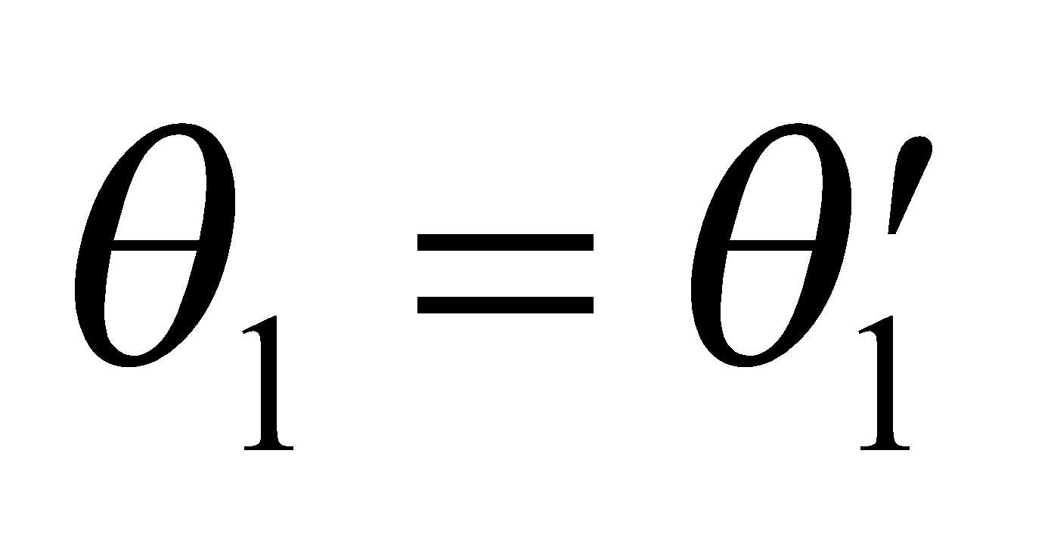 for specular reflection, (Equation 30.1) a reflected ray is deviated by 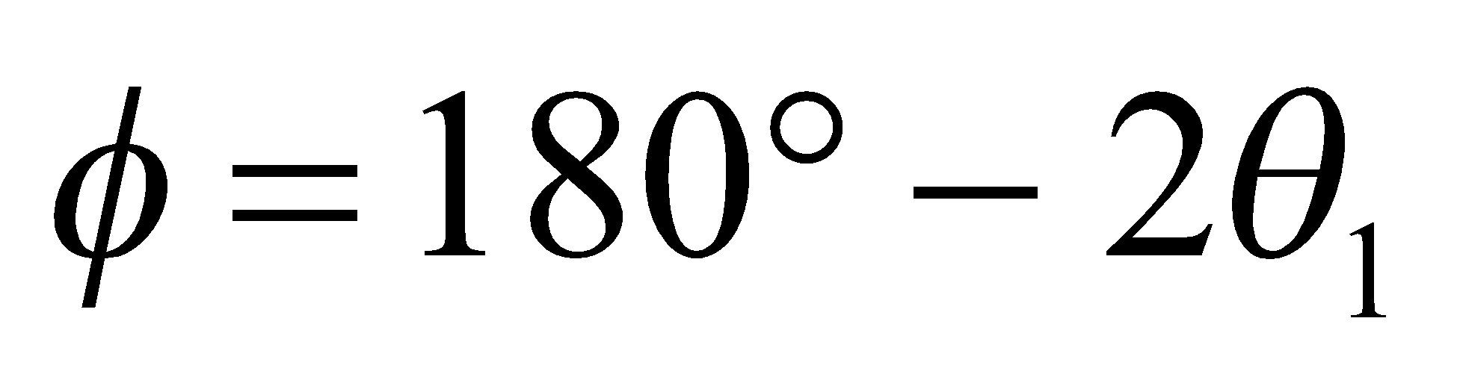 from the incident direction (see figure below). If rotating the mirror changes 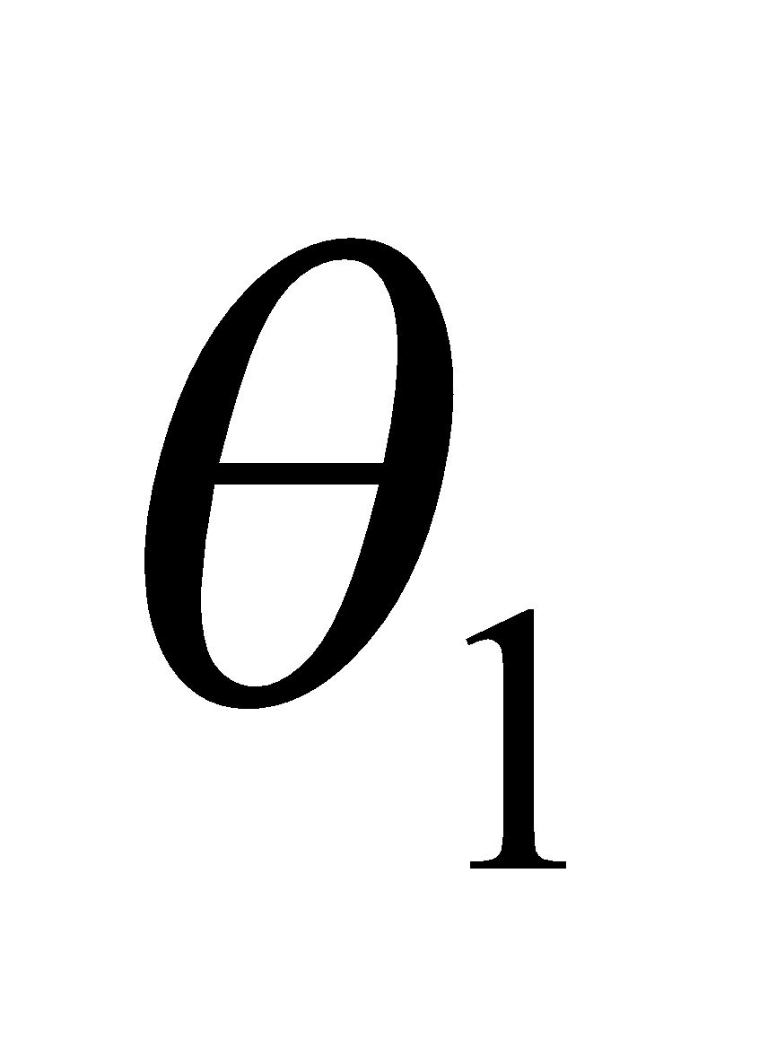by 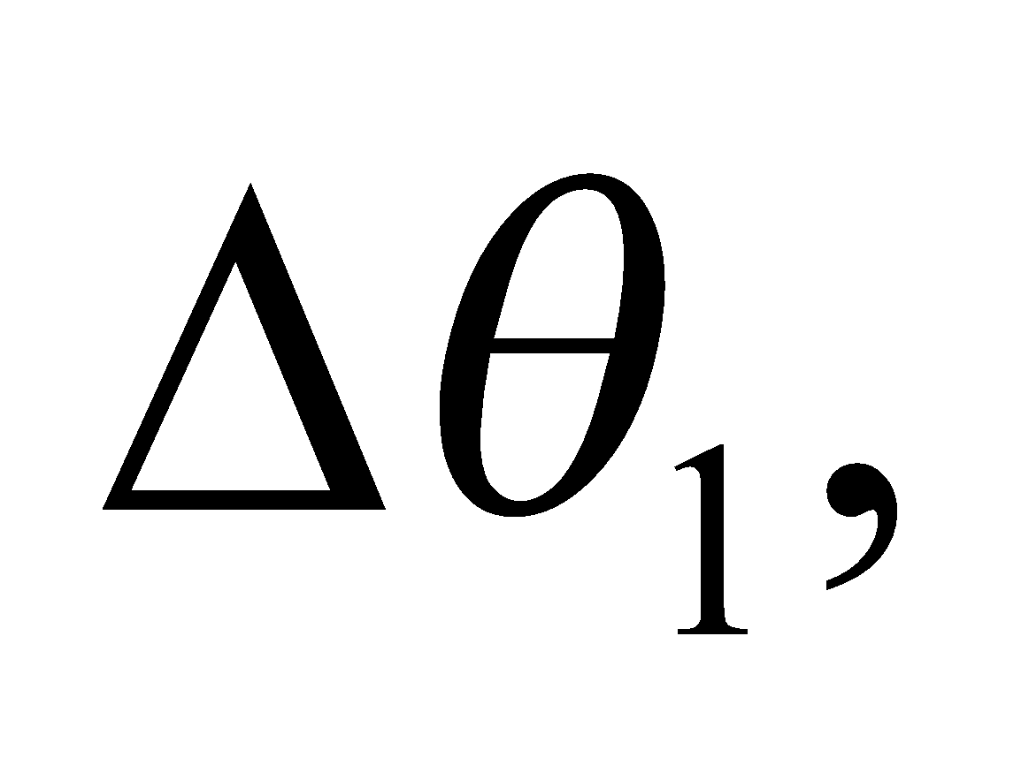 then the reflected ray is deviated by 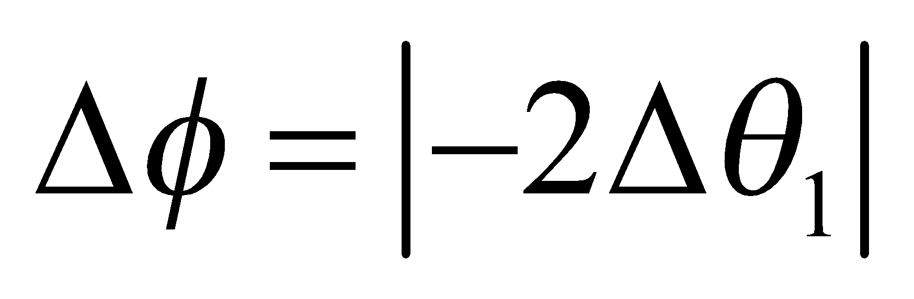 or twice this amount.



**Evaluate** Thus, if 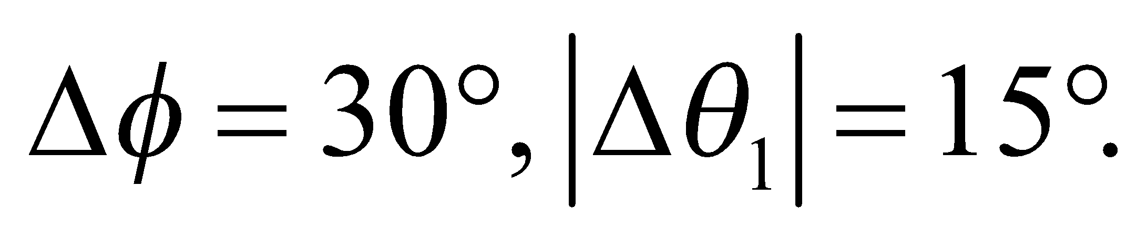

**Assess** This result can be easily verified with a small mirror.

**12. Interpret** This problem involves finding the path of an initially horizontal light ray reflected from the surfaces of two mirrors which are positioned as given in the problem statement.

**Develop** The path of the reflected ray can be constructed using the law of reflection which states that the angle of incidence equals the angle of reflection (Equation 30.1): 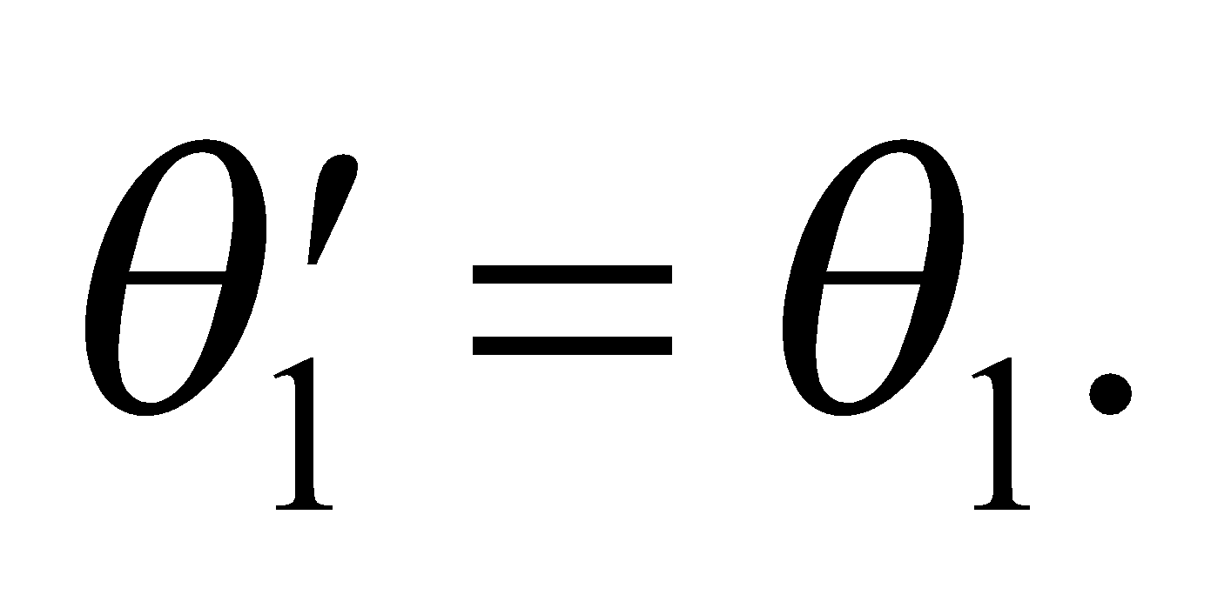

**Evaluate** (**a**) See figure below. The first reflected ray leaves the upper mirror at a grazing angle of 30°, and therefore strikes the lower mirror at normal incidence (i.e., perpendicular to the surface). It is then reflected twice more in retracing its path in the opposite direction, so the total number of reflections is 4.

(b) The resulting ray is antiparallel to the initial ray and goes through the same origin.



**Assess** Our double-mirror arrangement is a retroreflector that sends light rays back to their point of origin. Retroreflection has many practical applications (e.g., taillights, stop signs, etc.).

**13. Interpret** We are to find an expression for the angle of return of a light ray that is incident on a pair of perpendicularly aligned mirrors and use this expression to find the accuracy with which the mirrors must be aligned.

**Develop** A ray incident on the first mirror at a grazing angle *α* is deflected through an angle 2*α* (this follows from the law of reflection, see Problem 30.11). It strikes the second mirror at a grazing angle *β* and is deflected by an additional angle 2*β*. Let the total deflection be *θ*f: 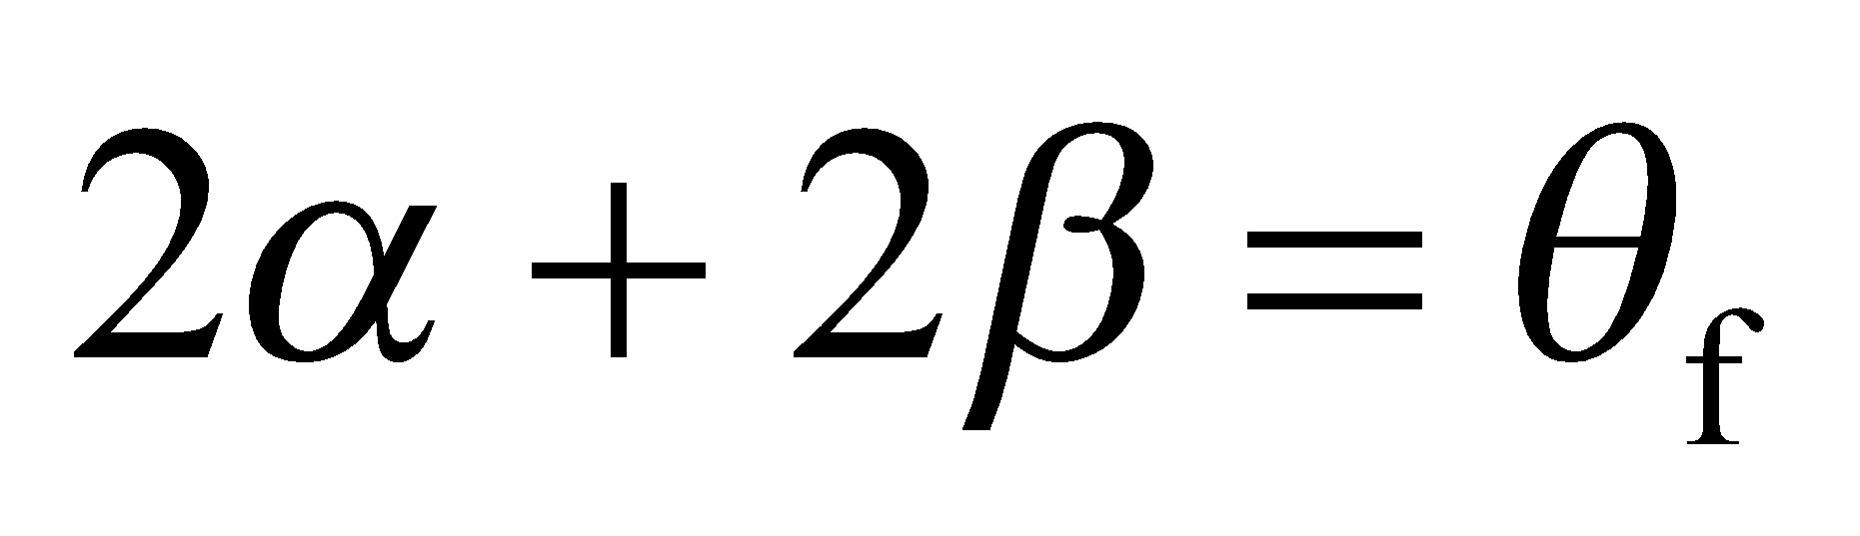. The alignment angle of the mirrors is *θ* = *π*/2 − *α* − *β* = *π*/2 − *Δθ*f /2.

**Evaluate** Differentiating this expression gives

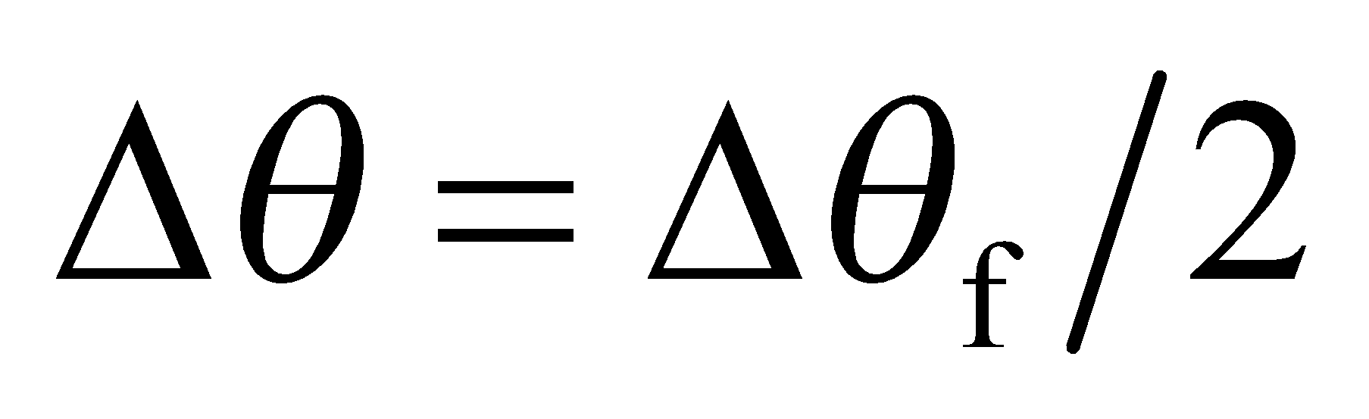

so for *Δθ*f = 1°, *Δθ* = 0.5°.



**Assess** This is another retroreflector, but this time there is a displacement in the retro-reflected beam.

**14. Interpret** This problem involves finding the angle through which a light ray is rotated after undergoing reflection from the given two-mirror arrangement.

**Develop** See figure below. The path of the reflected ray can be constructed using the law of reflection (Equation 30.1). The angle of incidence equals the angle of reflection (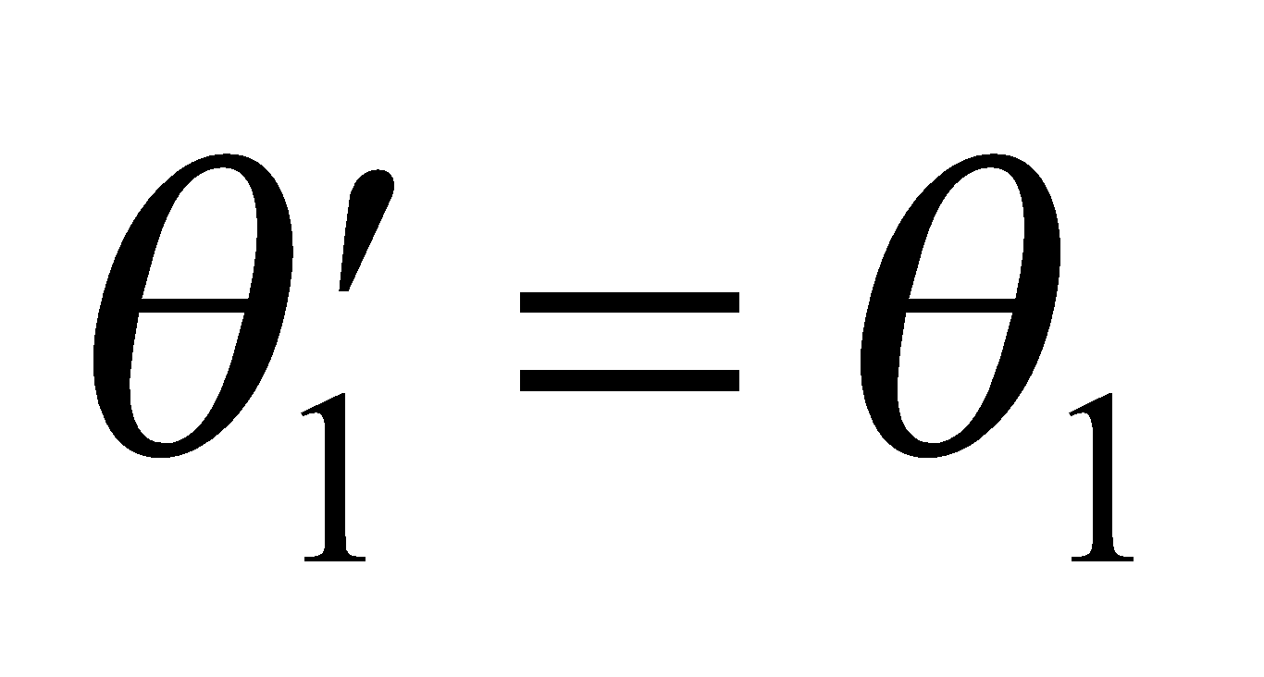). By simple geometry, we can find the angles *α* and *β*, and sum them to find the angle through which the incident ray is rotated.



**Evaluate** Entering parallel to the top mirror, a ray makes an angle of incidence of 30° with the bottom mirror. It then strikes the top mirror also at 30° incidence, and is reflected out of the system parallel to the bottom mirror (see the figure). The ray forms an isosceles triangle, which allows us to calculate the angles *α* and *β*. The total deflection is 2*α* + *β* = 240° counterclockwise (or 120° clockwise) from the incident direction.

**Assess** The reflected path follows from the law of reflection.

**Section 30.2 Refraction**

**15. Interpret** Given the speed of light in an unknown material, we are to find the index of refraction and thus identify the material.

**Develop** Apply Equation 30.2, *n* = *c*/*v* and use Table 30.1 to find the corresponding material.

**Evaluate** The index of refraction of the material is 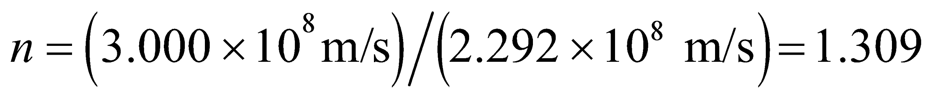, so the material is ice.

**Assess** This is a typical value for an index of refraction of a material that is transparent to visible light.

**16. Interpret** For this problem, we are to use the index of refraction of a CD to find the pit depth, given that it is one-quarter wavelength deep.

**Develop** From the discussion accompanying Equation 30.2, we know that 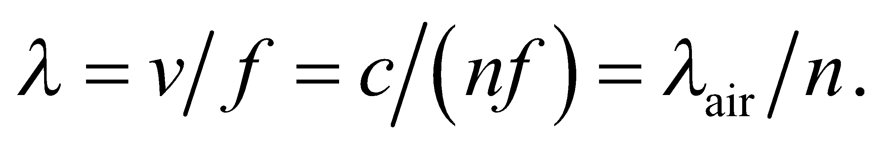 Given that the pit depth is *λ*/4, we can find the pit depth.

**Evaluate** Inserting the values given, the wavelength of the laser light is

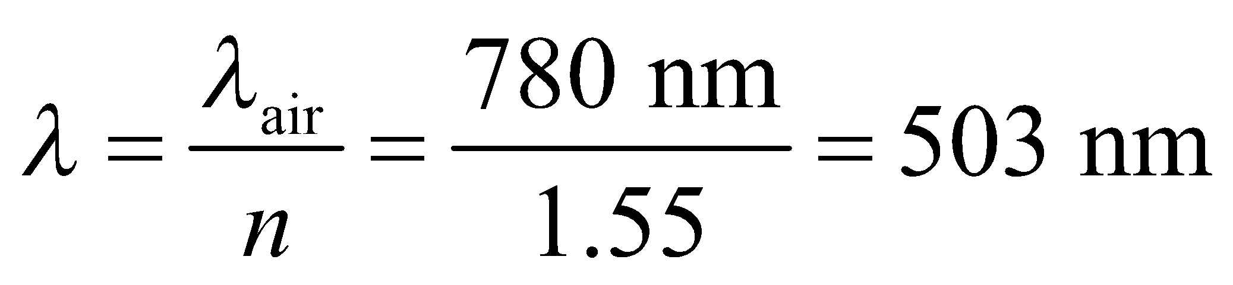

The pit depth is one quarter wavelength, or 126 nm.

**Assess** A typical pit on a CD is about 100 nm deep and 500 nm wide. Our result is within this range.

**17. Interpret** This problem involves Snell’s law, which we can use to find the incident angle of the light beam.

**Develop** Apply Snell’s law (Equation 30.3) to find the incident angle.

**Evaluate** Snell’s law (with 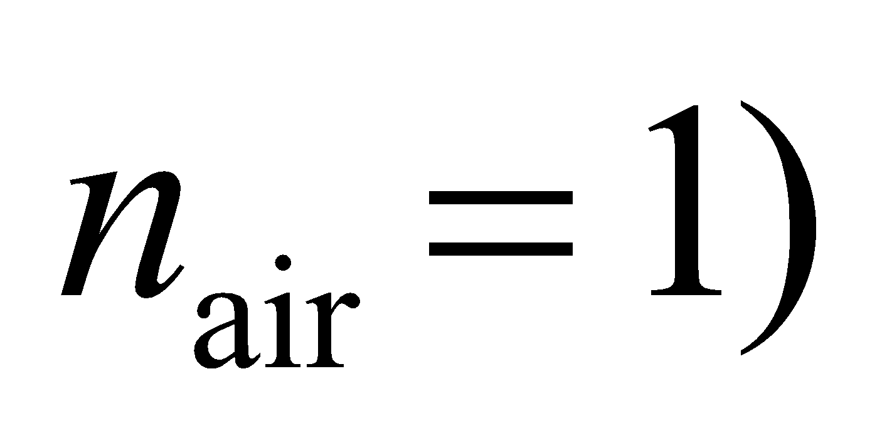 gives 

**Assess** The angle is between 0° and 90°, as expected.

**18. Interpret** This problem is about refraction at an interface. We shall apply Snell’s law to find the index of refraction of the material.

**Develop** Snell’s law (Equation 30.3) states that 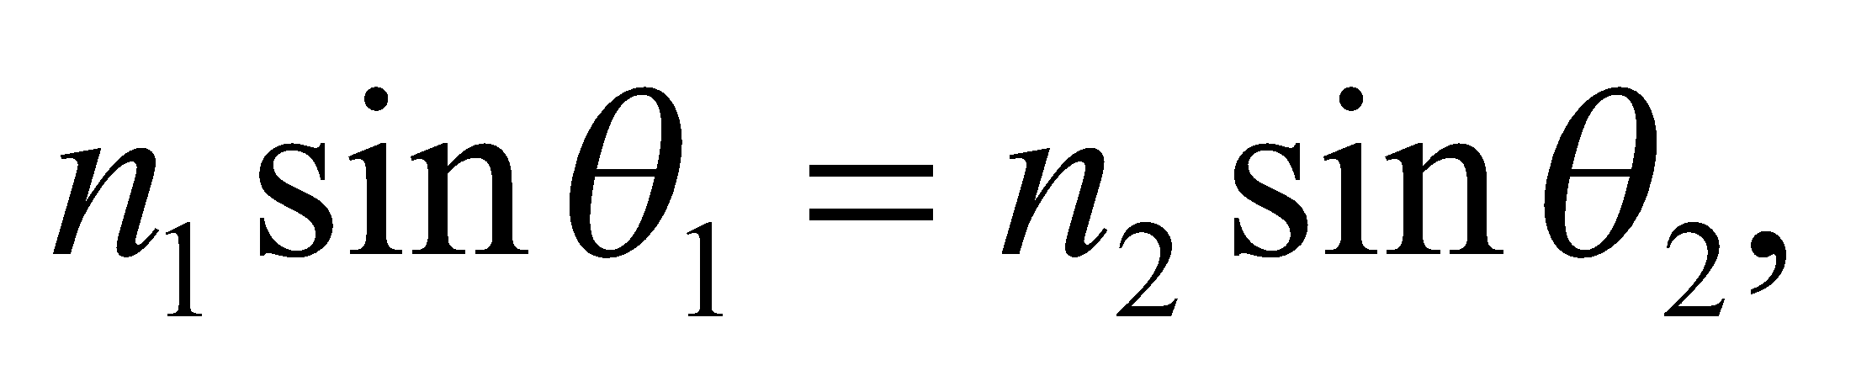 where 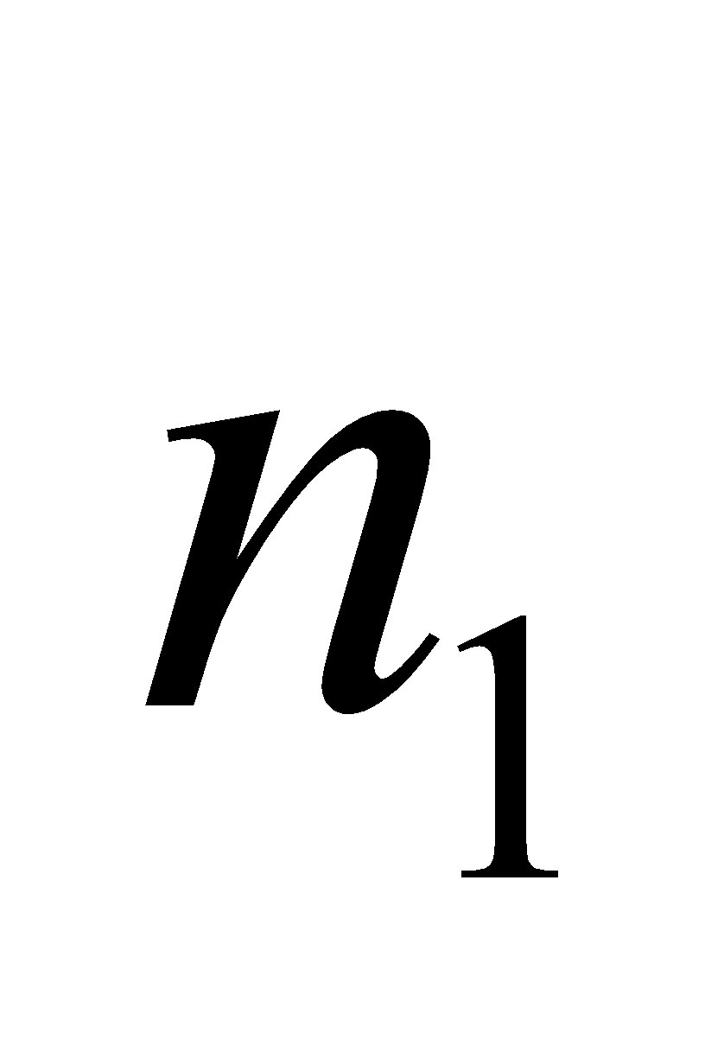 and 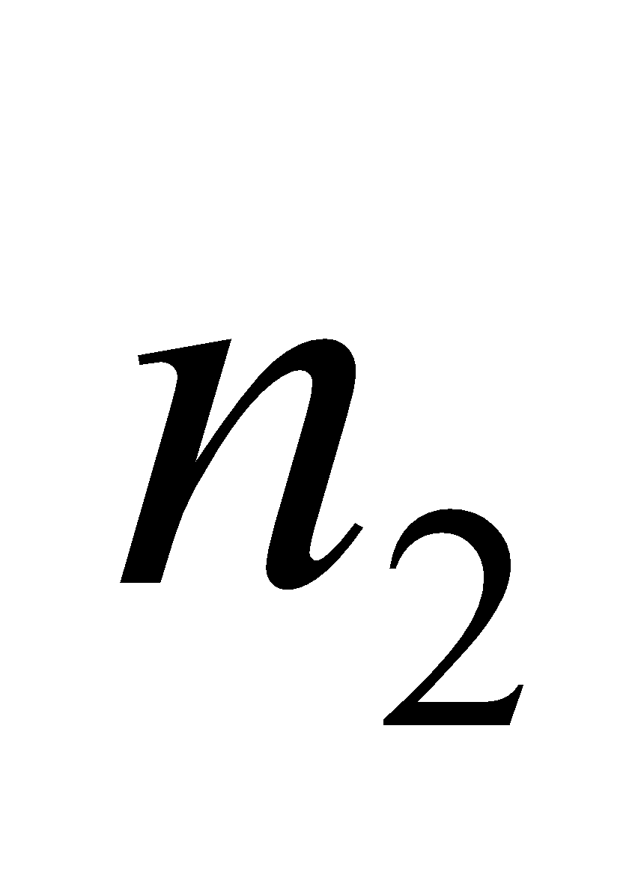 are the refractive indices of the two media, and  and 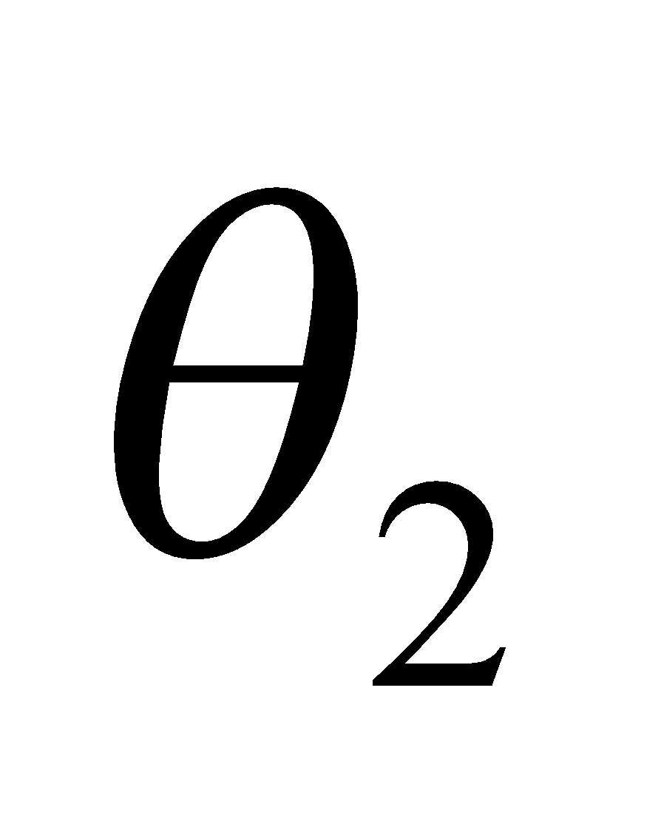 are the angles the light ray makes with the normal to the surface.

**Evaluate** With air as medium 1, the index of refraction of medium 2 is

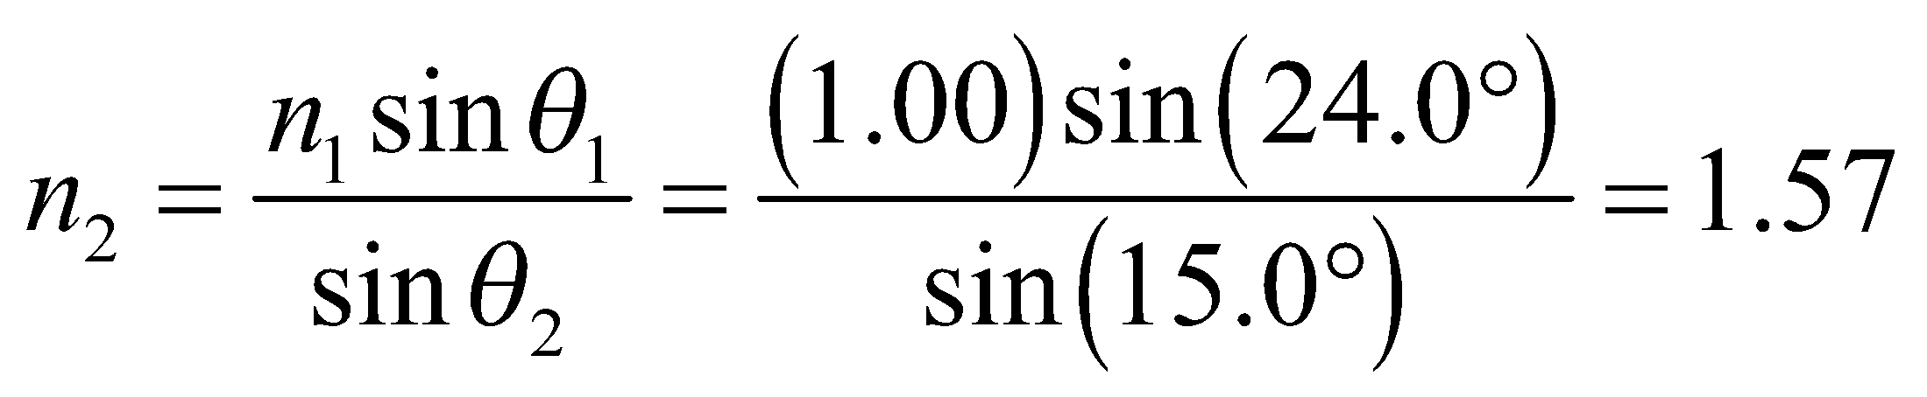

**Assess** Since 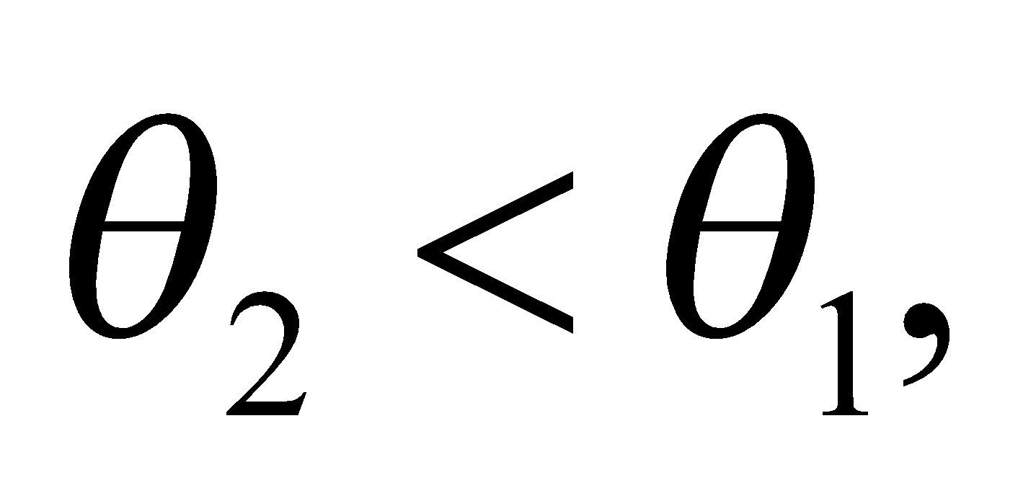 the light ray bends toward the normal and we expect 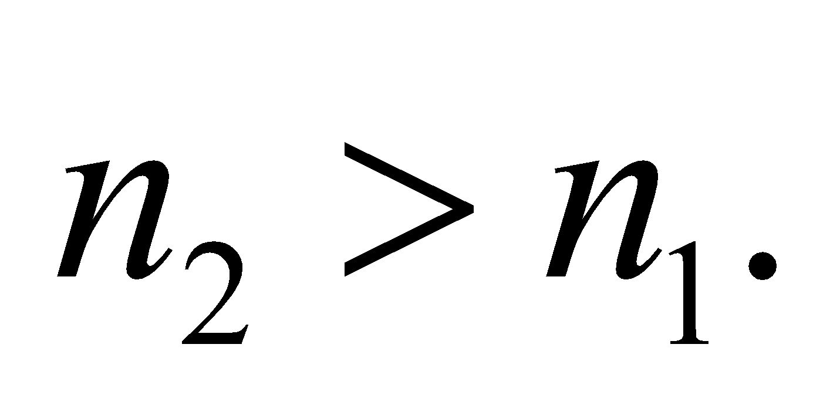

**19. Interpret** This problem involves Snell’s law, which we can use to find the angle of refraction of a light beam as it passes from glass into water.

**Develop** Apply Snell’s law (Equation 30.3) to find *θ*2, which is the angle of refraction in the water. From Table 30.1, the index of refraction of water is *n*2 = 1.333.

**Evaluate** Equation 30.3 gives 

**Assess** This angle is greater than the incident angle (12.4°), as expected because the index of glass is larger than that of water.

**20. Interpret** This problem asks for the polarizing angle of the air-diamond interface, which is the angle at which the reflected light is linearly polarized perpendicular to the plane of incidence (i.e., the plane containing the incident and reflected rays).

**Develop** Using Equation 30.4, the polarizing angle for light in air reflected from diamond is

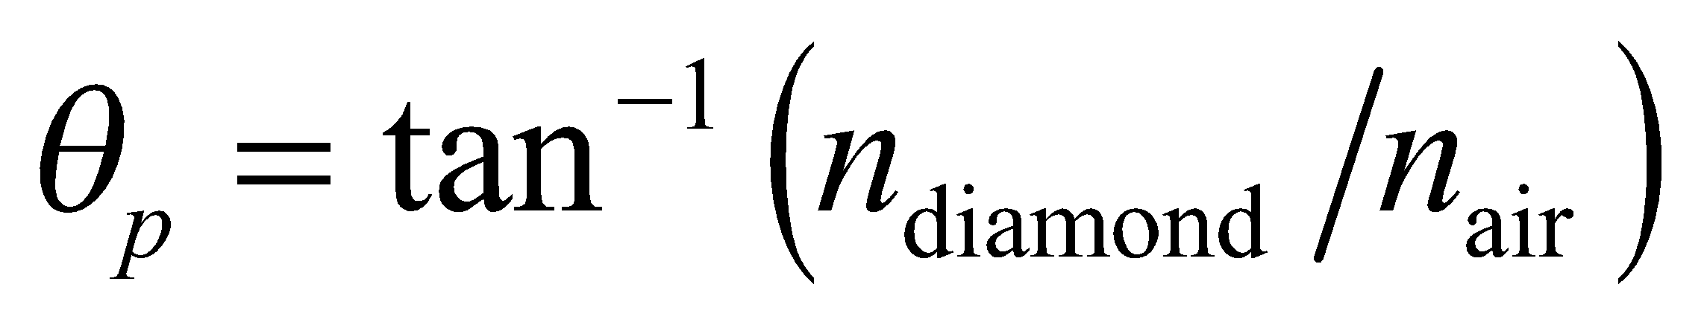

**Evaluate** From Table 30.1, 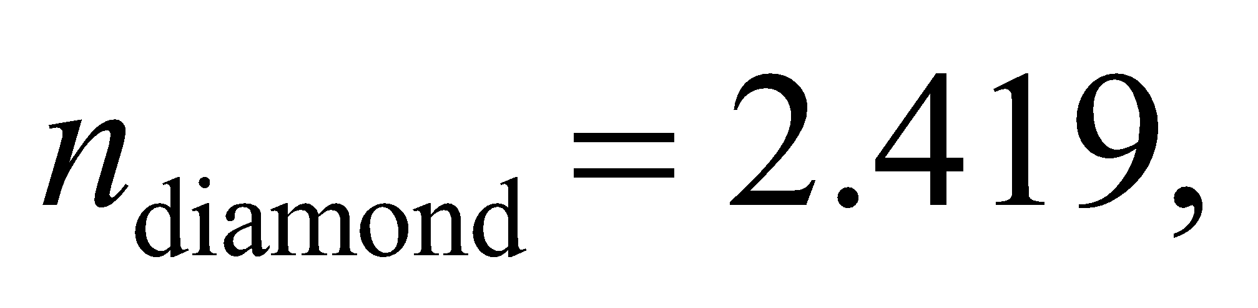and the polarizing angle is



**Assess** At this angle, the reflected light ray is perpendicular to the transmitted light ray, as illustrated in Figure 30.8.

**21. Interpret** We are to find the refractive index of a material given its polarizing angle in air.

**Develop** Apply Equation 30.4, with *n*1 = 1.0 and *θ*p = 62°.

**Evaluate** Solving Equation 30.4 for *n*2 gives

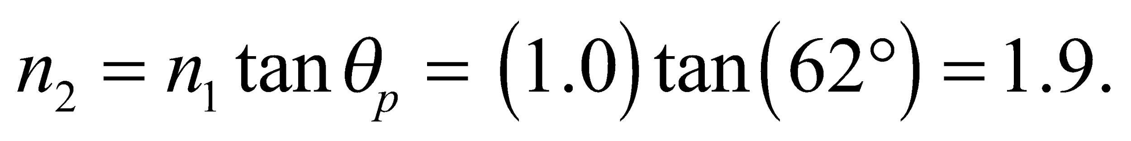

**Assess** From Table 30.1, this material could be a glass.

**Section 30.3 Total Internal Reflection**

**22. Interpret** We are to find the critical angle for total internal reflection in various media.

**Develop** For 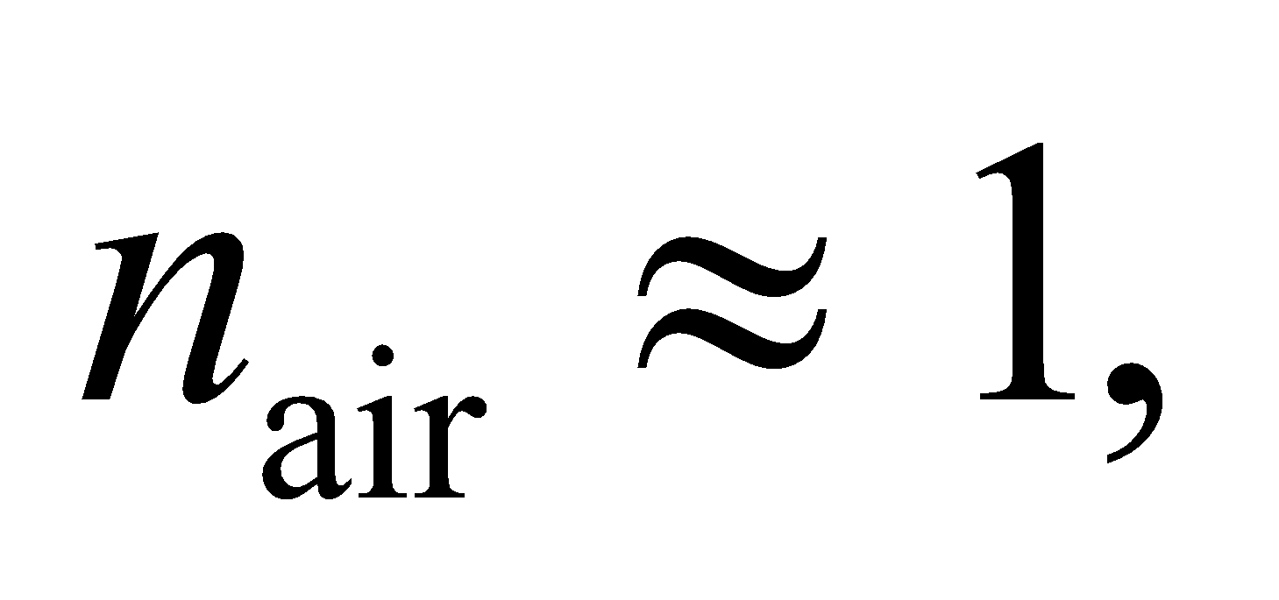 using Equation 30.5, the critical angle for total internal reflection in a medium of refractive index *n* is 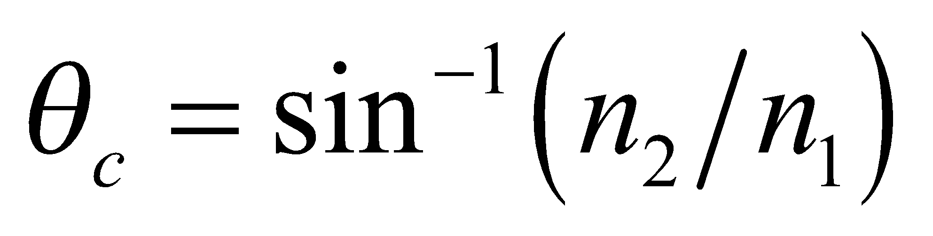 where air is medium 2. Use Table 30.1 to find the indices of the various materials.

**Evaluate** **(a)** From Table 30.1, we find *n* = 1.309 for ice, so 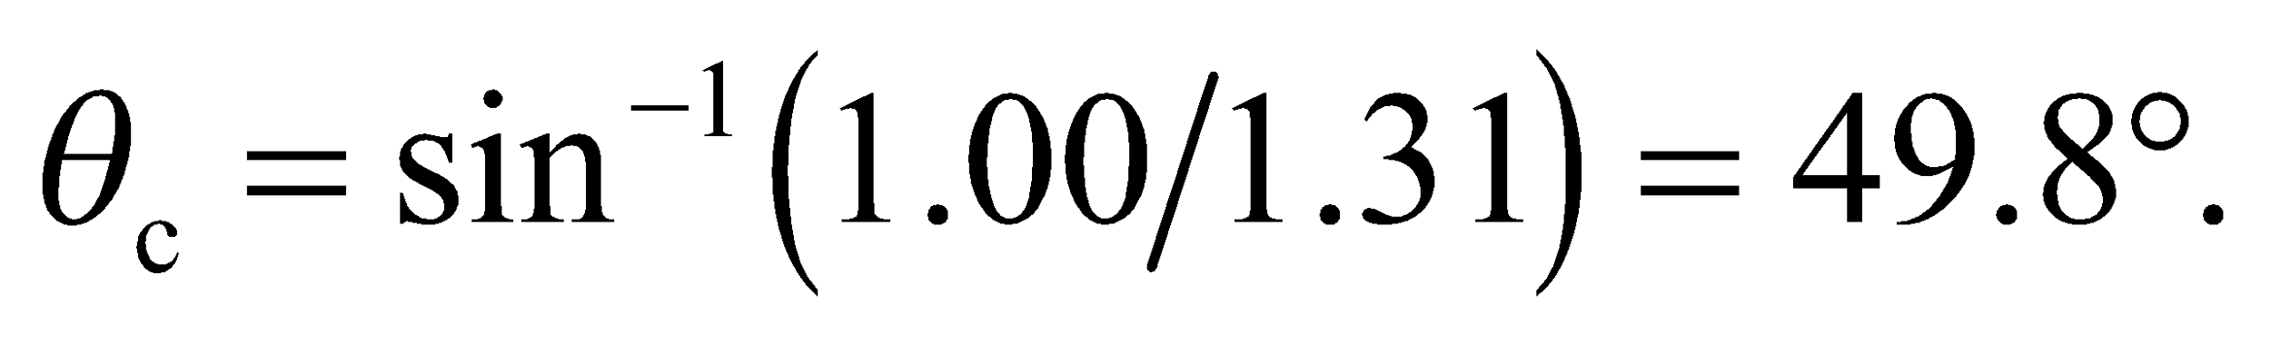

**(b)** With *n* = 1.49 for polystyrene, 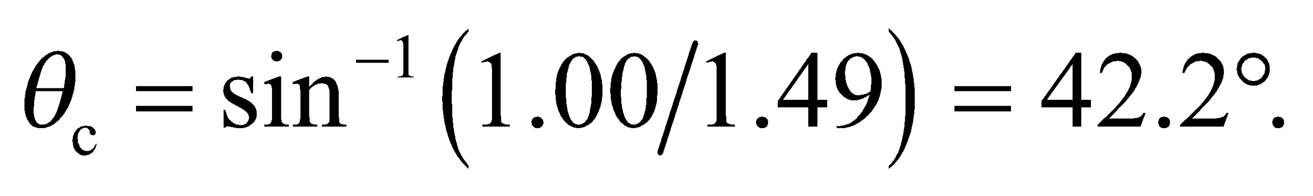

**(c)** Similarly for rutile, *n* = 2.62 and 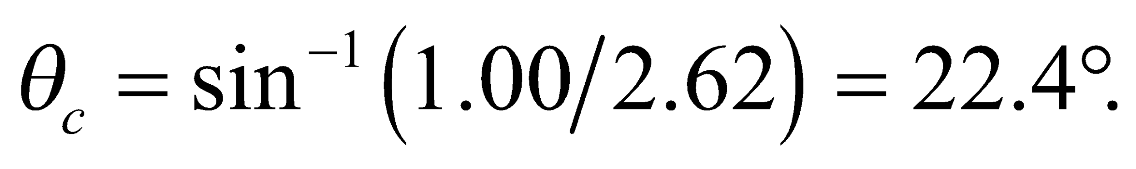

**Assess** The larger *n*, the smaller critical angle. Light incident at 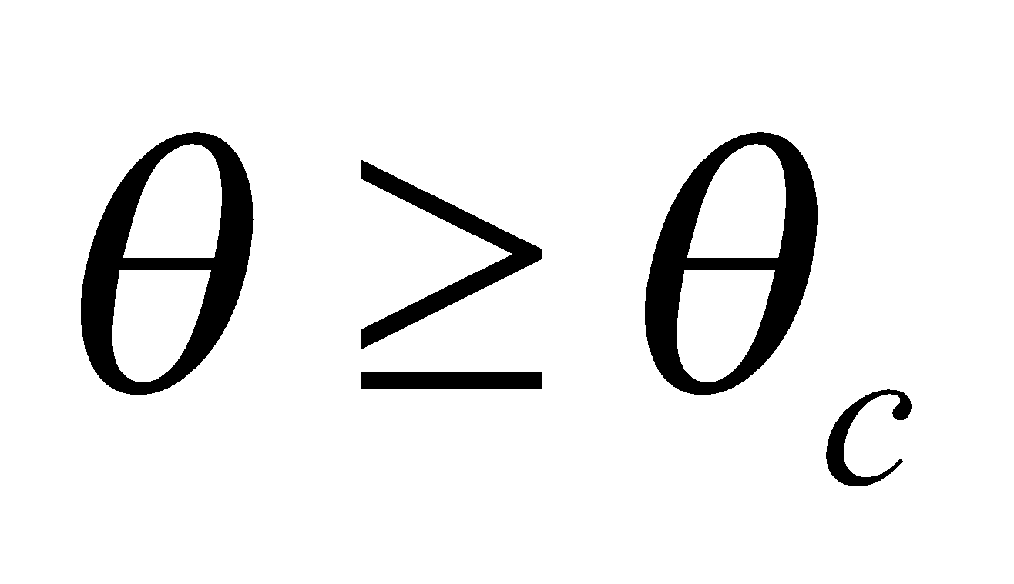 cannot escape from the medium.

**23. Interpret** We are to find the critical angle for light going from water to ice.

**Develop** Apply Equation 30.5, using Table 30.1 to find the indices of refraction of the media.

**Evaluate** The critical angle is



**Assess** This is a reasonable value for a critical angle between to similar media.

**24. Interpret** In this problem, we want to find the critical angle for total internal reflection at the interface between various media.

**Develop** The critical angle in medium-1, at an interface with medium-2, is given by Equation 30.5:

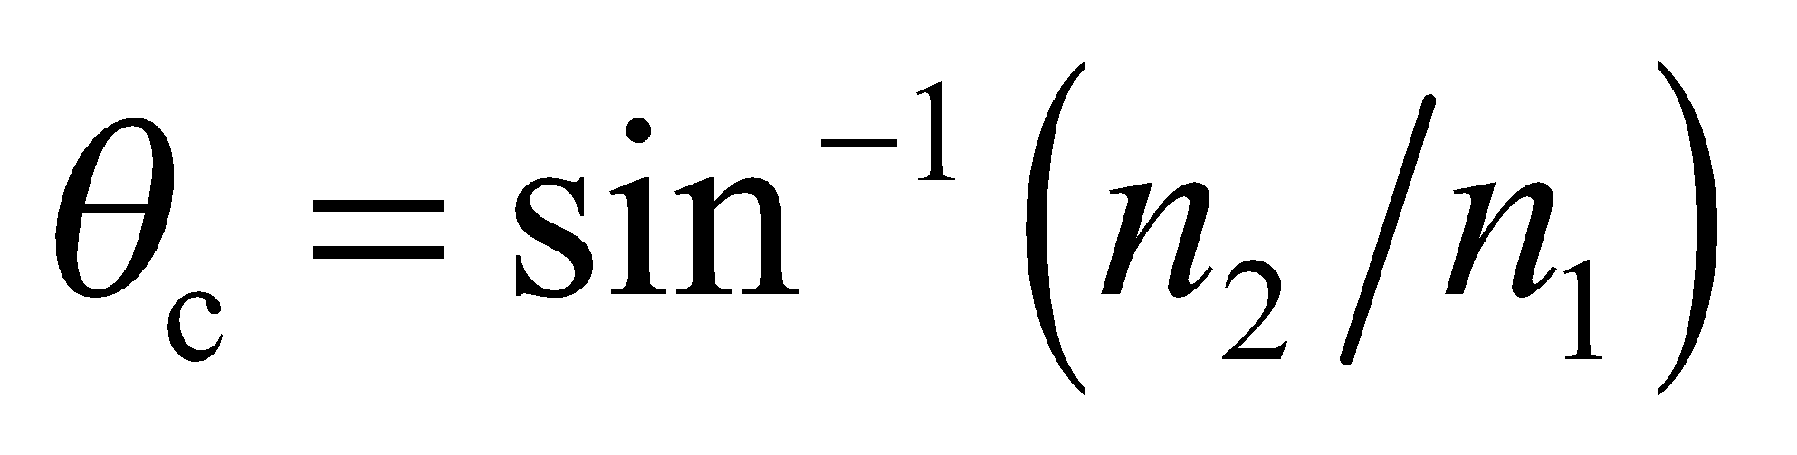 where 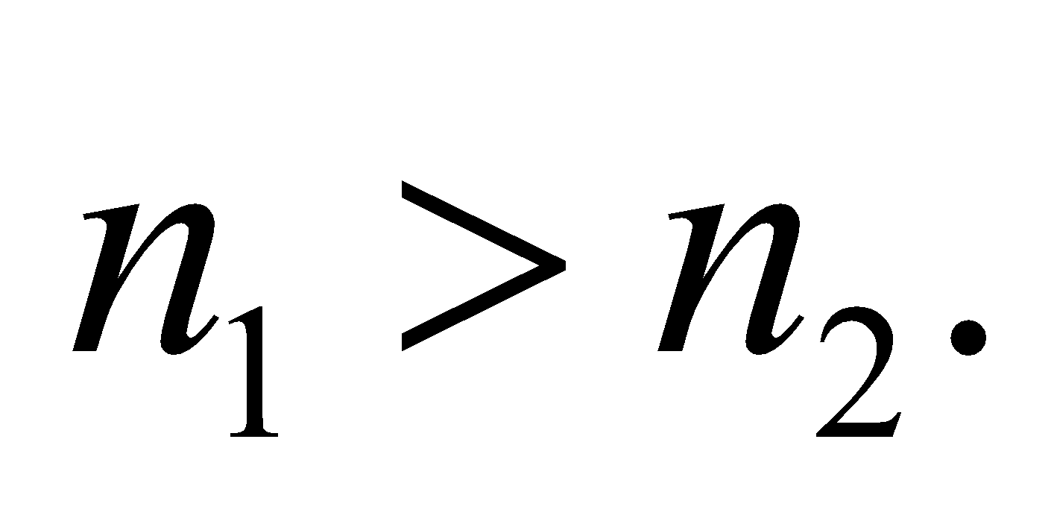

**Evaluate** **(a)** For glass (n1 = 1.52) immersed in water 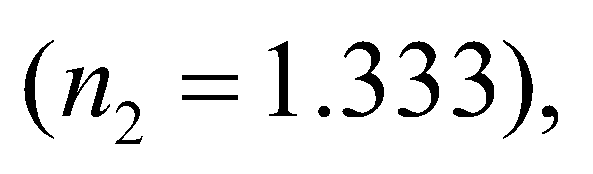 the critical angle is



**(b)** The same glass immersed in benzene has 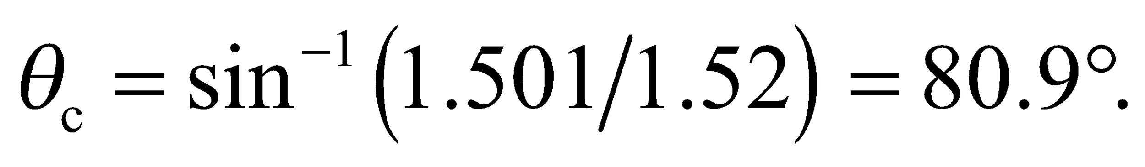

**(c)** Since the index of refraction of diiodomethane 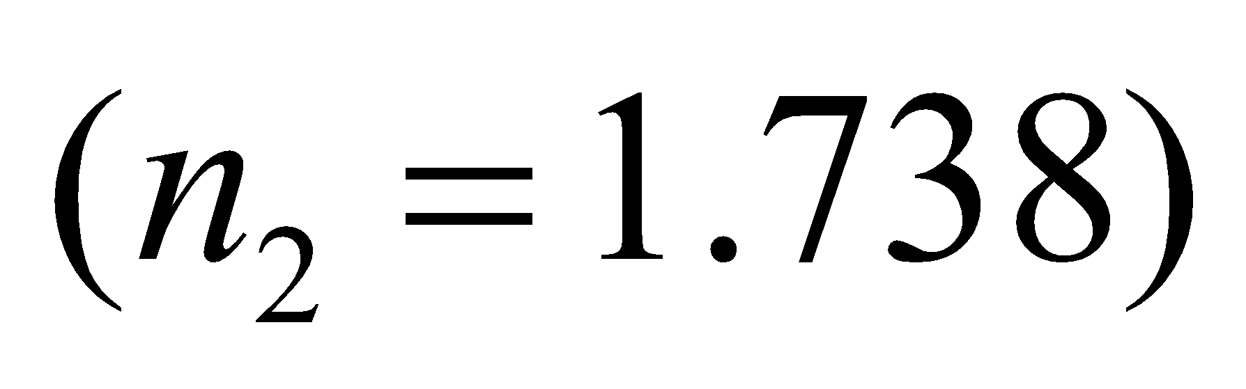 is not smaller than that for this glass, there is no total internal reflection for light propagating in the glass. However, for light originating in the liquid, the critical angle at the glass interface is 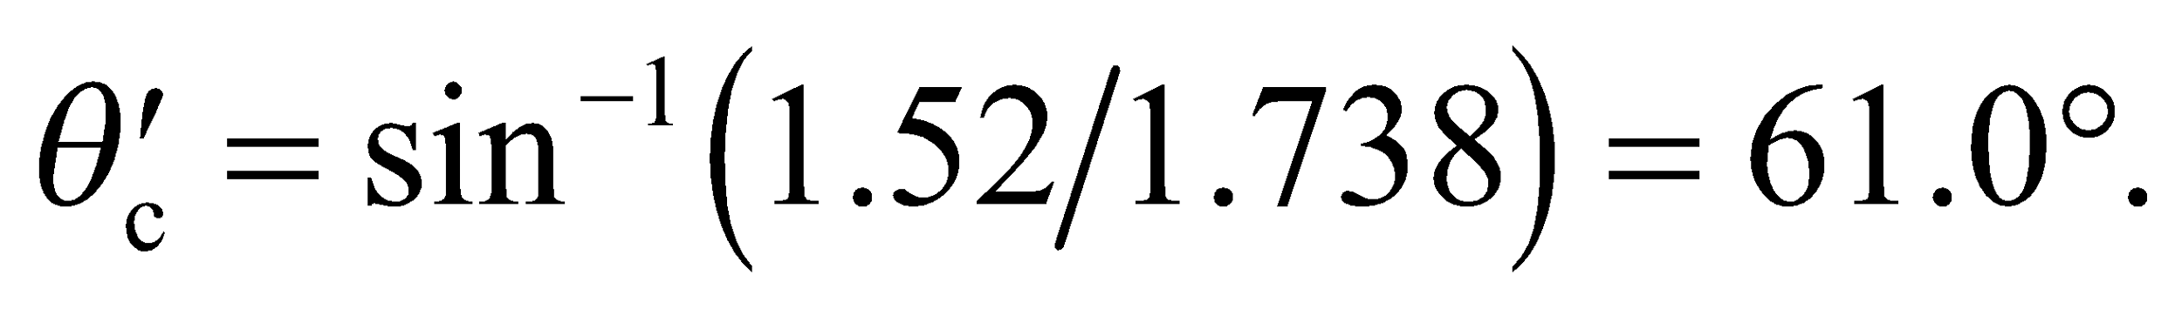

**Assess** This problem shows that for total internal reflection to take place as light propagates from medium 1 to medium 2, we must have 

**25. Interpret** We are to find the refractive index of plastic given the critical angle for light propagation from air to plastic.

**Develop** Apply Equation 30.5, with *n*1 = 1.00 *θ*c = 37°.

**Evaluate** At the critical angle in plastic, 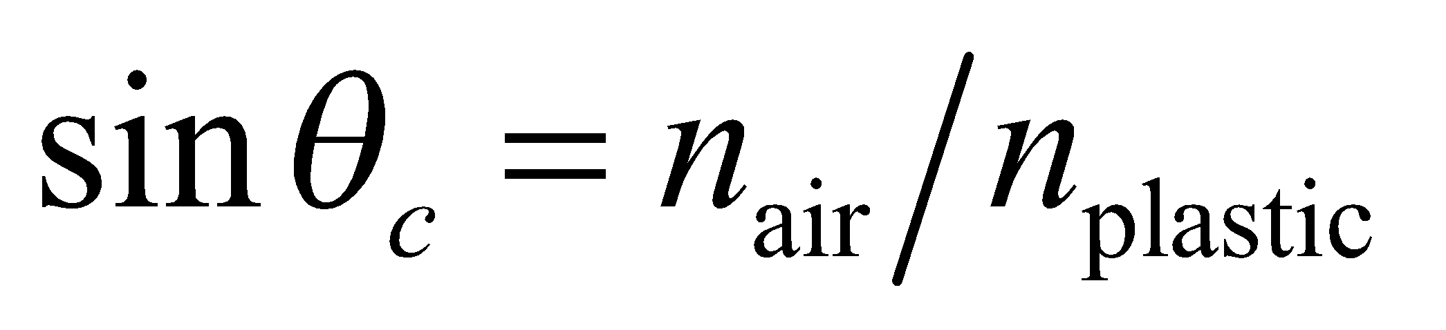 (Equation 30.5), so 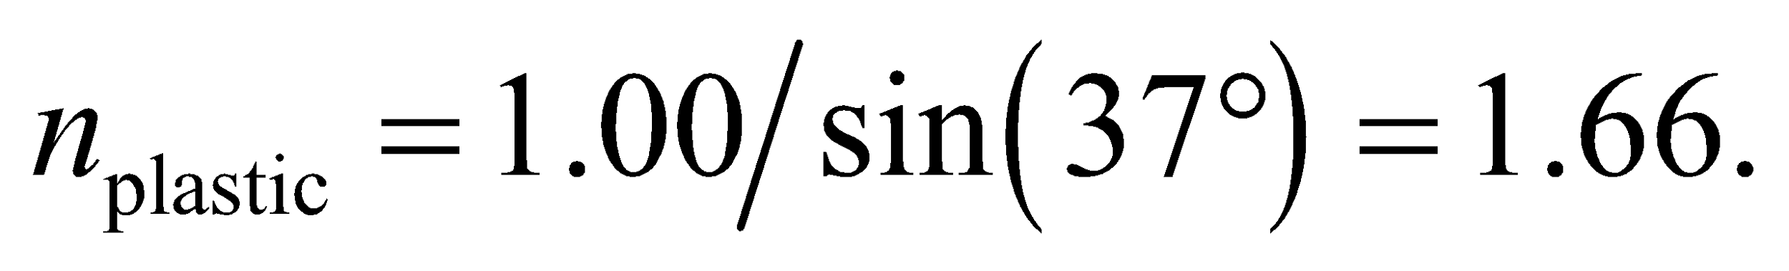

**Assess** This is a reasonable value for a refractive index for a plastic.

**Section 30.4 Dispersion**

**26. Interpret** This problem involves finding the angle between the red and the blue light that is created by dispersion in glass.

**Develop** Using Snell’s law (Equation 30.3), the angle of refraction for each wavelength is 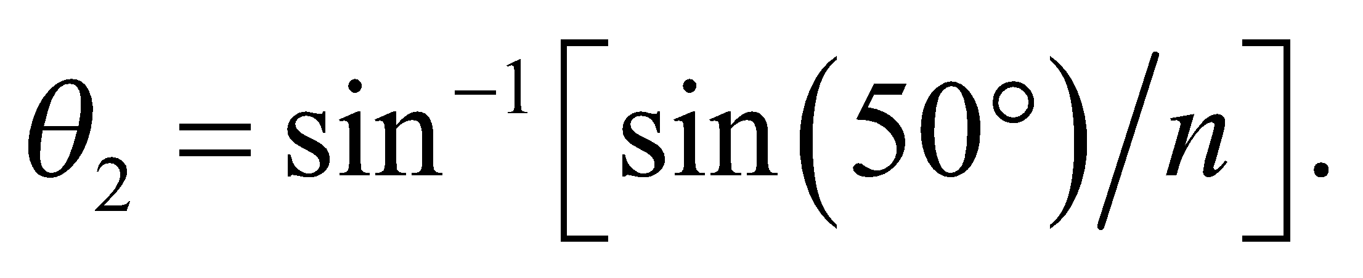 The angle between the two laser beams is 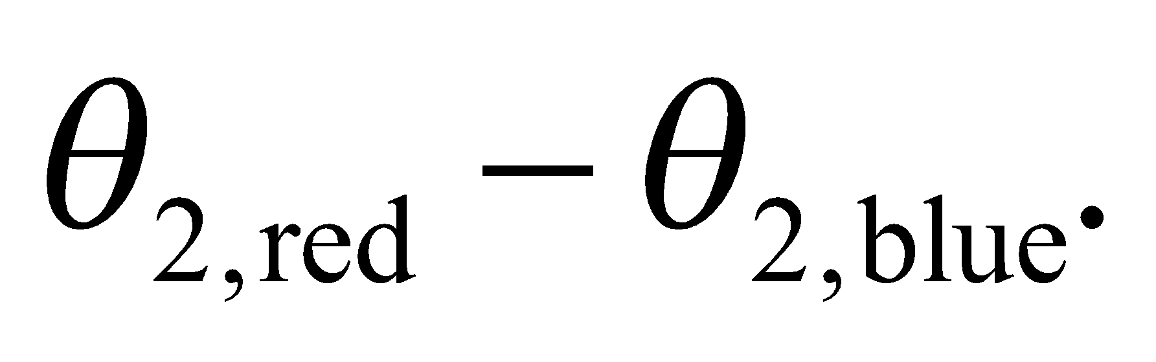

**Evaluate** Substituting the values given in the problem statement, we get



**Assess** The refractive index of a material is higher for blue light than the red light. So, from Equation 30.2, we expect red light to travel at a greater speed than the blue light.

**27. Interpret** We are to find the angular dispersion for a beam of white light that transits an equilateral prism.

**Develop** The geometry for refraction through a prism is shown in the figure below. Using Snell’s law (Equation 30.3) and the fact that 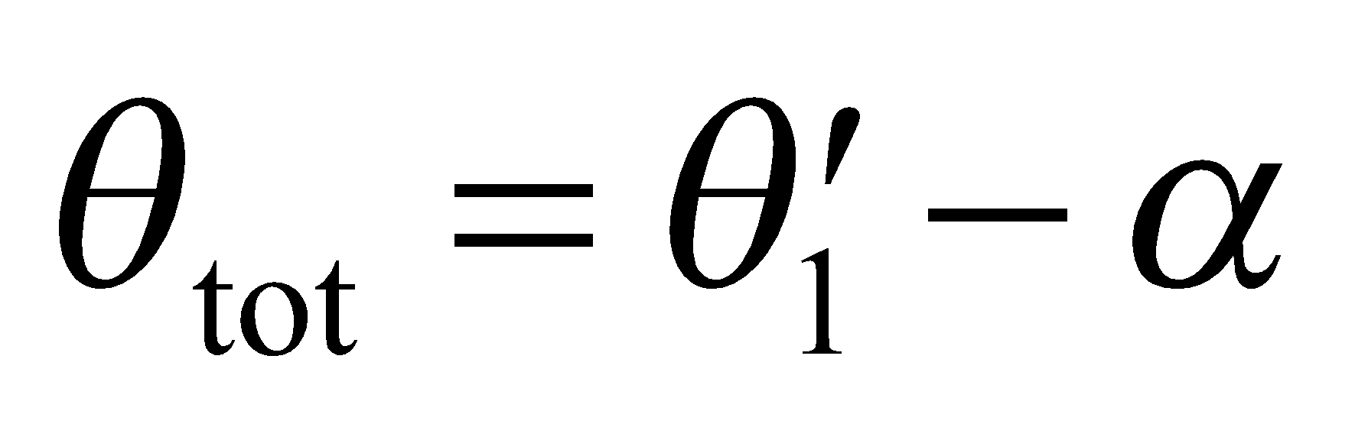 and 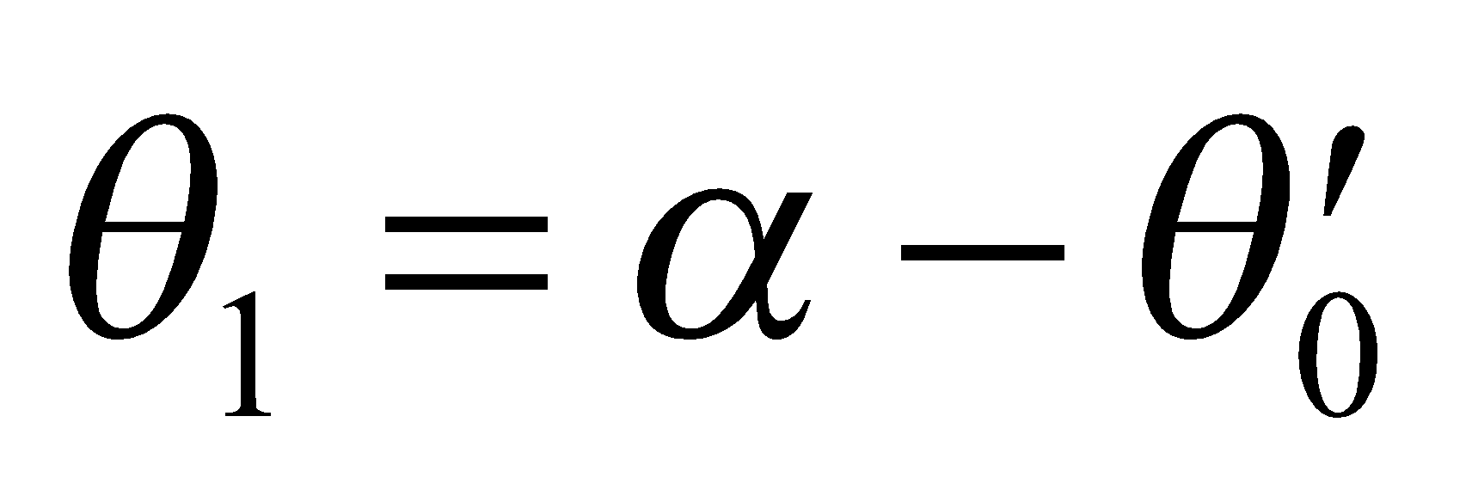, we find the following expression for *θ*tot:

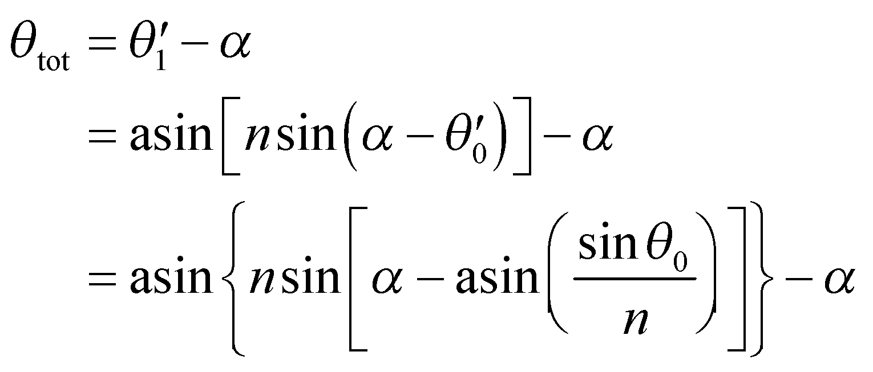

where *α* = 60°, *n* is the refractive index of the prism and we have used *n* = 1 for air. For red light, *n* = *n*red = 1.582, whereas for violet light, *n*violet = 1.633. The angular dispersion of the outgoing beam is the difference 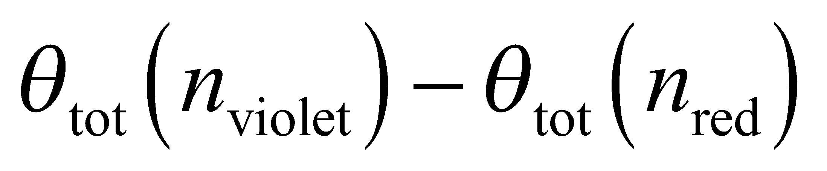.



**Evaluate** Using *θ*0 = 45°, we find 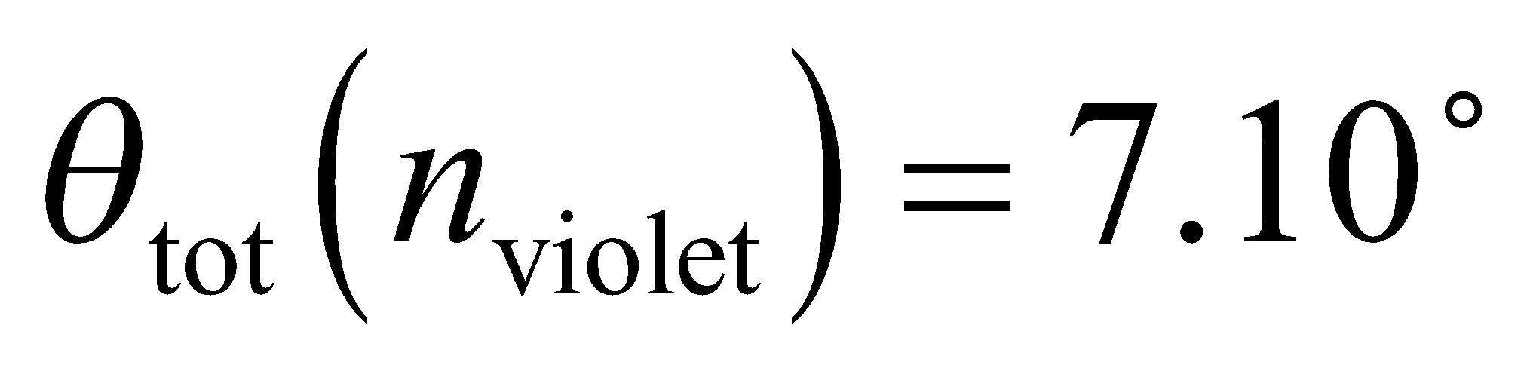 and 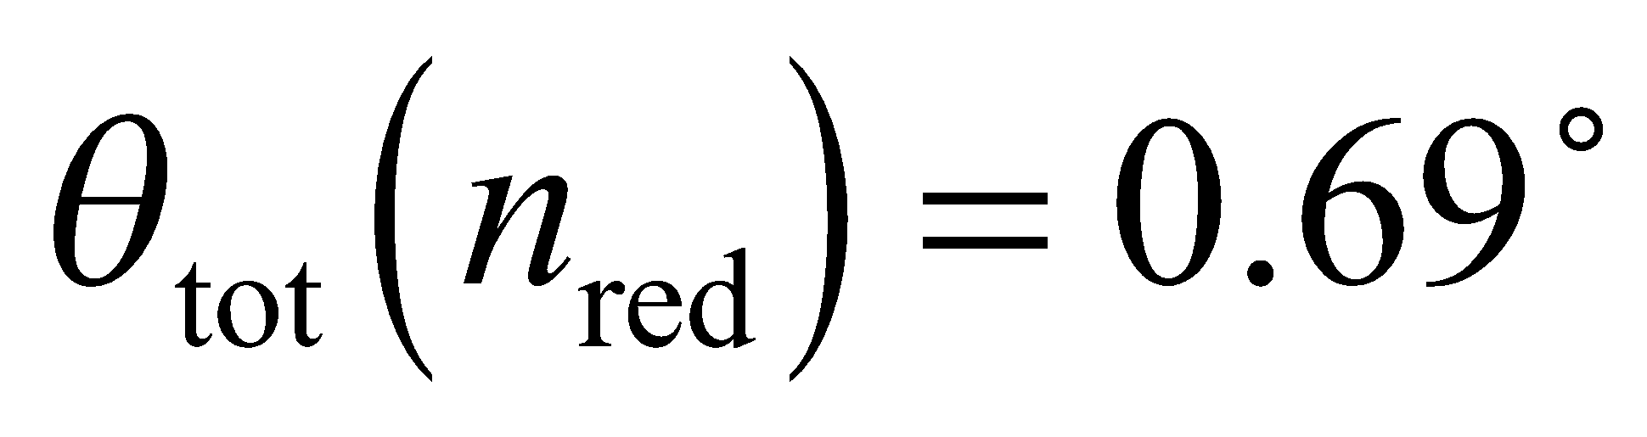, so the dispersion is 7.10° − 0.69° = 6.41°.

**Assess** We find that the violet light is deflected more than the red light, which is reasonable because the index of refraction for violet light is greater than for red light (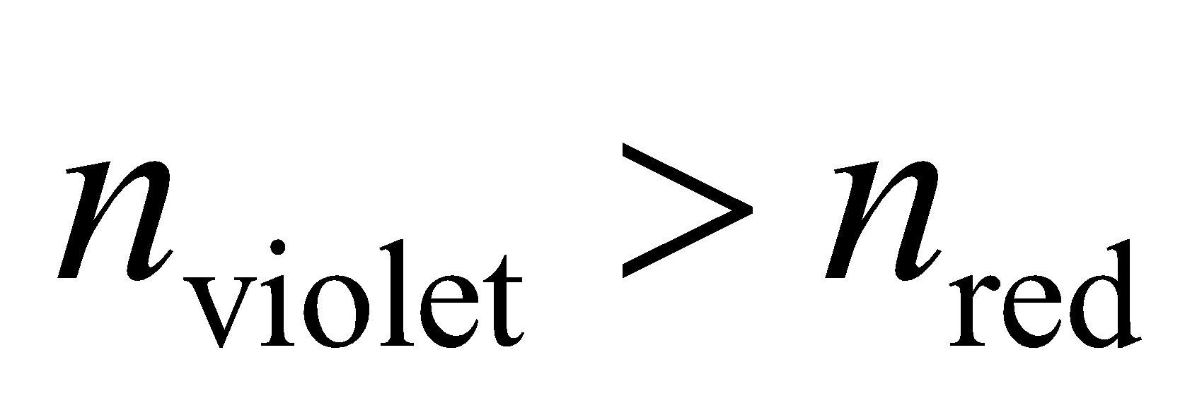).

**Problems**

**28. Interpret** This problem involves sketching the path of the light ray reflected from the surfaces of two mirrors.

**Develop** The path of the reflected ray can be constructed using the law of reflection (Equation 30.1), which says that the angle of incidence equals the angle of reflection (). In the following, refer to the sketch below of the mirror system.

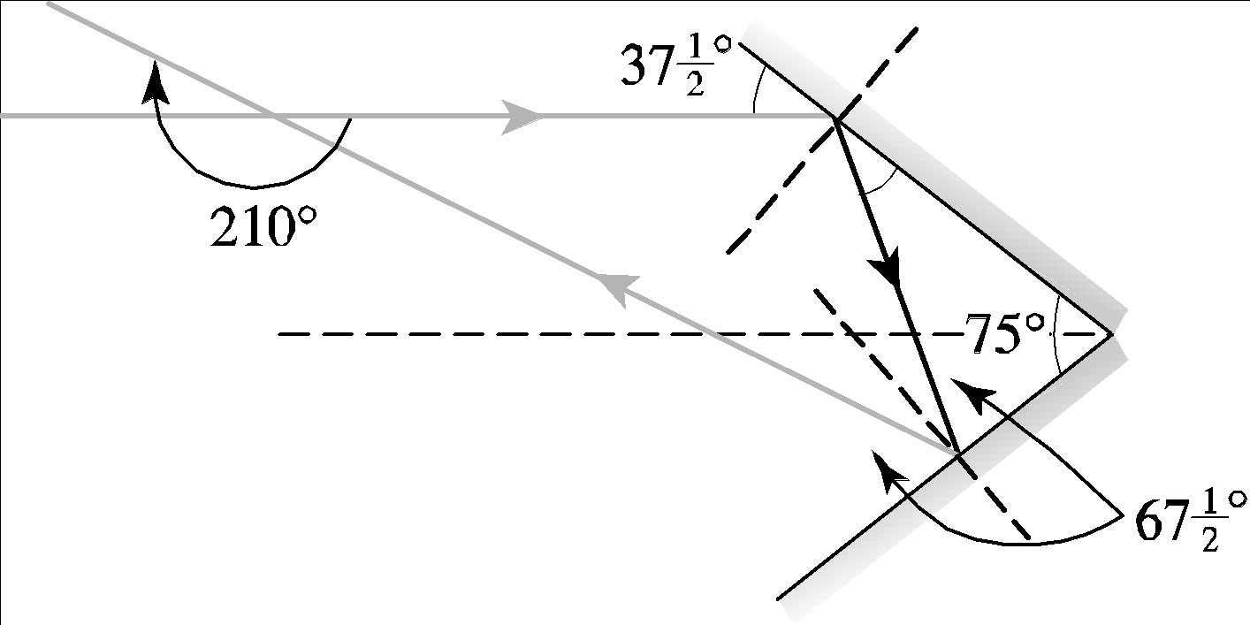

**Evaluate** After the first reflection, the ray leaves the top mirror at a grazing angle of 37.5° and so makes a grazing angle of 180° − 75° − 37.5° = 67.5° with the bottom mirror. It is therefore deflected through an angle of

2(37.5°) +2(67.5°) = 210° clockwise as it exits the system, after being reflected once from each mirror.

**Assess** The reflected path follows from the law of reflection.

**29.** **Interpret** We consider refraction in the human cornea.

**Develop**The angle of refraction, 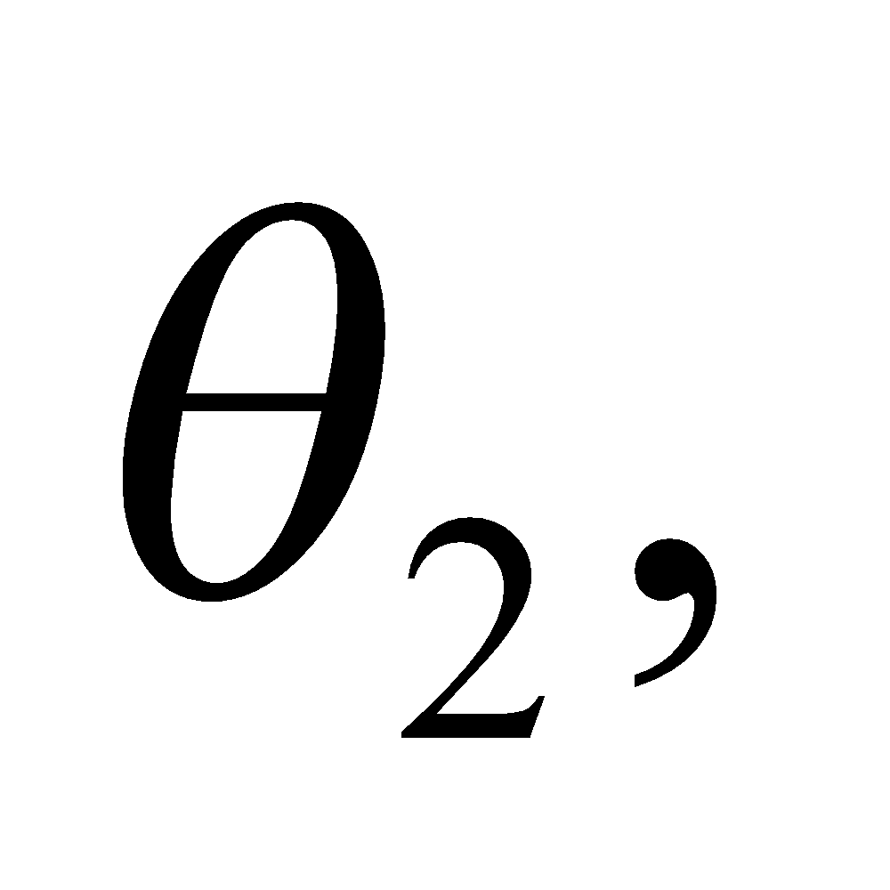 can be found from Equation 30.3: 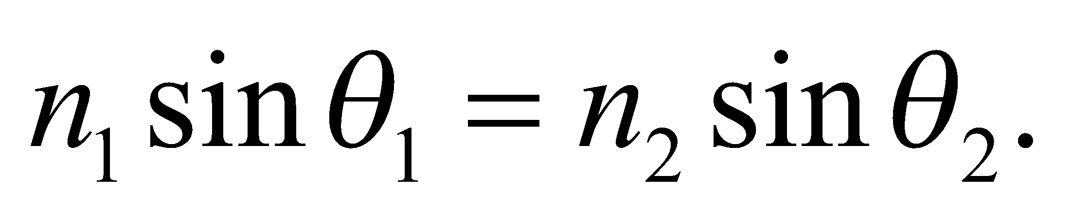 The light is coming from air 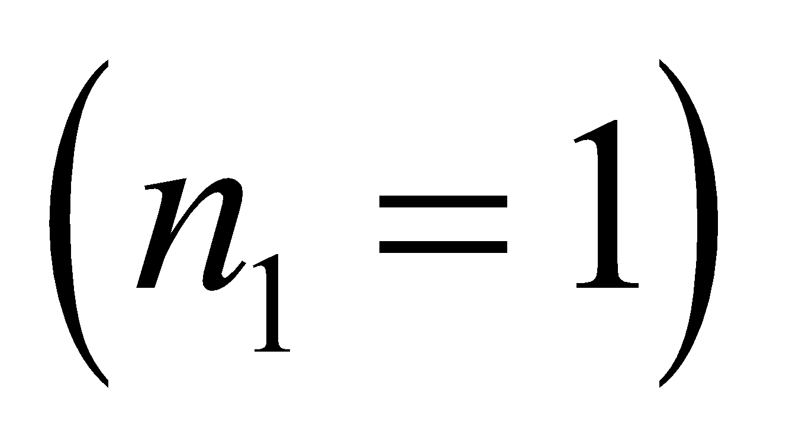, so the wavelength in the cornea is 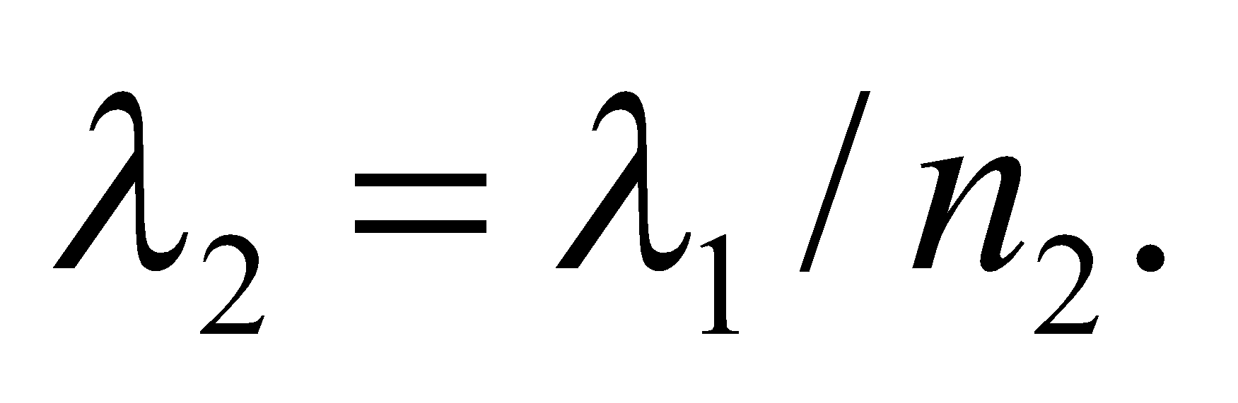

**Evaluate**(a) Solving for the angle of refraction gives

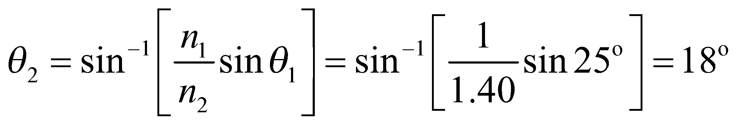

(b) The wavelength reduces to

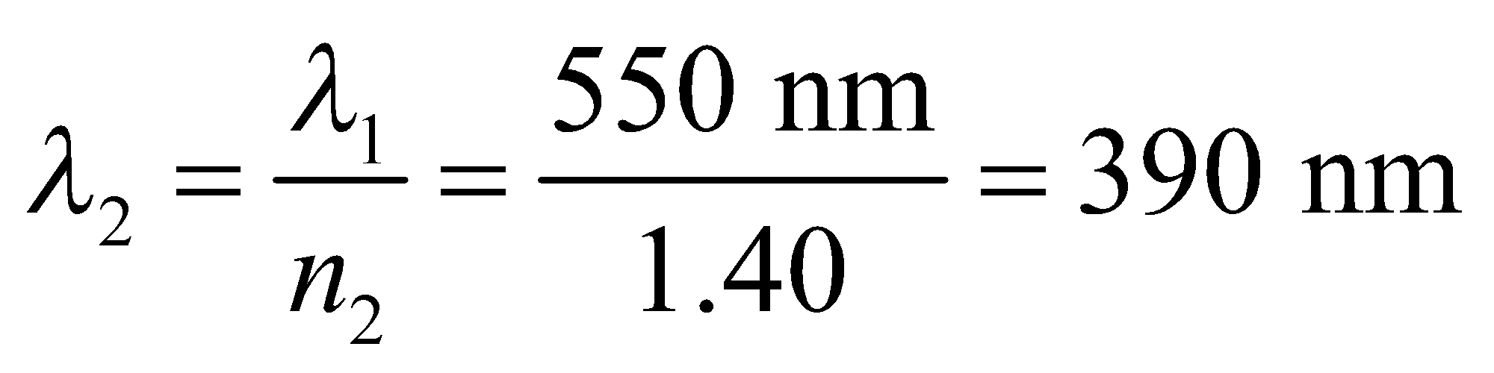

**Assess** The angle of refraction is less than the angle of incidence, which is what we would expect for light entering a material of higher index of refraction.

**30. Interpret** This problem is a generalization of the preceding problem. We are to find the angle through which a light ray is deviated if it is reflected once off each mirror of a two mirror system with an arbitrary angle between the mirrors.

**Develop** Using the sketch below, we see that 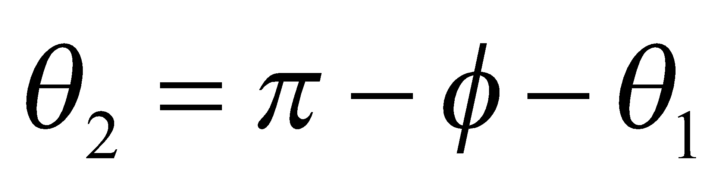. The total angle of deviation is 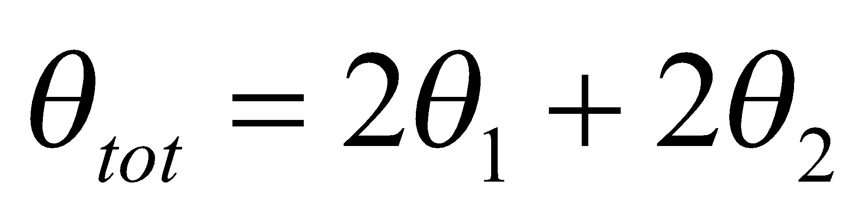.



**Evaluate** Substituting the expression for *θ*2 into the expression for *θ*tot gives

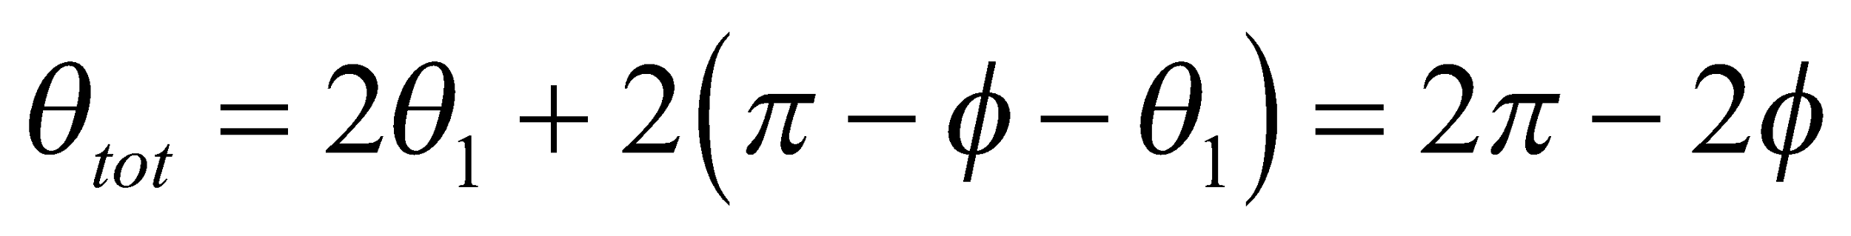

**Assess** This agrees with the expression in the problem statement, given that *π* = 180°.

**31. Interpret** You want to identify an unknown liquid by measuring the way that light refracts at the interface between the liquid and glass of known index of refraction.

**Develop**You shine the laser light so that it first passes through the unknown liquid before entering the glass 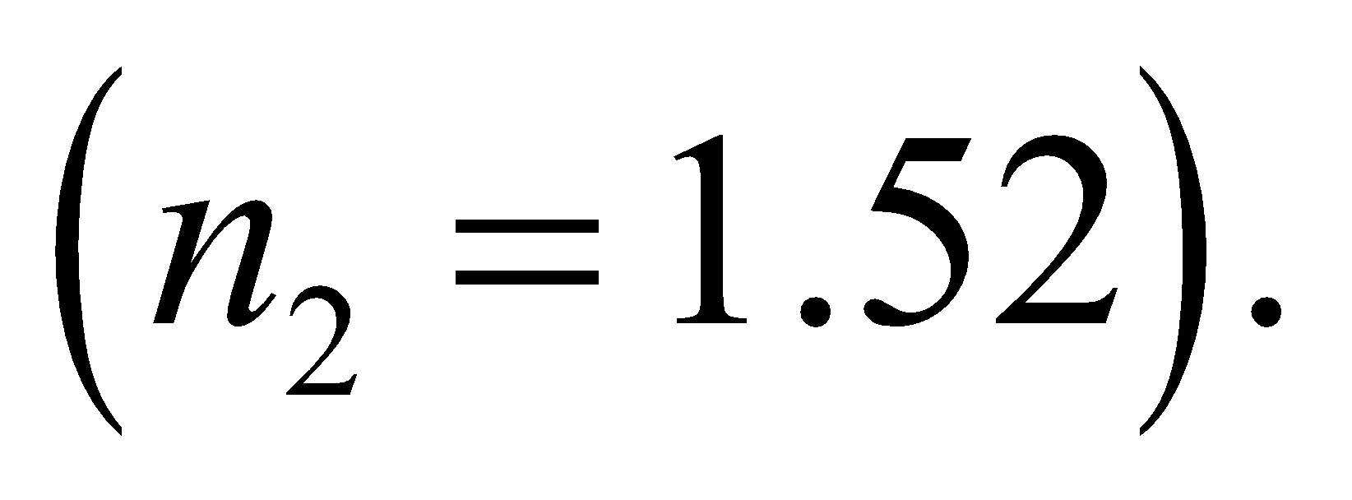 With the measured angles, you can determine the liquid's index of refraction from Equation 30.3: 

**Evaluate**Solving for *n*1 gives

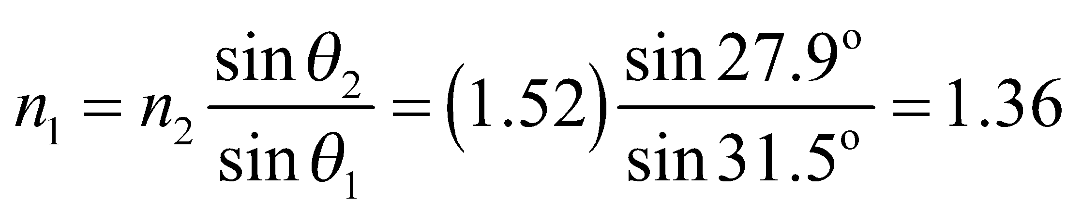

This agrees with the index of refraction for ethyl alcohol in Table 1.1.

**Assess** The ethyl alcohol has smaller index of refraction than glass, so the light should bend toward the normal, as it does here. If the liquid had been benzene, which has an index of refraction very close to that of glass, the change in angle would have been nearly imperceptible.

**32. Interpret** This problem is about refraction at the air-water interface. The mark you see is the point at the bottom of the tank along the refracted path.

**Develop** As shown in the diagram below, the mark seen on the meter stick is at position

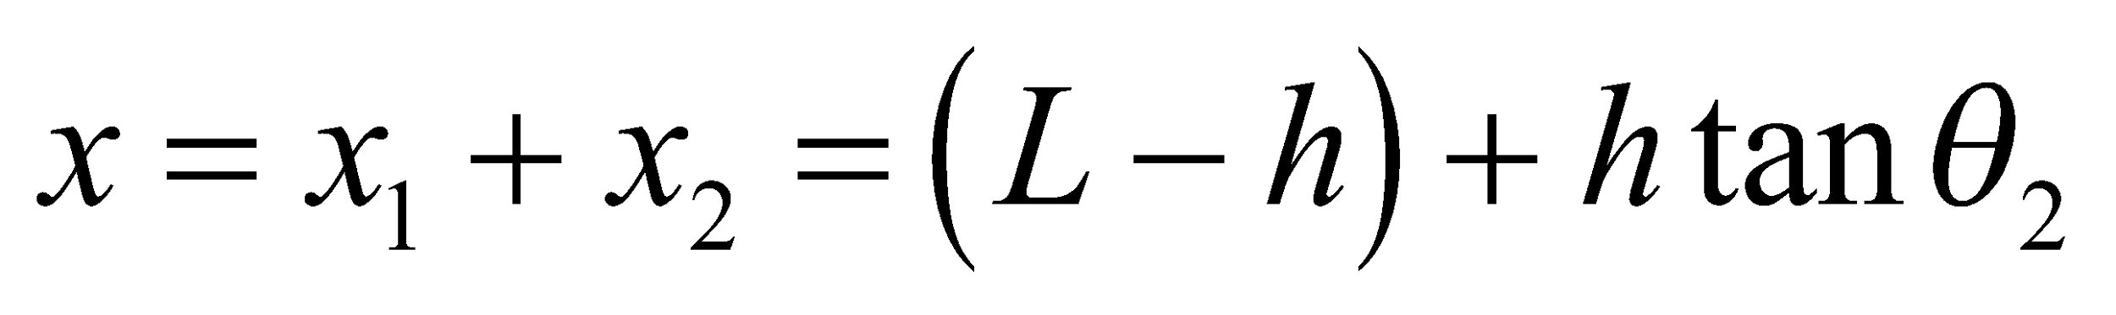

where 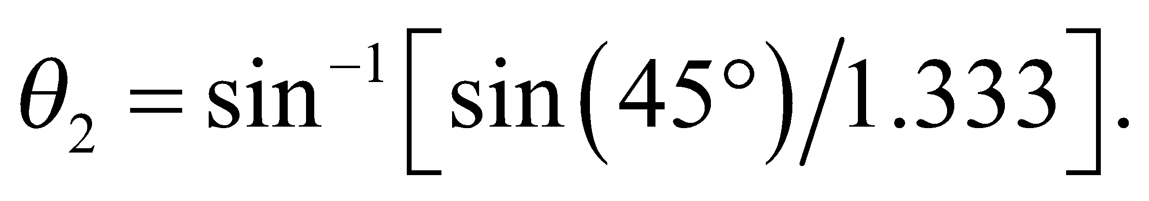 Thus, 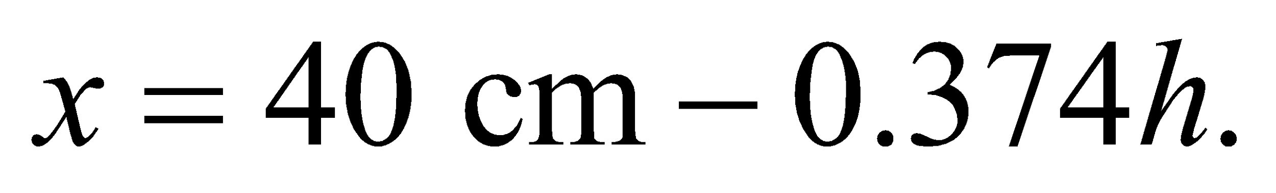



**Evaluate** **(a)** For *h* = 0 (empty), *x* = 40 cm.

**(b)** For *h* = 20 cm (half full), 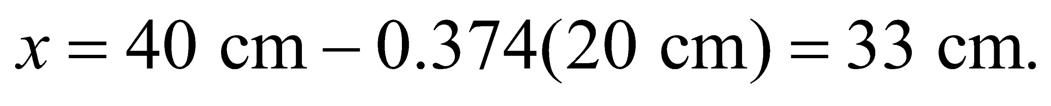

**(c)** Similarly, for *h* = 40 cm (full), 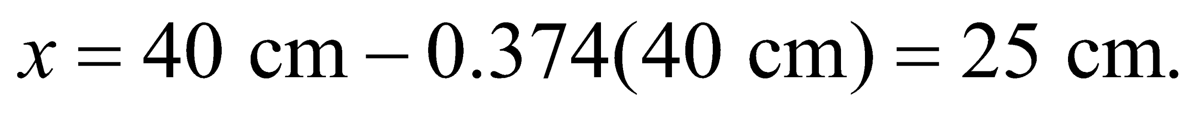

**Assess** The more water in the tank, the more the path “bends” the path, and hence the smaller mark on the meter stick you see. The results are given to two significant figures, as warranted by the data.

**33. Interpret** We are to find the refractive index such that a ray impinging on the center of a cube will transect the opposing vertex (see figure below).

**Develop** From the figure below, we see that the angle of refraction in the glass, given by 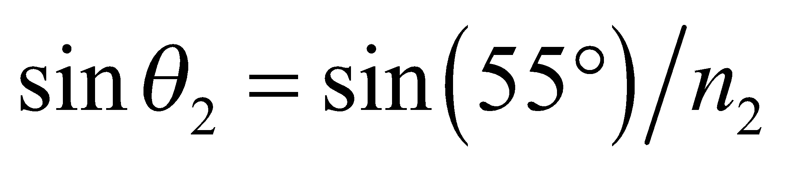must be less than 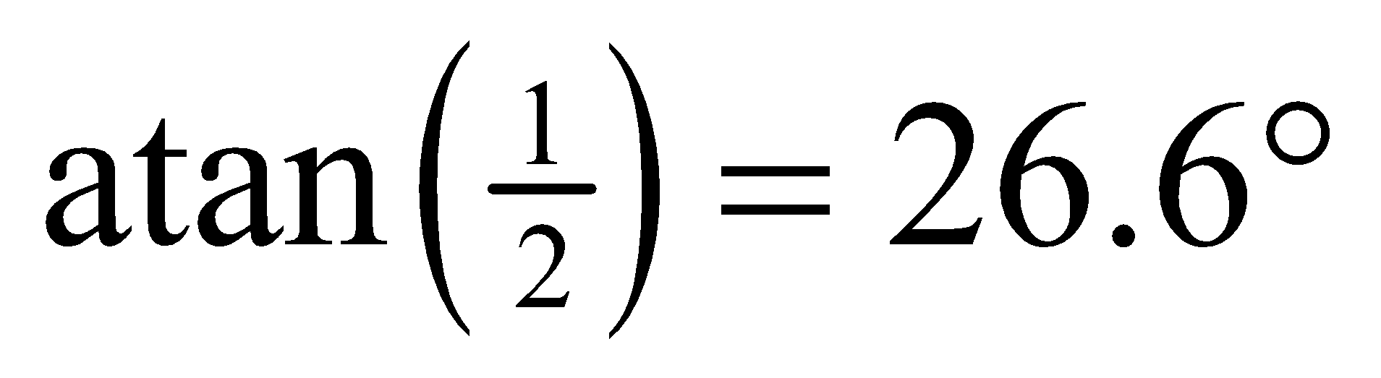 for the ray to emerge from the opposite face



**Evaluate** Therefore, 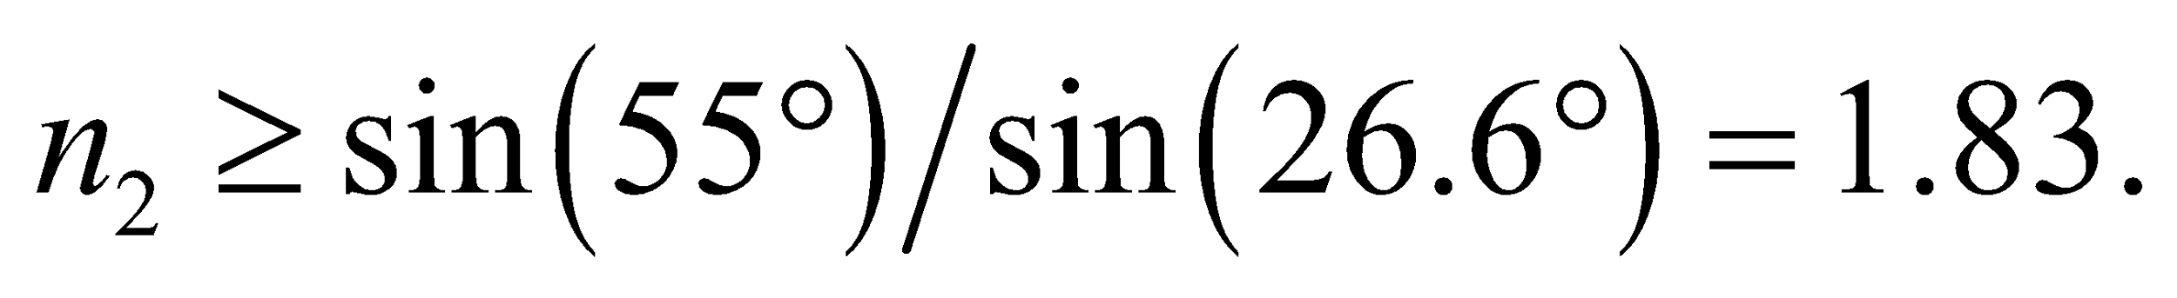

**Assess** The vertical face appears shorter than it really is, as is the case when one looks at legs in the 3-ft section of a swimming pool.

**34. Interpret** This problem involves refraction at an air-water interface. We are to find the minimum angle with the horizontal for which a beam of white light will illuminate the bottom of the tank.

**Develop** From the sketch below, we see that, if the beam enters at the rim of the tank, the maximum angle of refraction it can have and still reach the bottom is

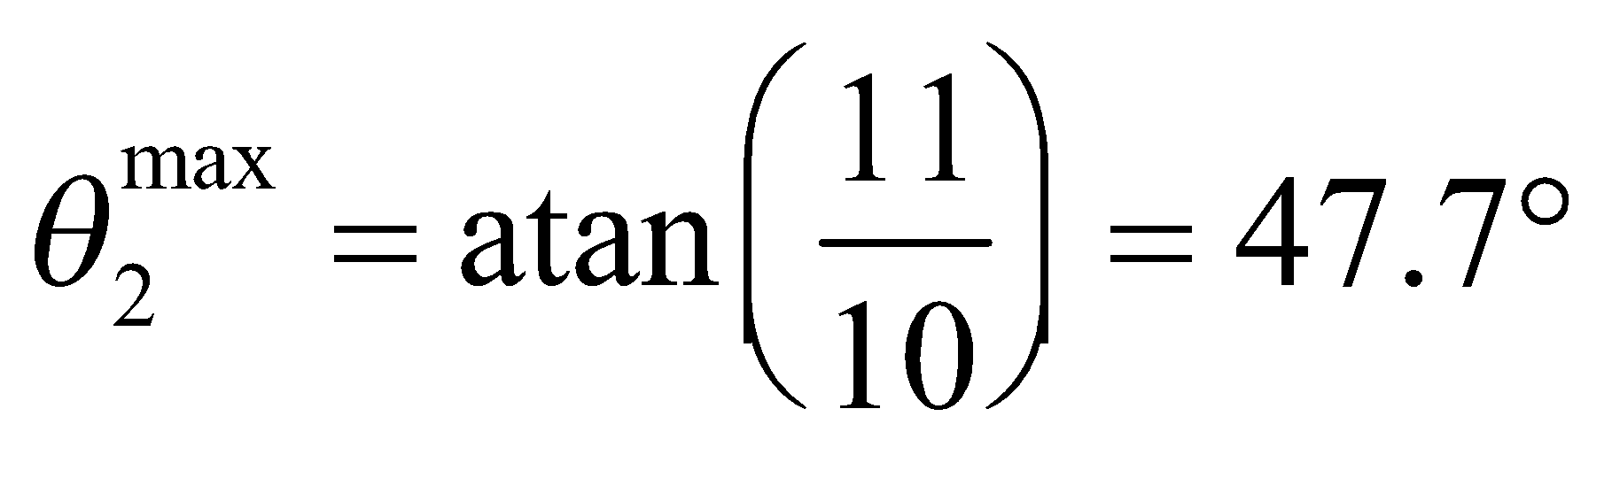

From Snell’s law, the maximum angle of incidence is given by 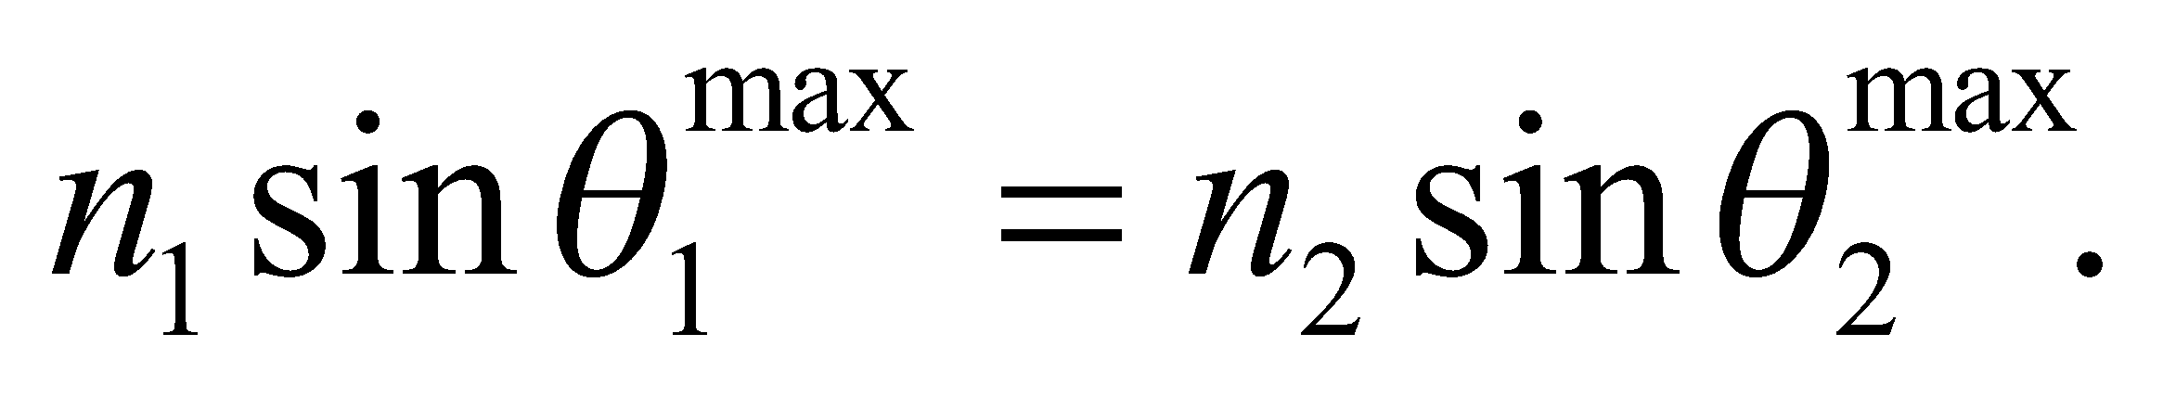



**Evaluate** Using the above equation, we see that the angle of incidence in air must be less than



In other words, the grazing angle *α* (the angle with the horizontal water surface) must be greater than

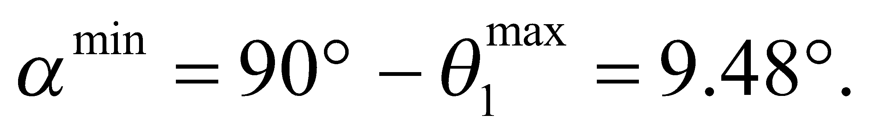

**Assess** Below 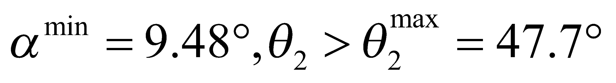, the refracted path will not reach the bottom of the tank.

**35. Interpret** This problem involves the refraction of light at an air-water interface, which we shall use to find the distance at which the diver is from the lake edge.

**Develop** Consider the sketch below, which describes the situation. Snell’s law gives the angle of refraction (*θ*1) in terms of the angle of incidence (*θ*2 = 42°) for the light path from the flashlight to your eye. These can be related to the other given distances by means of a carefully drawn diagram. Thus,



where we have used indices of refraction from Table 30.1, with *n*1 = 1.00 for air. Given this angle, we can find the desired distance from geometry.



**Evaluate** The geometry of the diagram makes the horizontal distances apparent:

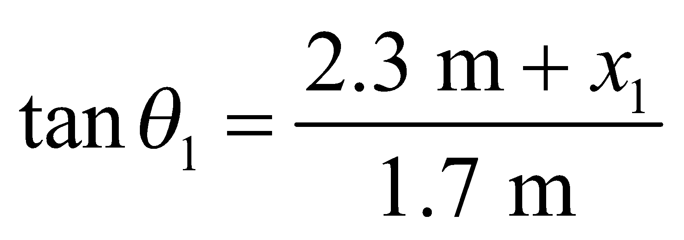 or 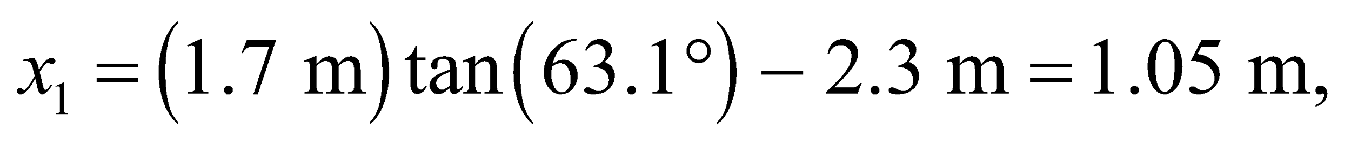

and

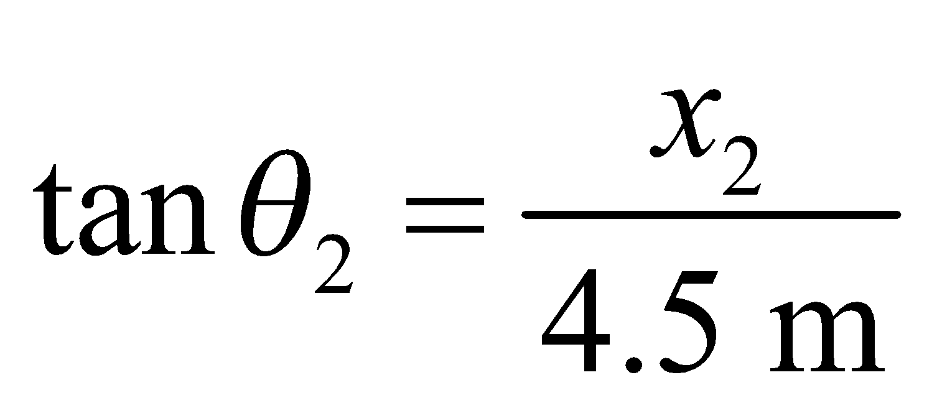 or 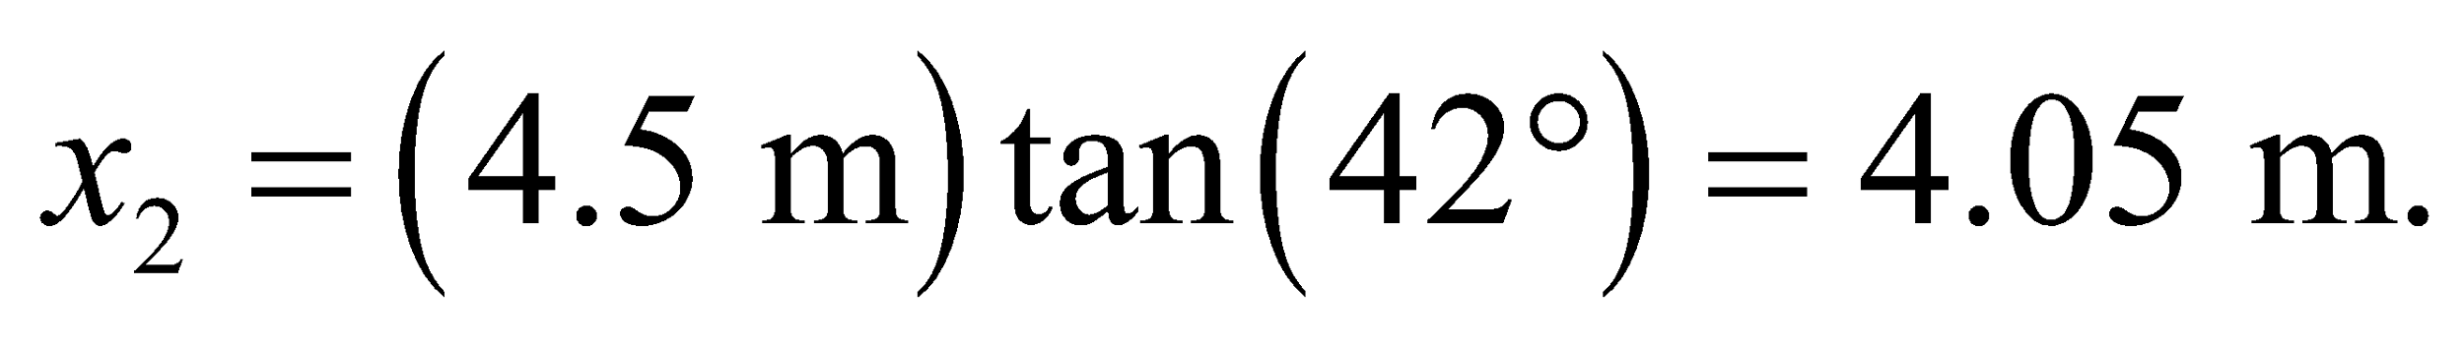

The total horizontal distance from the edge is 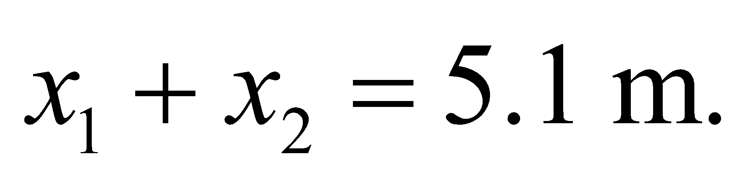

**Assess** The diver will appear to be farther from the edge of the lake, but in reality will be at the given distance.

**36. Interpret** This problem is about the refraction of light at an air-water interface.

**Develop** From the geometry shown in Figure 30.19, we have

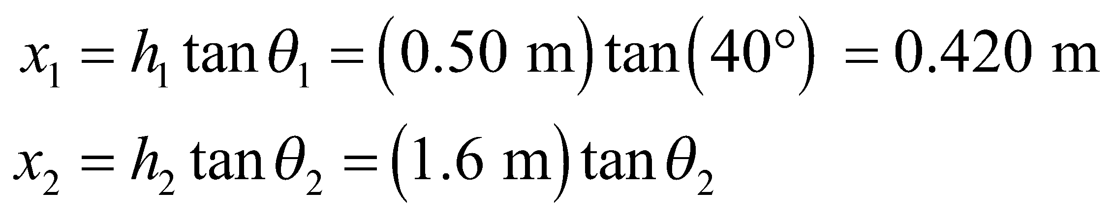

From Snell’s law, 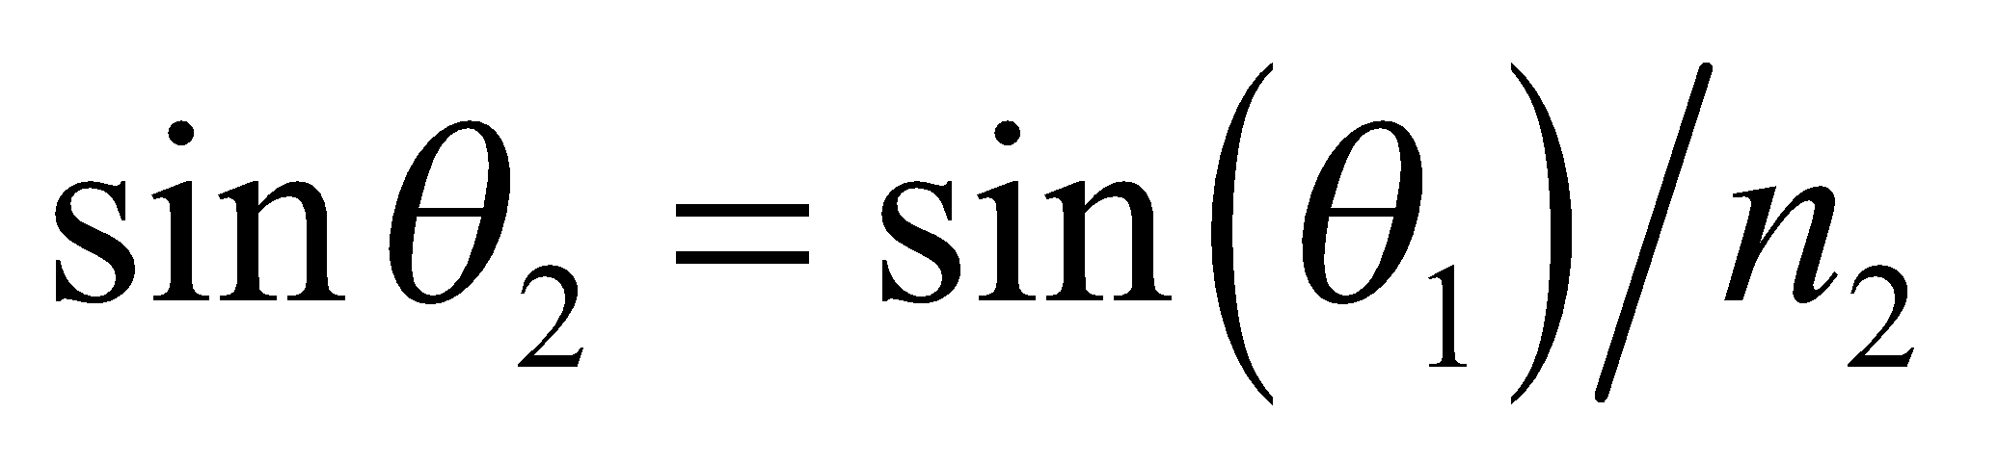 or 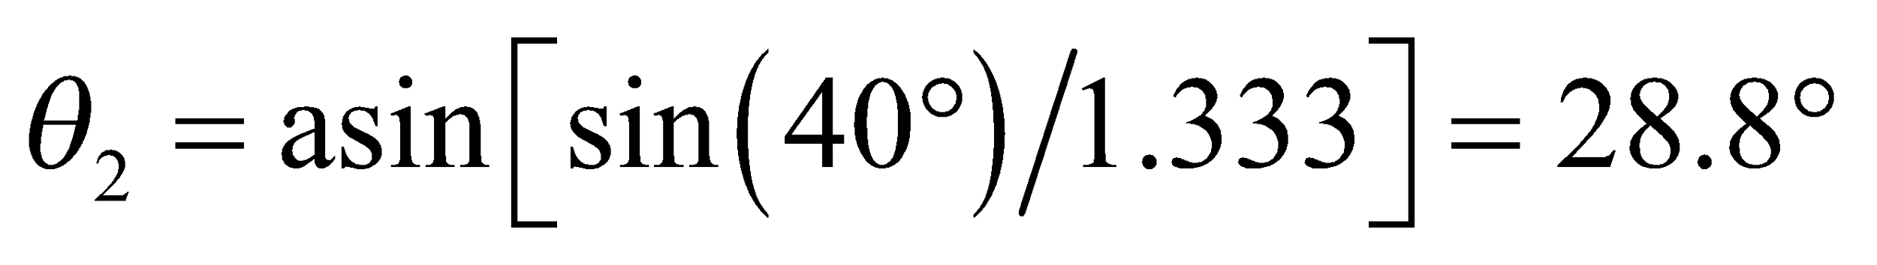 (*n*1 = 1.00 for air). This gives 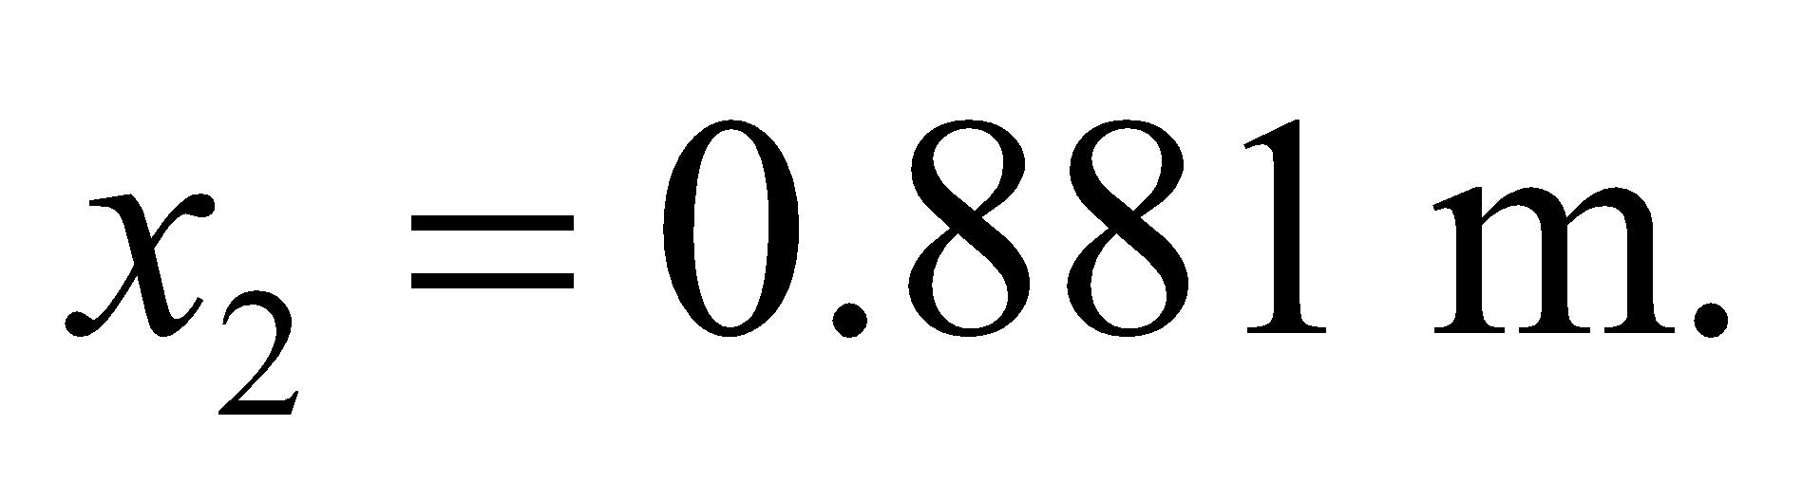

**Evaluate** The total horizontal distance from the dock is 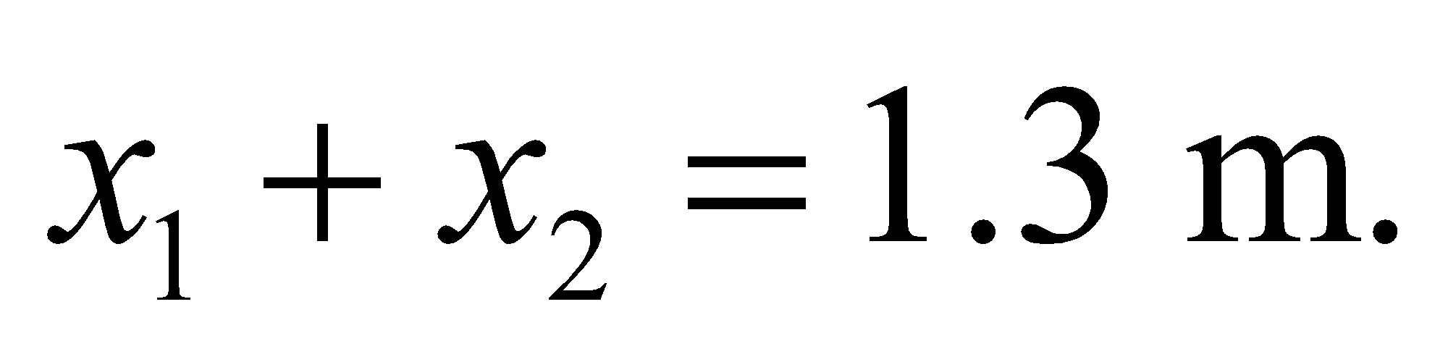

**Assess** The horizontal distance increases with *θ*1, so the smaller the angle *θ*1, the closer the keys are to the dock.

**37. Interpret** The problem concerns laser surgery and the wavelength of UV light when it passes into the eye.

**Develop**The light is coming from air , so the wavelength in the lens is 

**Evaluate**Using the wavelength in air and the index of refraction of the lens, the wavelength becomes

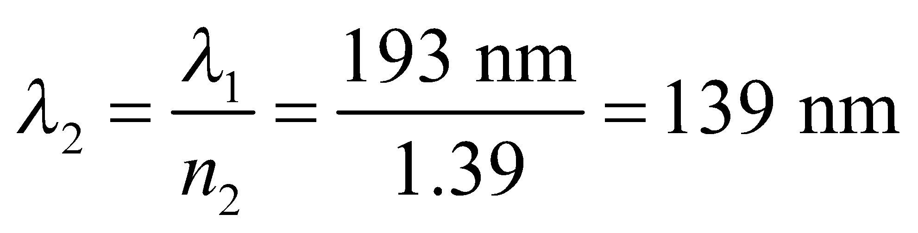

**Assess** The laser light isn't technically supposed to enter the lens. Instead it is used to sculpt the cornea in front of the lens. The procedure helps to redirect light into the eye (through refraction) to improve vision.

**38. Interpret** This problem is about light that is refracted at the entrance and exit air-prism interfaces. We are to find the angle through which the light beam is deflected when it exits the prism.

**Develop** From Snell’s law (Equation 30.3) and plane geometry, we have 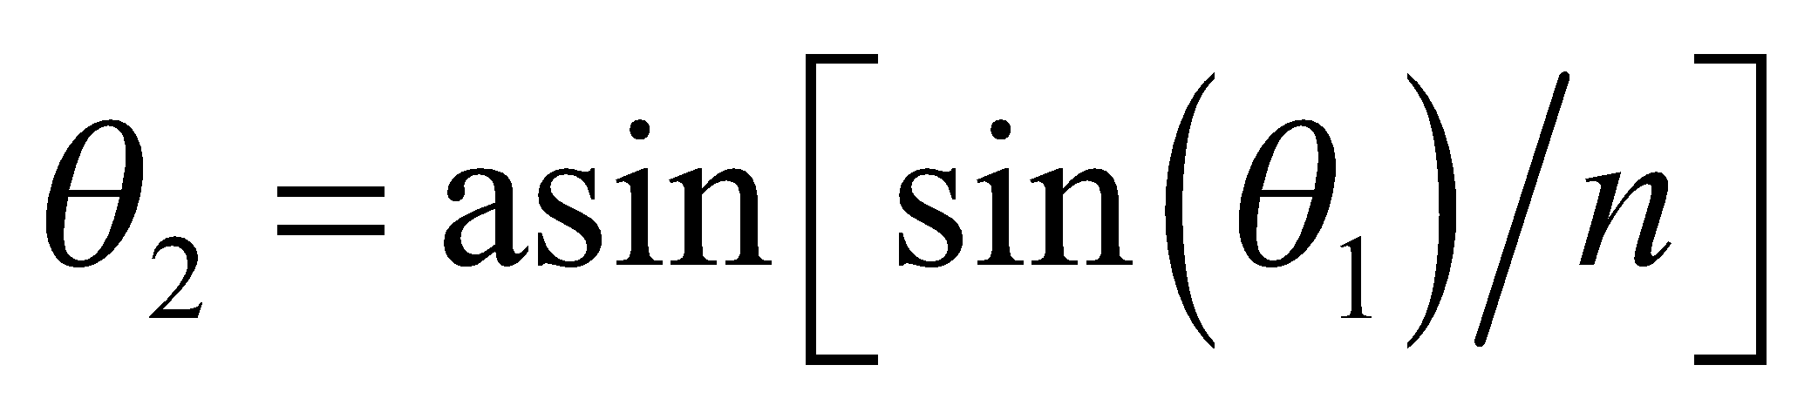 (Snell’s law for the first refraction, with *n*1 = 1.00 and 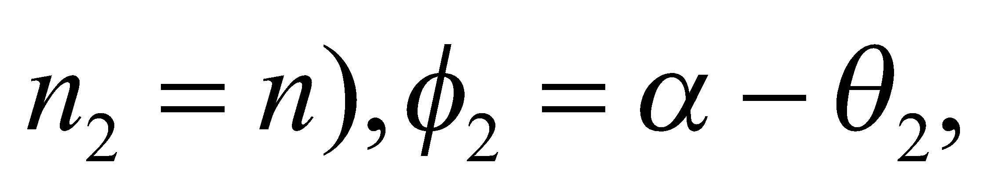 where *α* is the exterior angle to the triangle formed by the ray segment in the prism and the normals to the surfaces, 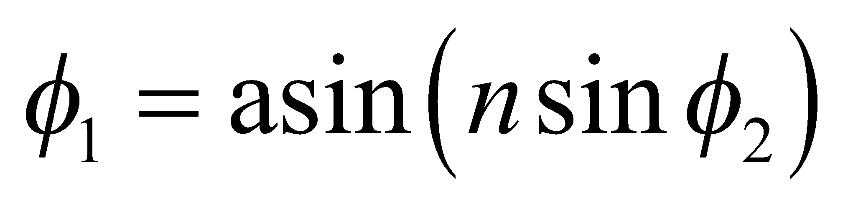 (Snell’s law for the second refraction). The total deflection is the sum of the deflections at each refraction, taking clockwise deflection to be positive in Fig. 30.23. Substituting the expressions obtained above, one gets (see Problem 27)

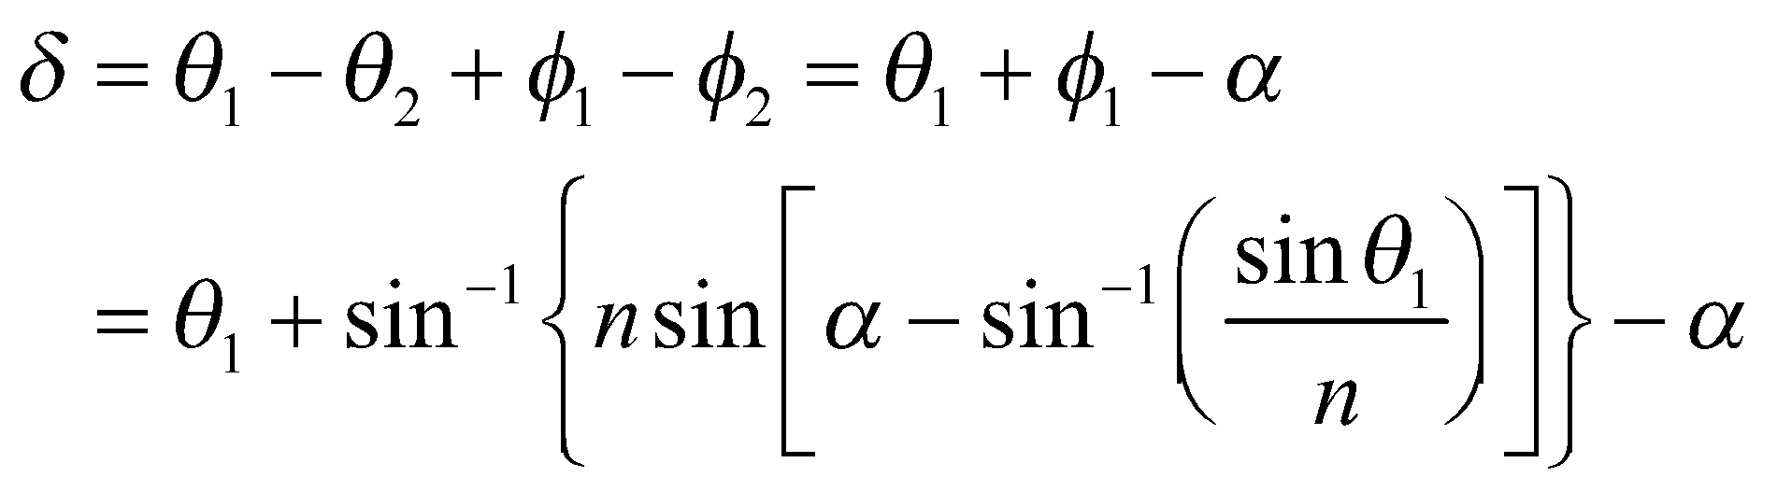



**Evaluate** For the data in this problem, the other angles and the deflection are:

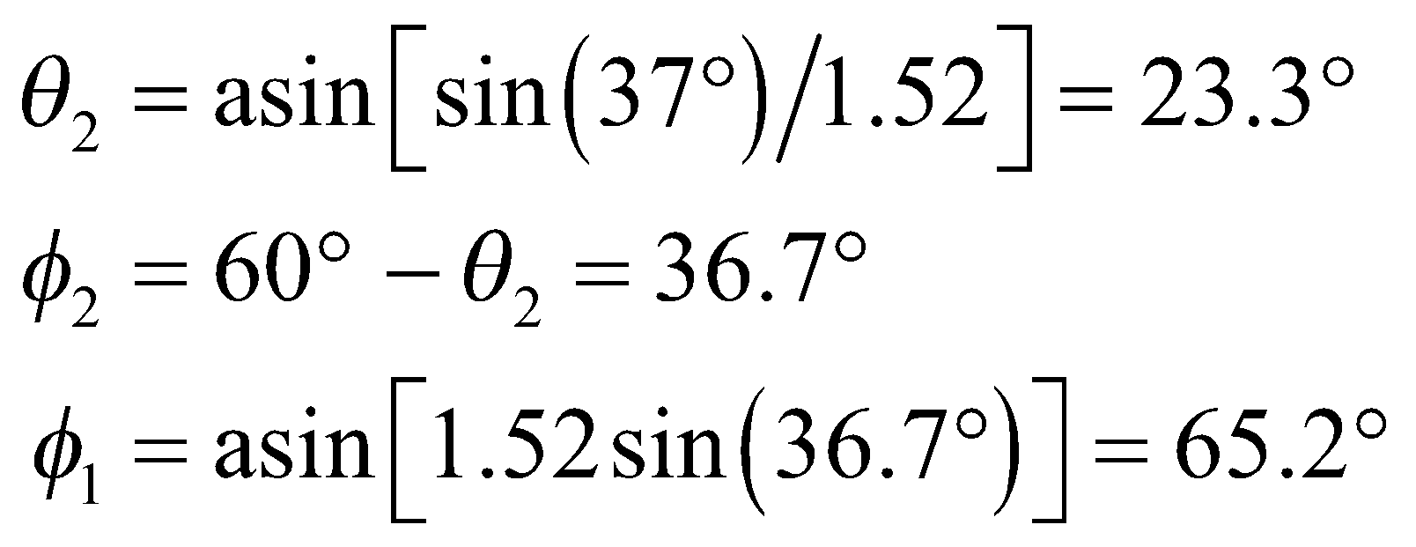

Therefore, the total deflection is



**Assess** The total deflection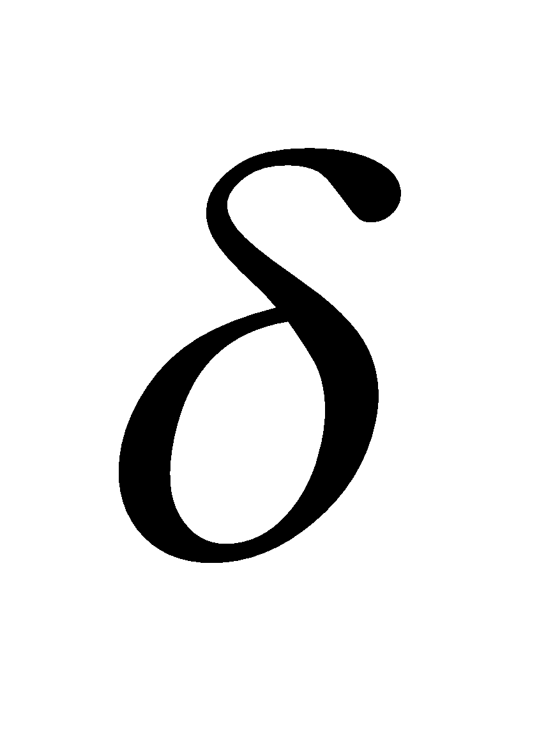is a complicated nonlinear function of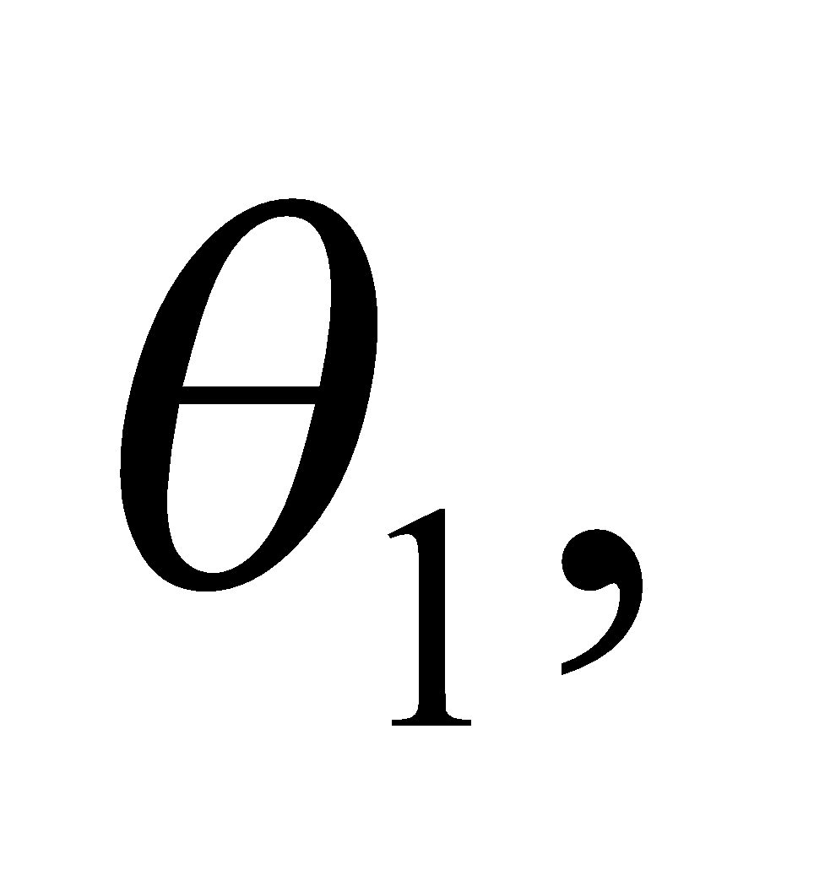as shown in the figure below.



**39. Interpret** We are to redo the preceding problem with different values for the refractive index of the prism, the incident angle, and the prism’s apex angle.

**Develop** A general treatment of refraction through a prism of index of refraction 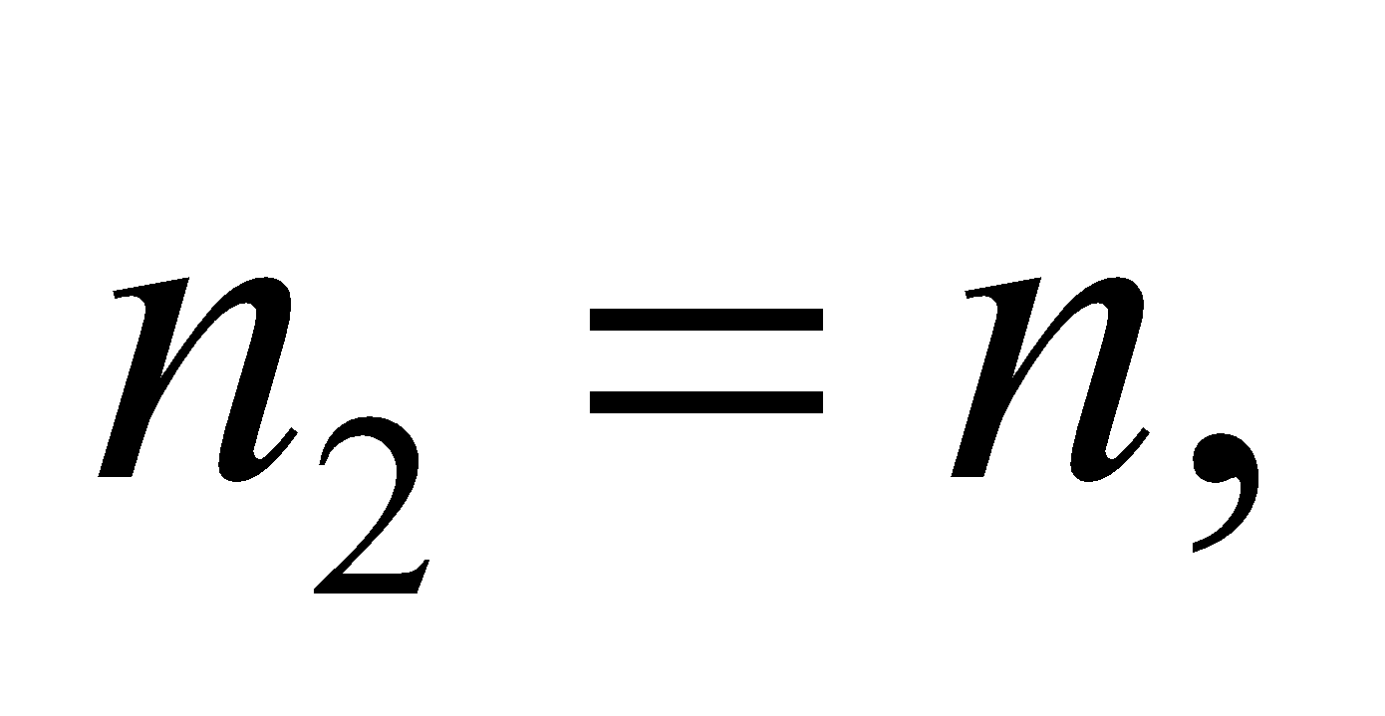 surrounded by air of index 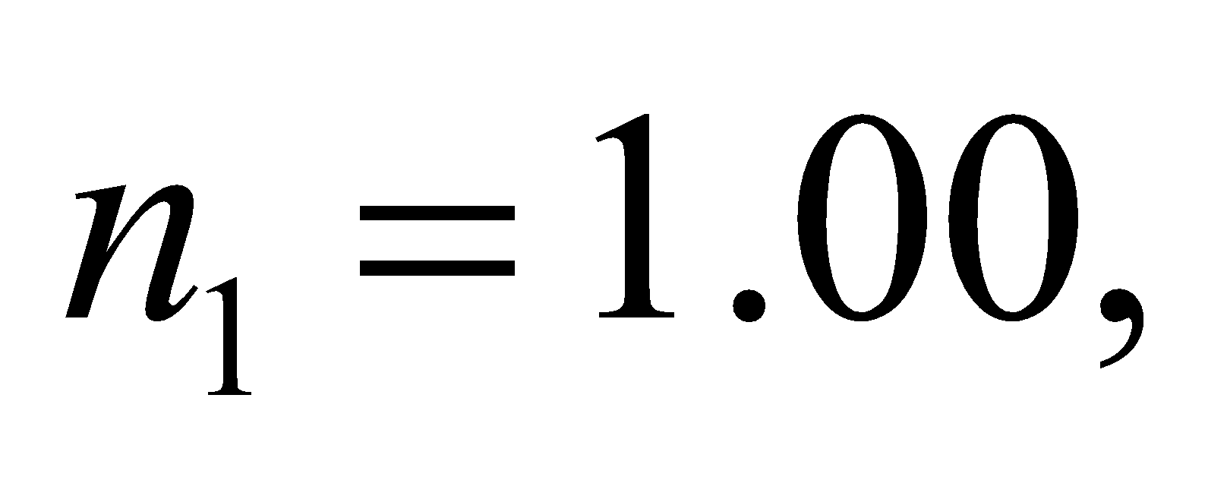 for the geometry of Figure 30.20, is given in the solution to Problem 27.

**Evaluate** For 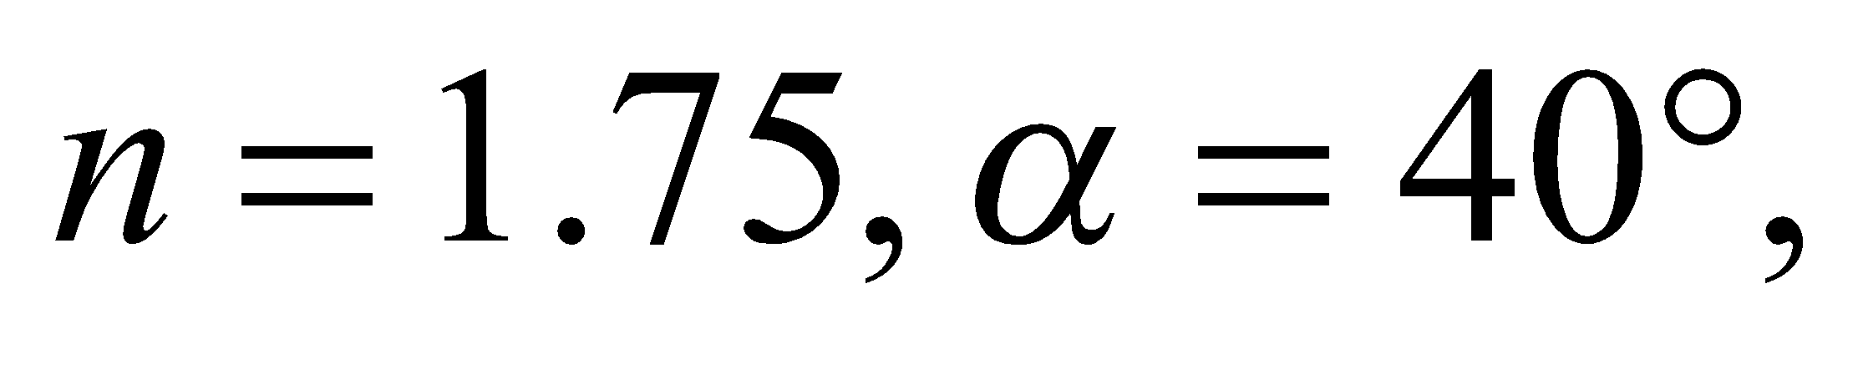 and 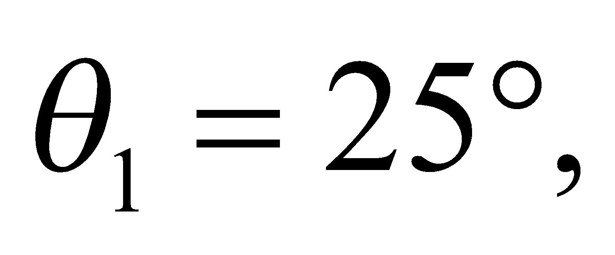 the other angles defined there are

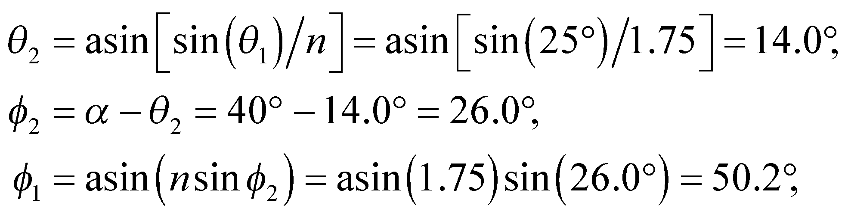

and 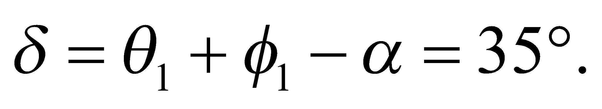

**Assess** Note that 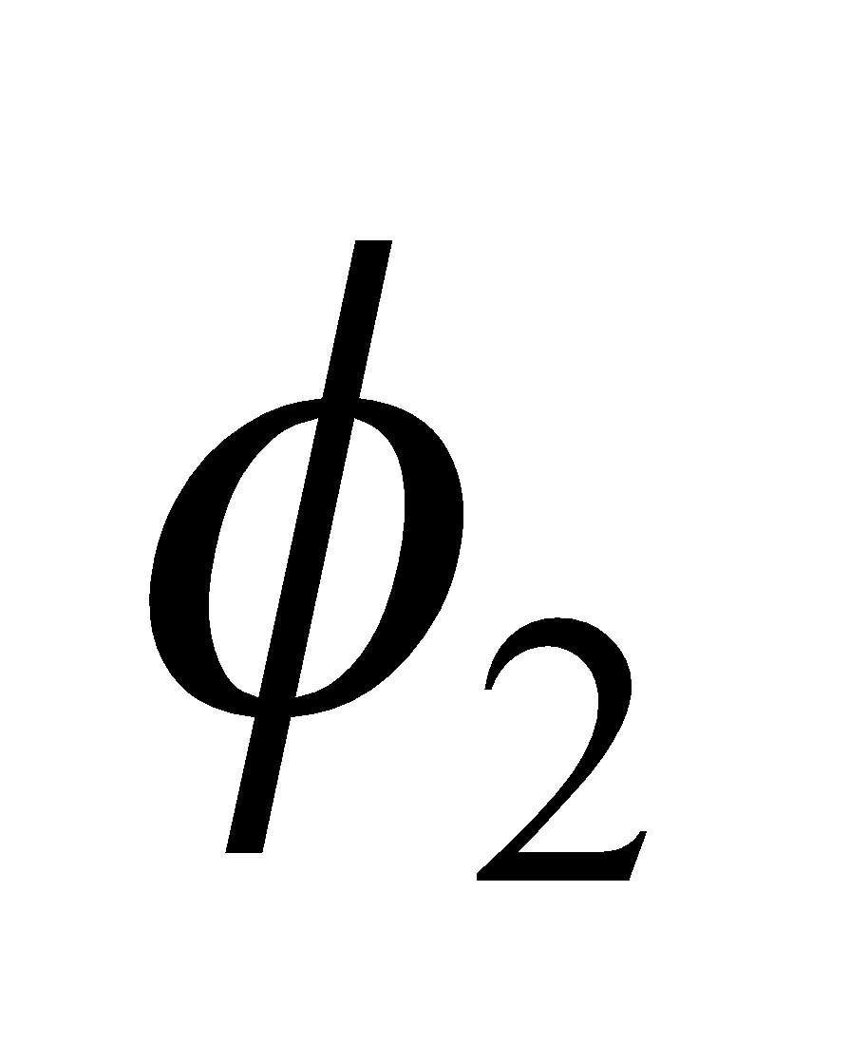 is less than the critical angle for this prism, which is 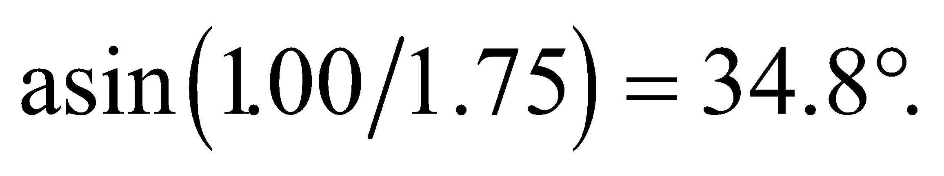

**40. Interpret** We are to find the minimum index of refraction for the prism shown in Figure 30.11 so that total internal reflection occurs. The prism is surrounded by air and we shall use Equation 30.5 for the critical angle.

**Develop** Equation 30.5 for critical angle is 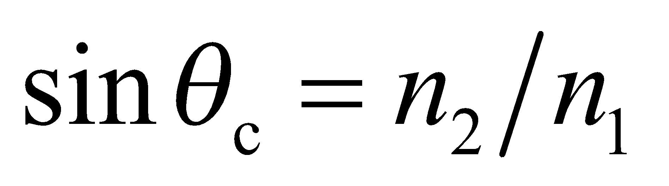, where 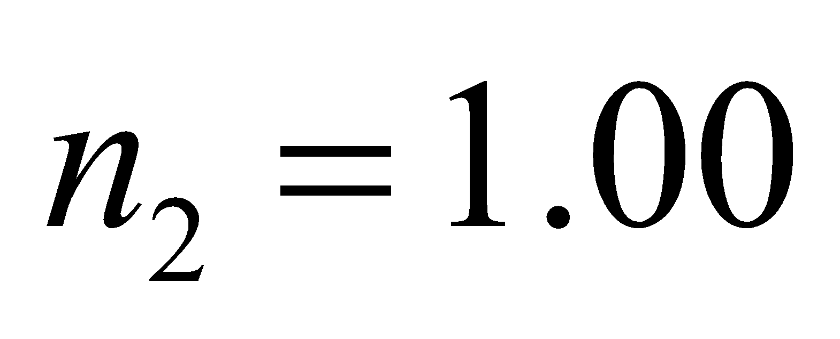 and, by inspection of the geometry of the figure, 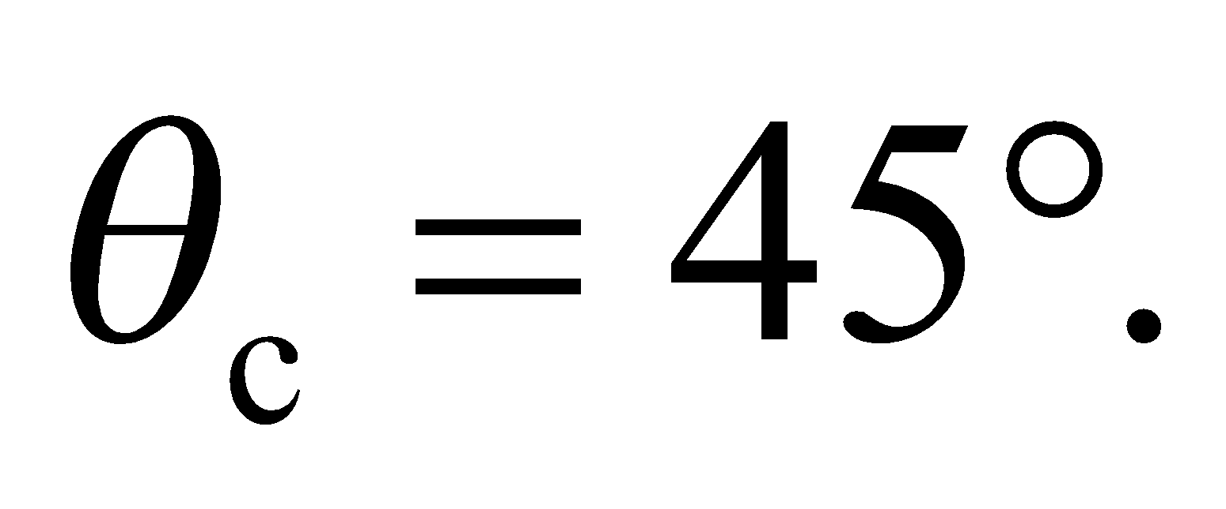 Solve for 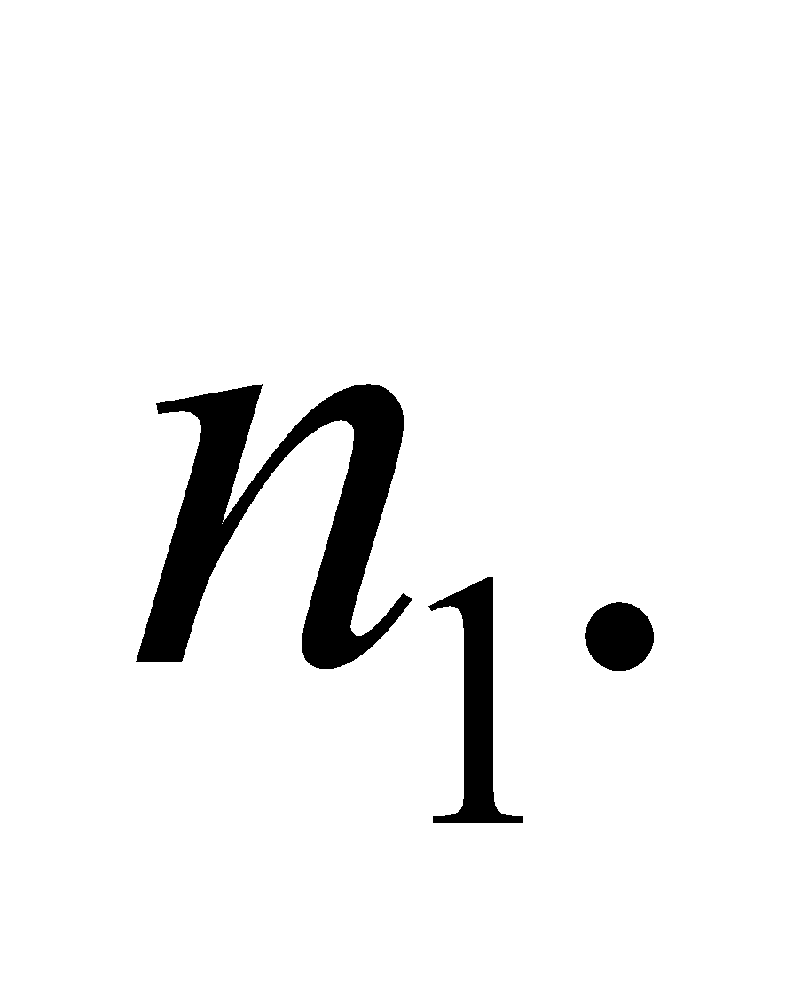

**Evaluate**  The minimum refractive index for total internal reflection is

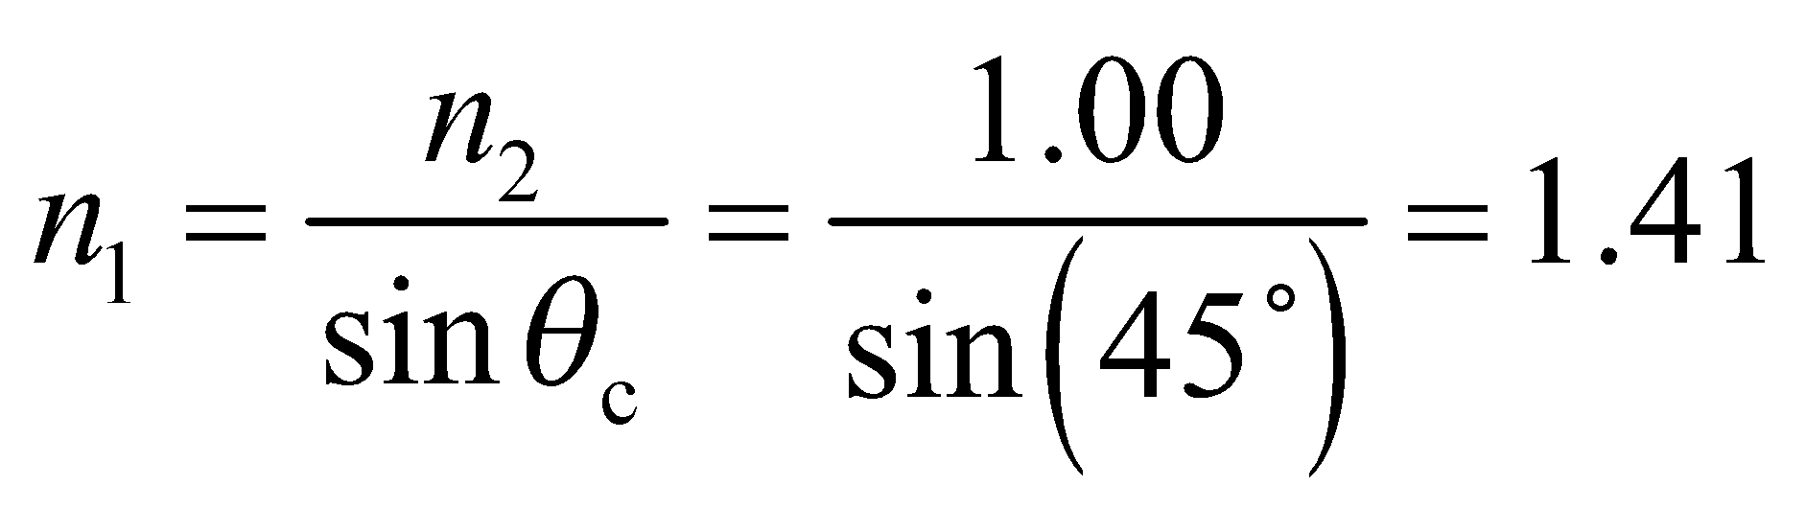

**Assess** Most types of glass and clear plastic have an index of refraction greater than 1.5, so this type of prism is not unusual. If you take apart a pair of binoculars, you’ll see several of these.

**41. Interpret** For this problem, we are to determine if the main beam emerges from the prism at the diagonal face or at the bottom face of the prism, and at what angle it emerges with respect to the exit face normal.

**Develop** The critical angle for an ice-air interface is 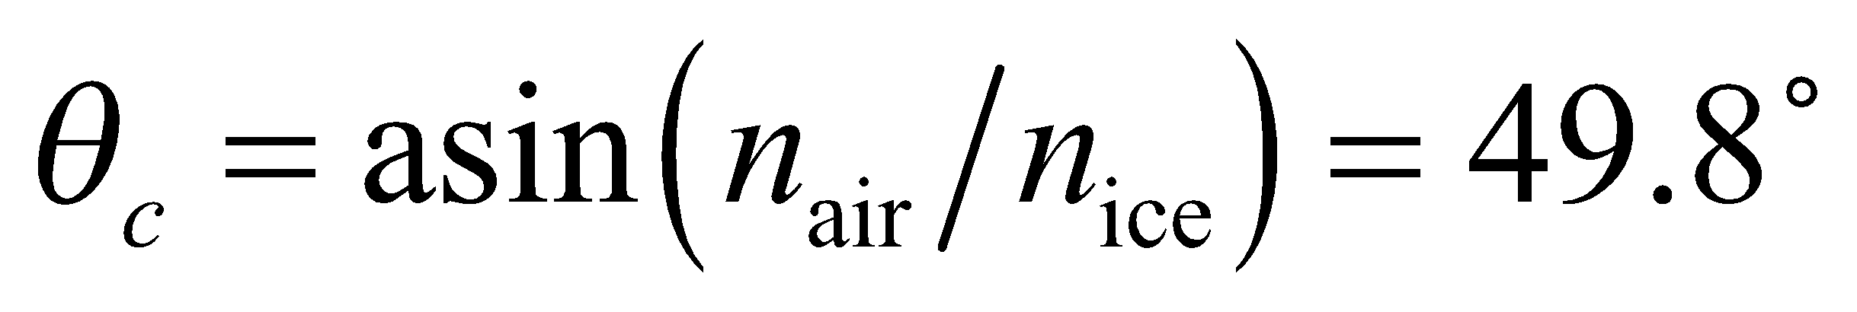, which is greater than the incident angle of 45° (see figure below). Thus, total internal reflection does not occur, and the beam emerges from the diagonal face of the prism at an angle with respect to the face normal determined by Snell’s law (Equation 30.3).



**Evaluate** From Snell’s law, the exit angle (*θ*2 in the sketch above) is

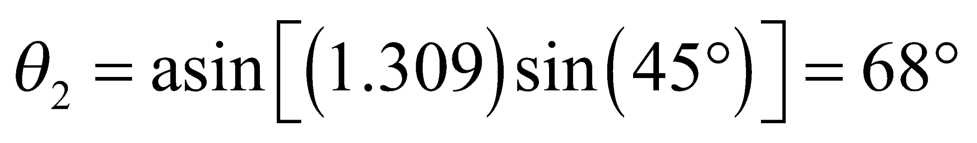

The deviation from the incident direction is 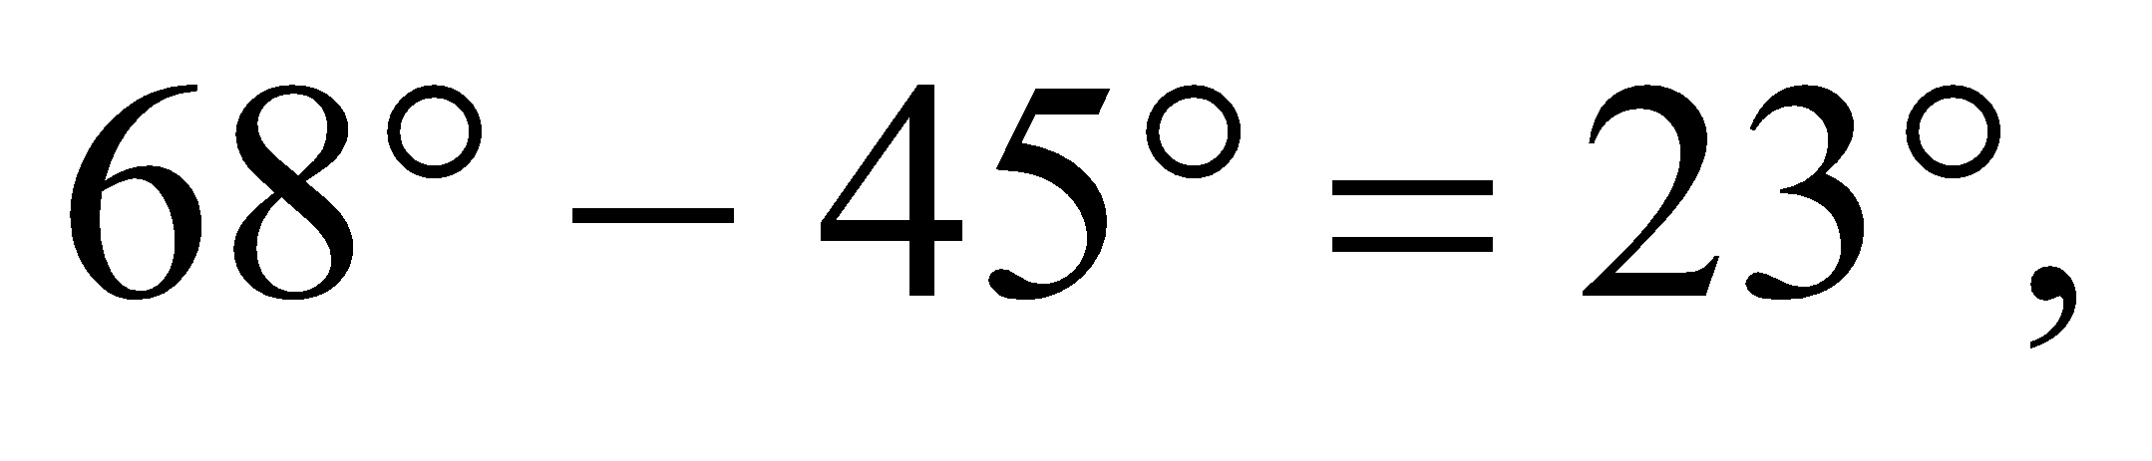 as shown in the sketch above.

**Assess** Because *n*2 < *n*1, *θ*2 > *θ*1 to compensate and satisfy Snell’s law.

**42. Interpret** This problem involves finding the speed of light in a medium. We are given its critical angle at an interface with air, which allows us to calculate the index of refraction.

**Develop** From Equations 30.2 and 30.5, the relationship between the critical angle and the speed of light in a material can be written as

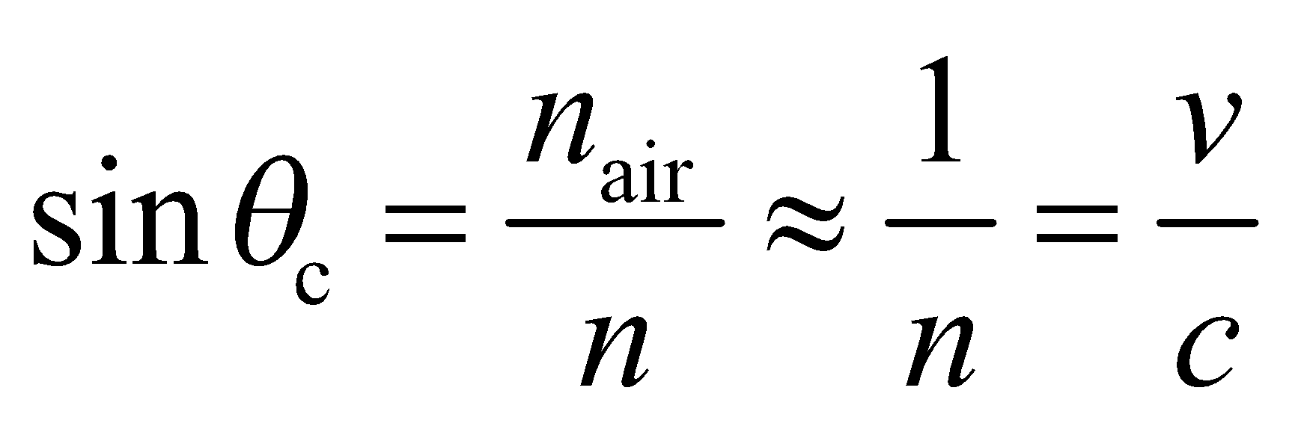

**Evaluate** With 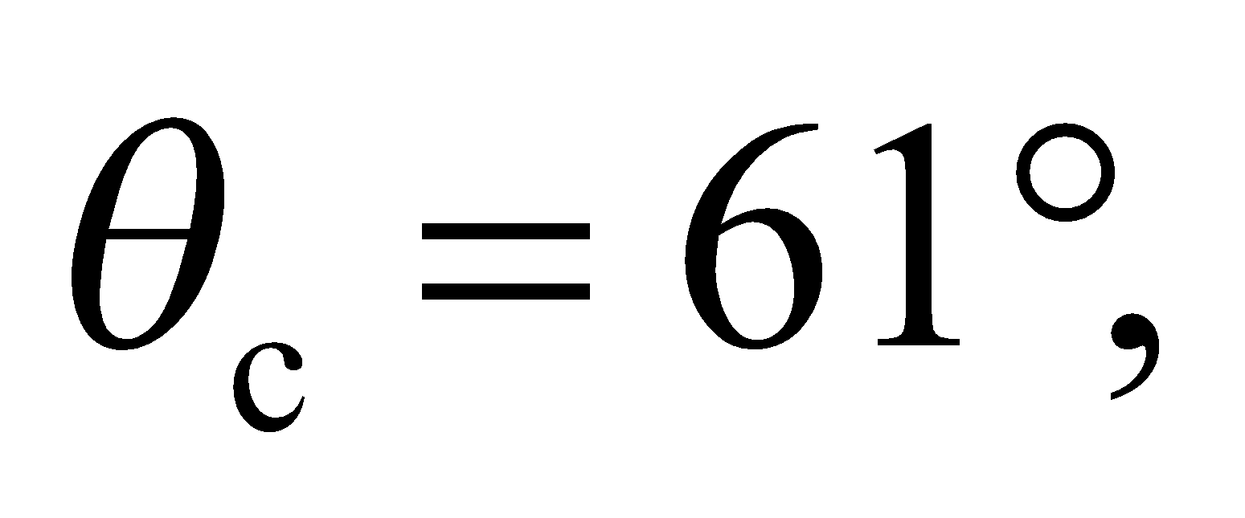 the speed of light in the medium is



**Assess** The critical angle and the speed of light in a material are both related to the index of refraction. When

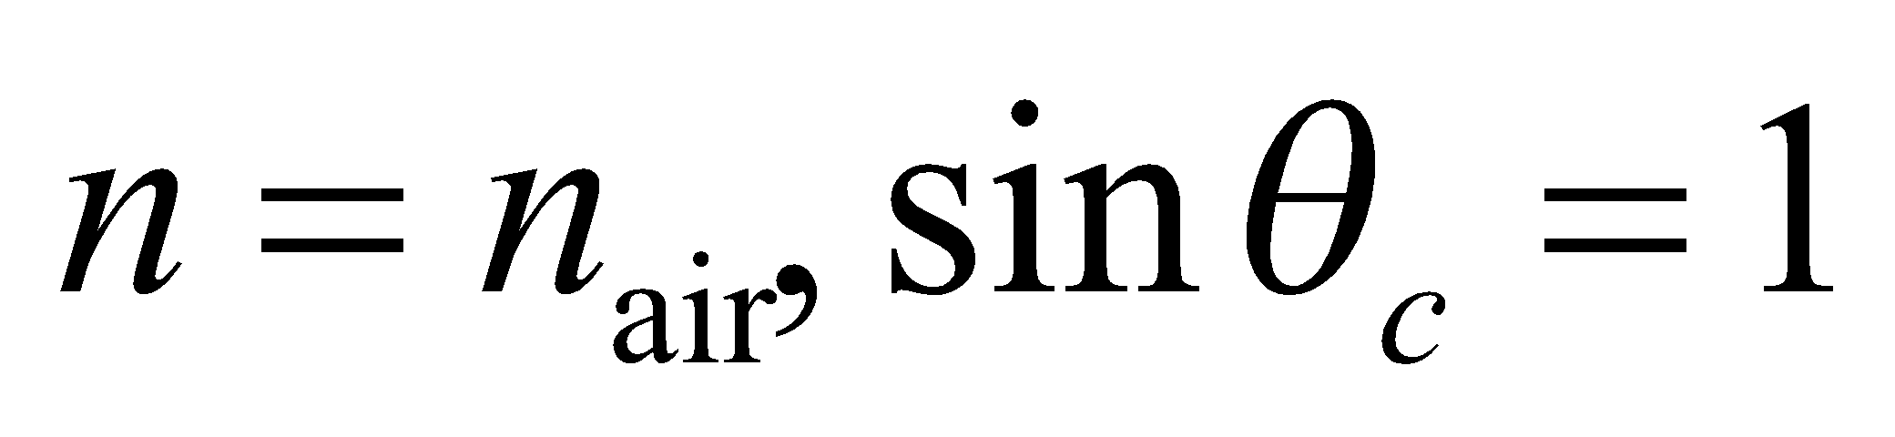 and *v* = *c*, as expected.

**43. Interpret** We are to find the minimum refractive index for the medium surrounding the prism in Figure 30.10 for which total internal reflection does not occur.

**Develop** When the prism is immersed in liquid, 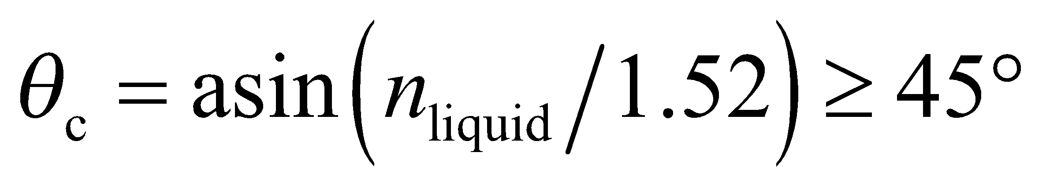 for total internal reflection to occur.

**Evaluate** Therefore, 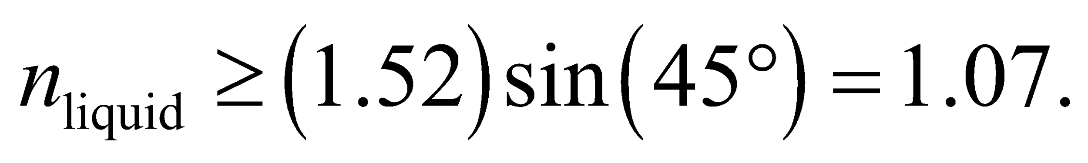

**Assess** Because the liquid constitutes the second medium (i.e., the light propagates from the prism into the liquid), its refractive index must be less than that of the prism for total internal reflection to occur.

**44. Interpret** We are to find the relationship between the critical angle and the polarizing angle at an interface between air and another medium.

**Develop** For an interface with air, the critical angle is usually specified for light propagating from the material into the air (as in Figure 30.9). Thus, *n*1 is the index of the material and *n*2 is the index of air. Equation 30.5 for the critical angle then takes the form



However, the polarizing angle for the same interface is usually specified for incident light propagating in the reverse direction (i.e., from air into the material), so in Equation 30.4, *n*1 is the index of air and *n*2 is the index of the material, which leads to

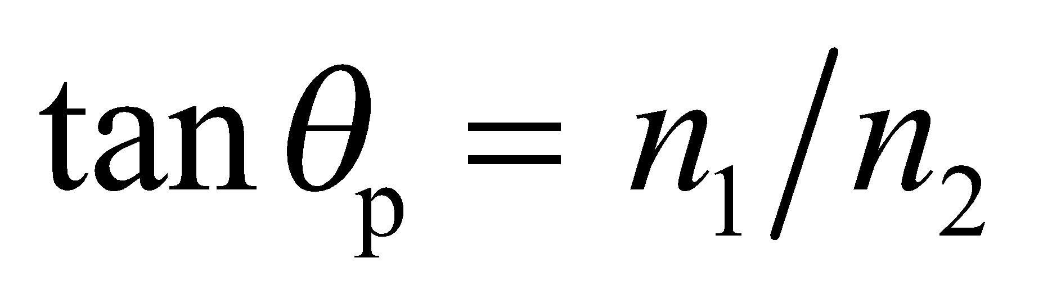

**Evaluate** Combining the two equations, we obtain

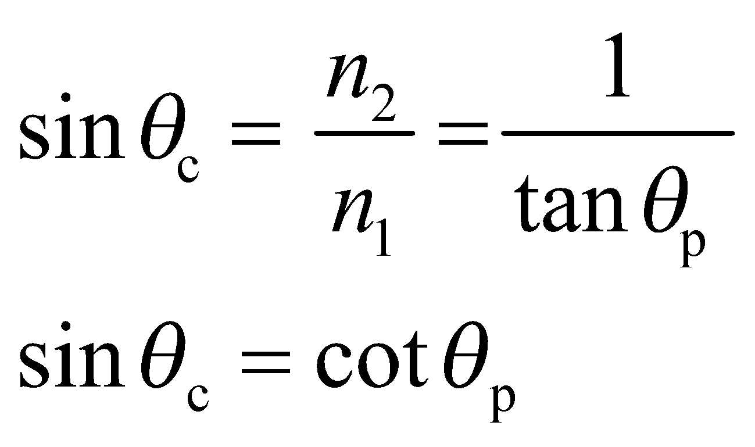

**Assess** This is not a fundamental relation; it merely reflects the fact that both angles depend on the ratio of the indices of refraction.

**45. Interpret** We are to show that light emanating from a point source in on material will enter a second medium in a circle with the given diameter. The critical angle at which the light is totally internally reflected will be useful for this problem.

**Develop** Consider the diagram below. Light from the flash will strike the water surface at the critical angle for a distance 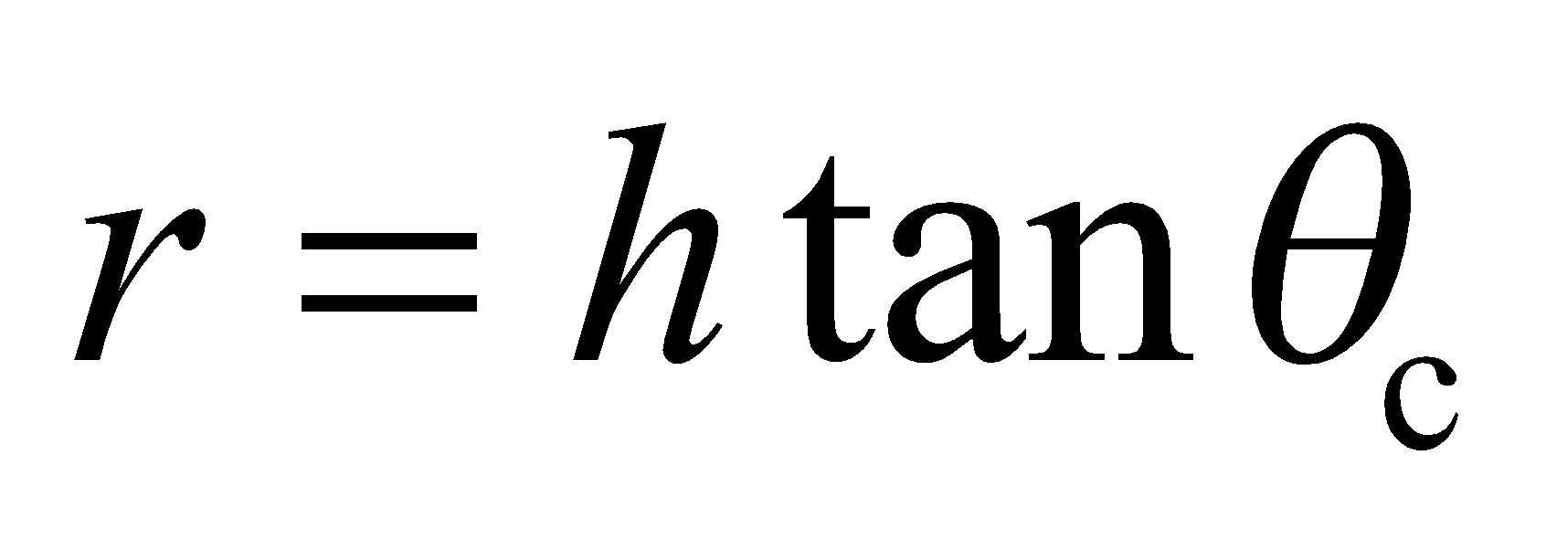 from a point directly over the flash. Therefore, the diameter *d* of the circle through which the light will emerge is 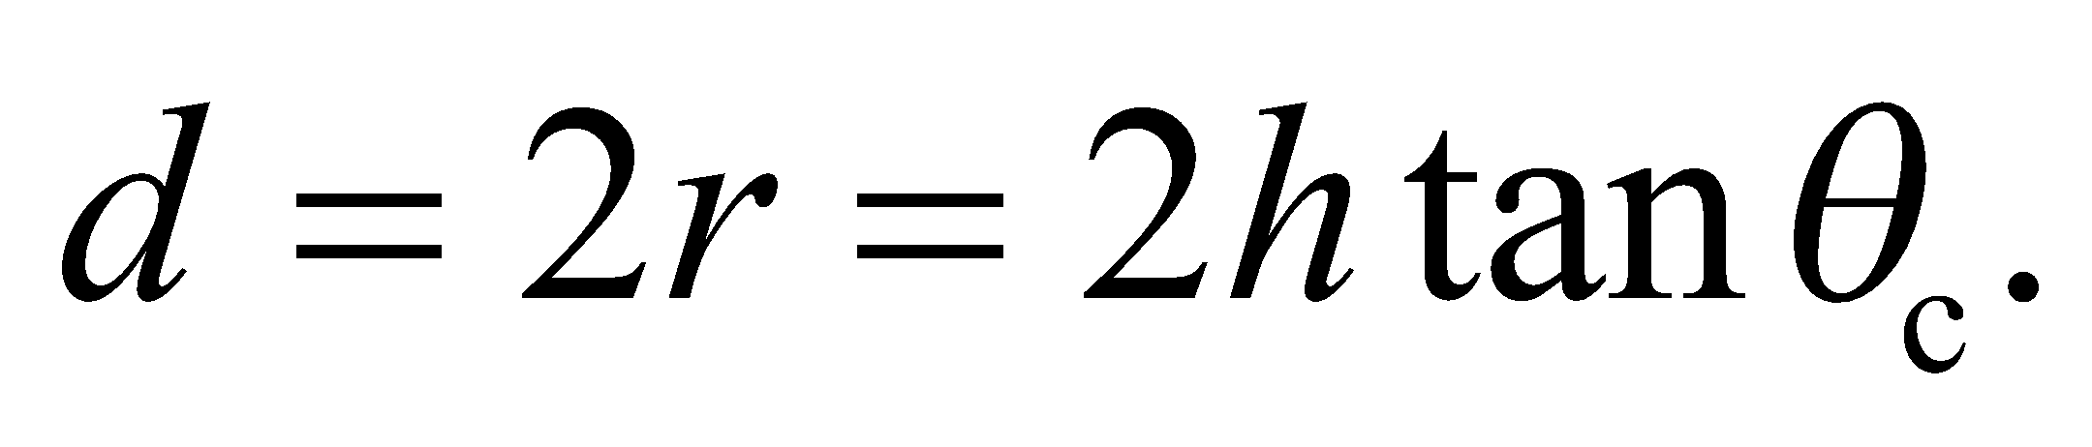 But 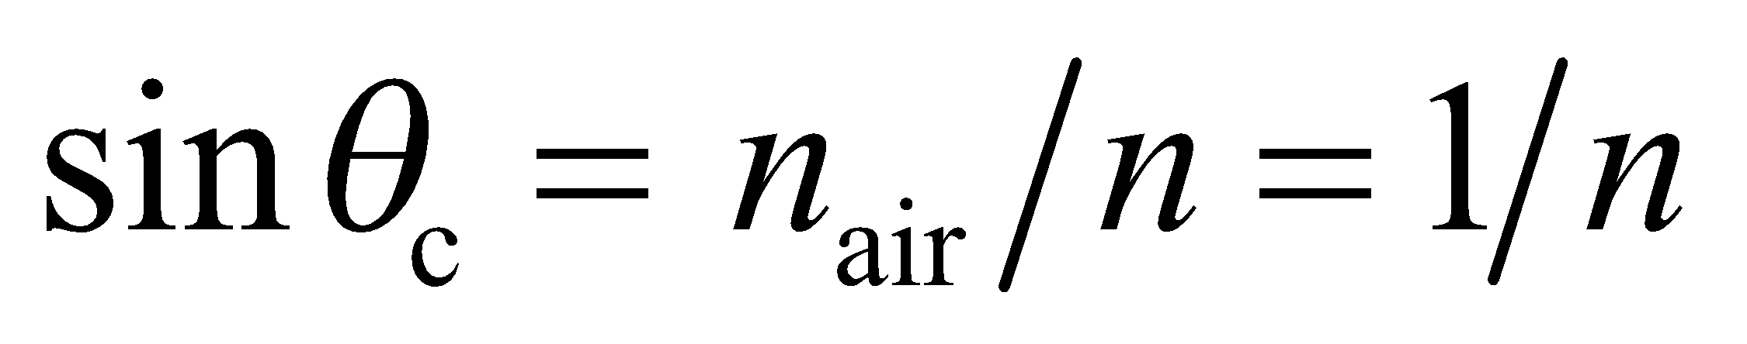 (Equation 30.5 at the water-air interface), and 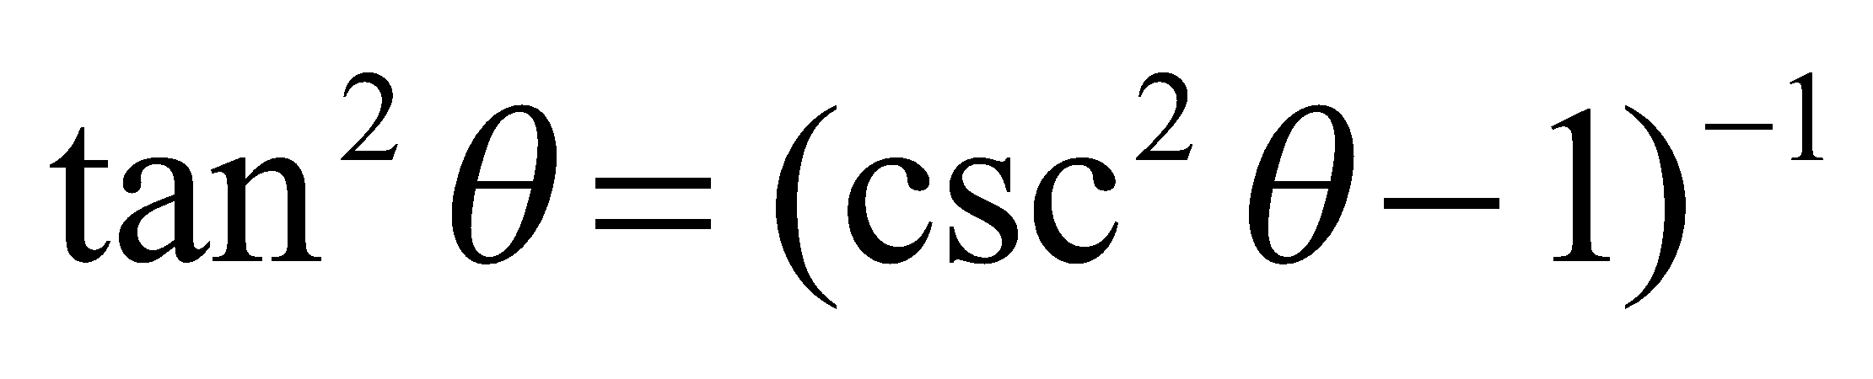 (a trigonometric identity), which we can use to show the desired relationship.



**Evaluate** The diameter of the circle through which the light emerges can therefore be expressed as

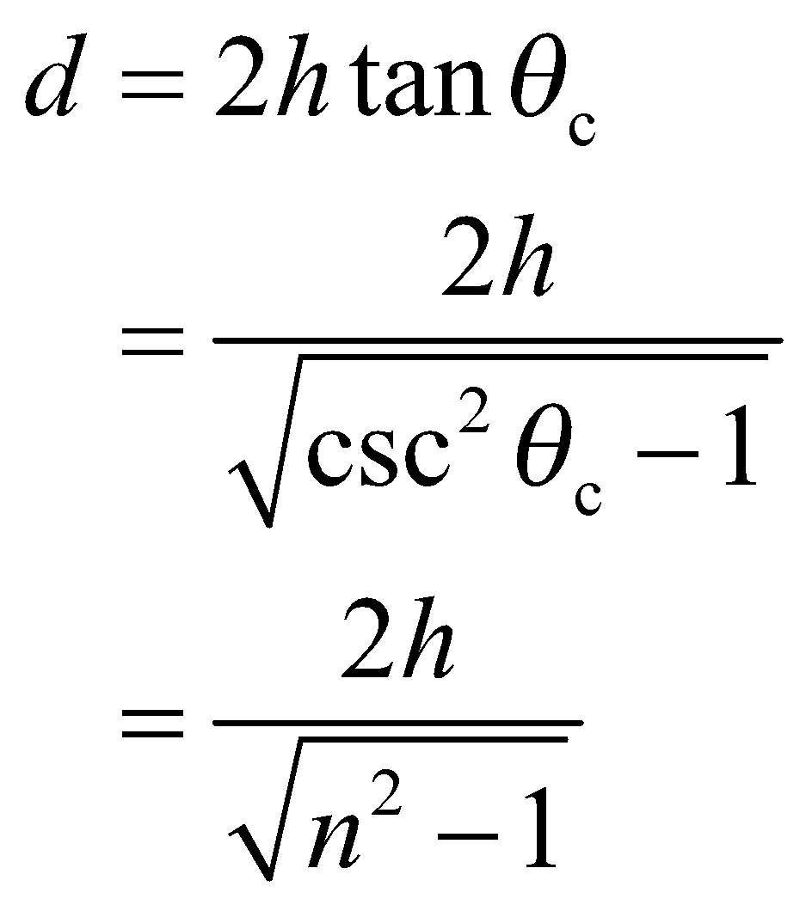

**Assess** The more general form of this relationship is

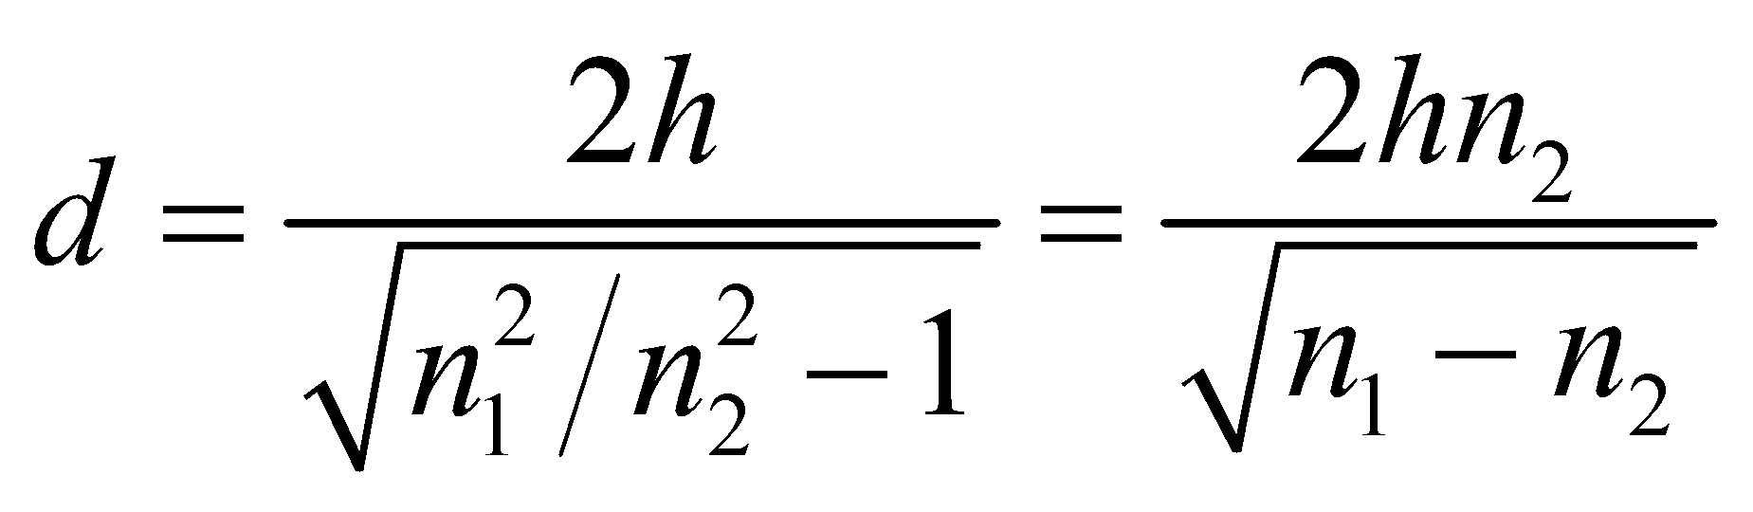

which shows that the critical angle is only relevant for *n*1 > *n*2, which is expected because sin*θ*c = *n*2/*n*1 cannot be greater than unity.

**46. Interpret** This problem involves the critical angle for total internal reflection at the glass-air interface and dispersion (i.e., the index of refraction is wavelength dependent). We shall use to this find the range of angles for which blue light is totally internally reflected whereas red light is not.

**Develop** The critical angle for the blue light and the red light are

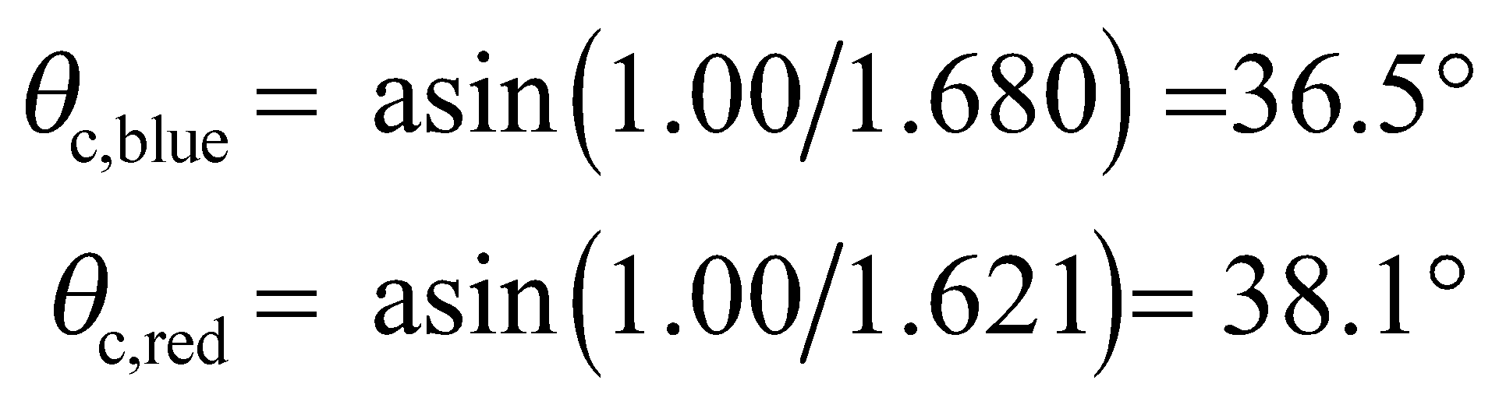

**Evaluate** For incidence angles between these values 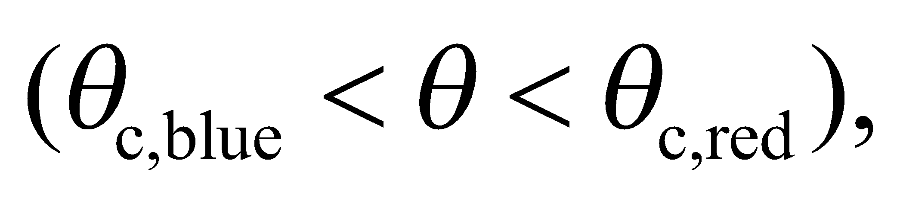 blue light will be totally reflected, while some red light is refracted at the glass-air interface. Therefore, the angular range of interest is 36.5° to 38.1°.

**Assess** Because the refractive index for the blue light is greater than that of the red light 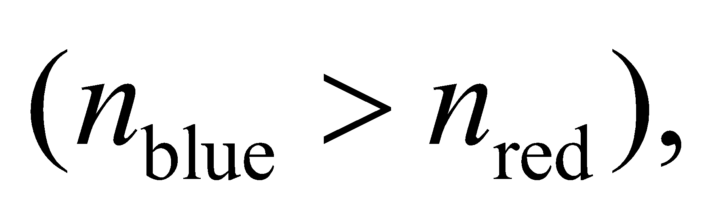 the critical angle for blue light is less than for red light.

**47. Interpret** This problem involves finding the critical angle at the interface between two given media.

**Develop** Apply Equation 30.5, sin*θ*c = *n*2/*n*1 with *n*2 = *n*glass and *n*1 = *n*flint.

**Evaluate** The critical angle is

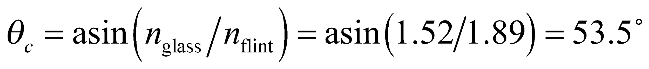

**Assess** In the reverse direction, there is no critical angle because *n*flint > *n*glass.

**48. Interpret** We are to find a “simple” relationship between the speed of light in a medium and its critical angle at an interface with air.

**Develop** The speed of light in a medium with refractive index *n* is (Equation 30.2) *v* = *c*/*n*. On the other hand, from Equation 30.5, the critical angle of the medium is 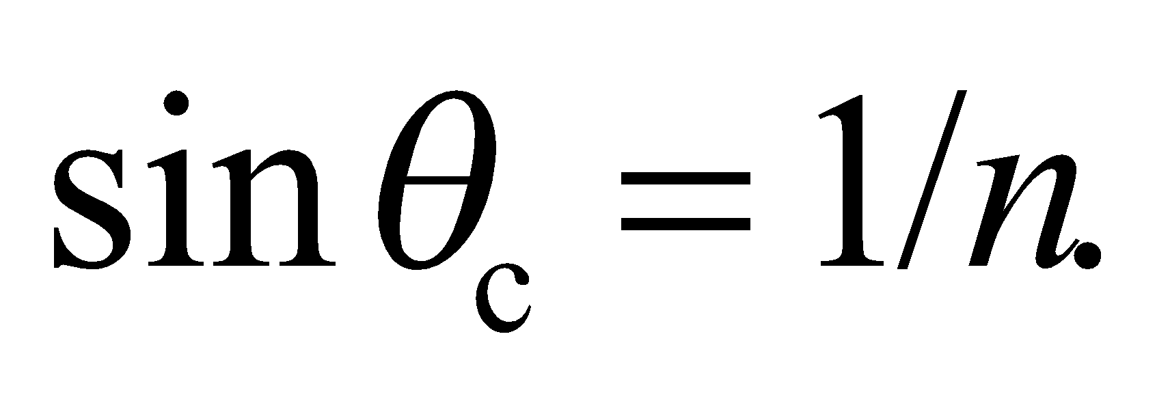 Thus, the relationship between the critical angle and the speed of light in a material can be written as



**Evaluate** From the above equation, the speed of light in the medium may be expressed as

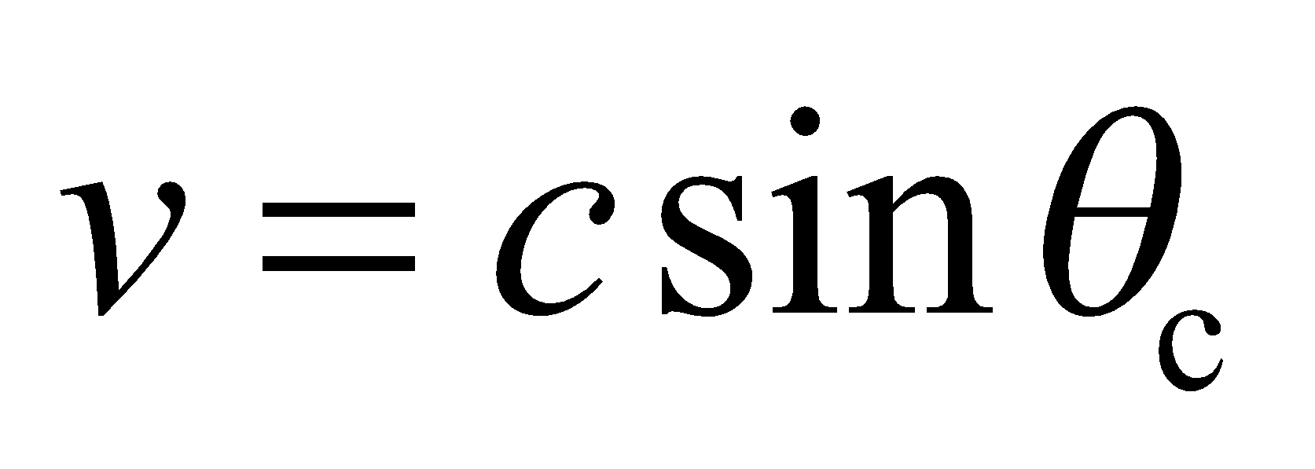

**Assess** The critical angle and the speed of light in a material are both related to the index of refraction of the medium. When 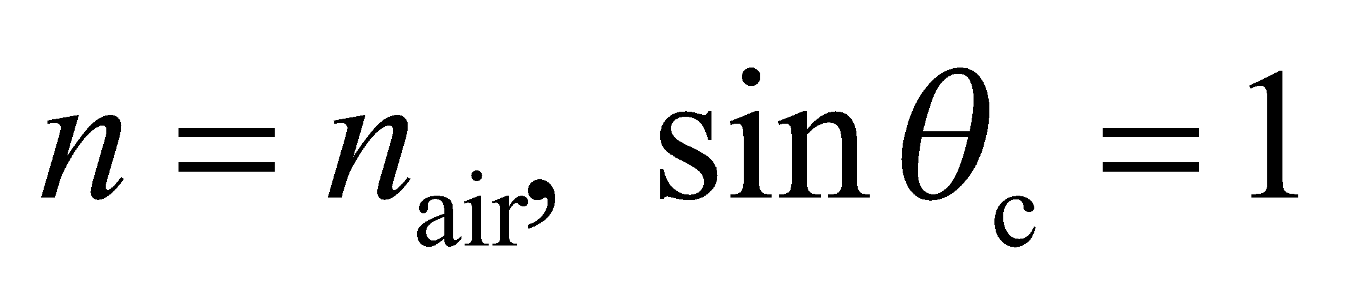 and *v* = *c*, as expected. Note that a more general form of this expression is

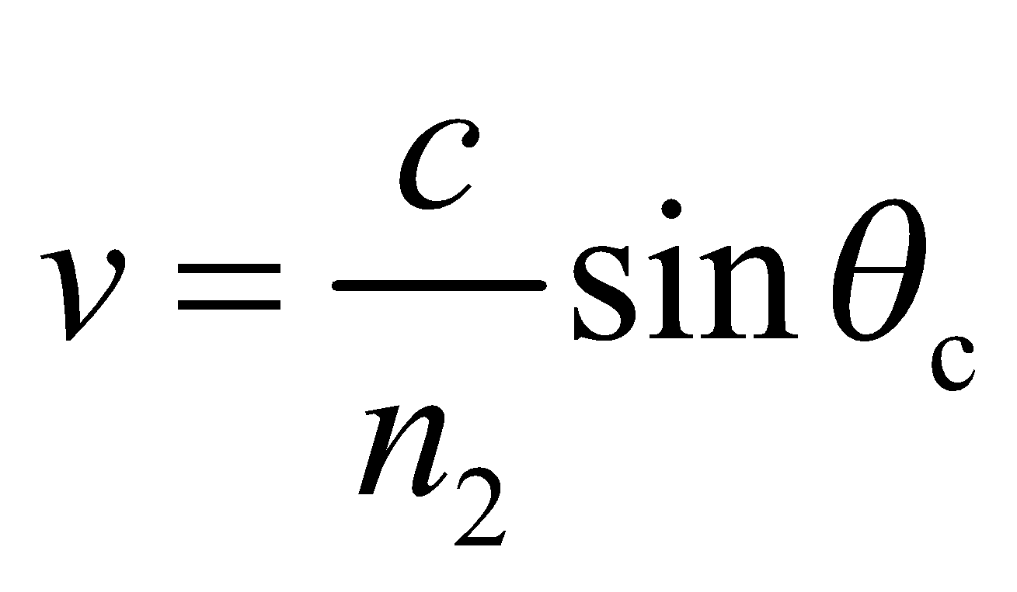

which reduces to *v* = *c* =for *n*2 = 1.

**49. Interpret** We are to find the polarizing angle for a water-air interface.

**Develop** Apply Equation 30.4, with *n*2 = *n*air and *n*1 = *n*water.

**Evaluate** The critical angle is



**Assess** This may be qualitatively verified in your neighborhood swimming pool.

**50. Interpret** We are to find the diameter of a water tank given the incident angle at which light will traverse from the top right to the bottom left of the tank.

**Develop** Consider the sketch below. The diameter *d* and depth *h* of the tank are related to the angle of refraction *θ*2 by

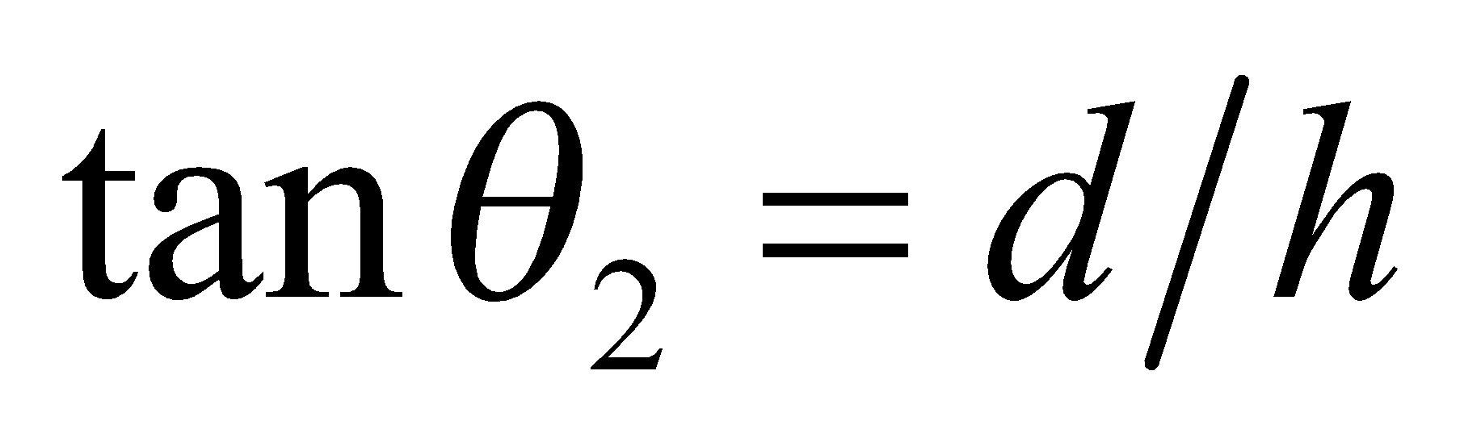

Combine this with Snell’s law (Equation 30.3) to find the diameter of the tank.



**Evaluate** Using *n*1 = 1.00 for air and *n*2 = 1.33 (see Table 30.1), we find the diameter of the tank to be



**Assess** The result is reported to two significant digits because we are given the incident angle and the tank depth to two significant digits.

**51. Interpret** This problem is about refraction of sunlight. We want to know the diameter of the tank such that sunlight can reach part of the tank bottom whenever the Sun is above the horizon.

**Develop** The rays of sunlight which first hit the bottom of the tank just skim the opposite edge of the rim. The diameter and depth of the tank (*d* and *h*) are related to the angle of refraction by . Combining this with Snell’s law (Equation 30.3), we find (with *n*1 = 1.00 for air and *n*2 = 1.333 for water)

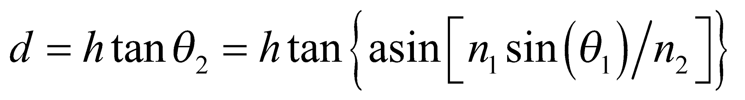

**Evaluate** If we let *θ*1 approach 90° (Sun angle approaches 0°), then the tank diameter becomes

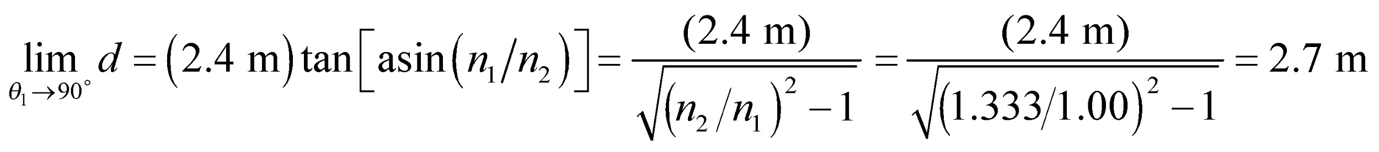

where we have used 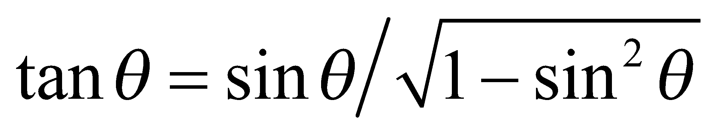.

**Assess** If the diameter is smaller than 2.7 m then, in order for the sunlight to reach the bottom of the tank, a smaller value of *θ*1 would be required. The diameter of the tank as a function of *θ*1 is depicted in the figure below.



**52. Interpret** This problem involves refraction at two interfaces: (1) air-polystyrene and (2) polystyrene-water. Given the incident angle at the air-polystyrene interface, we are to find the angle of refraction in the water.

**Develop** Consider the figure below. Appling Snell’s law to each interface gives

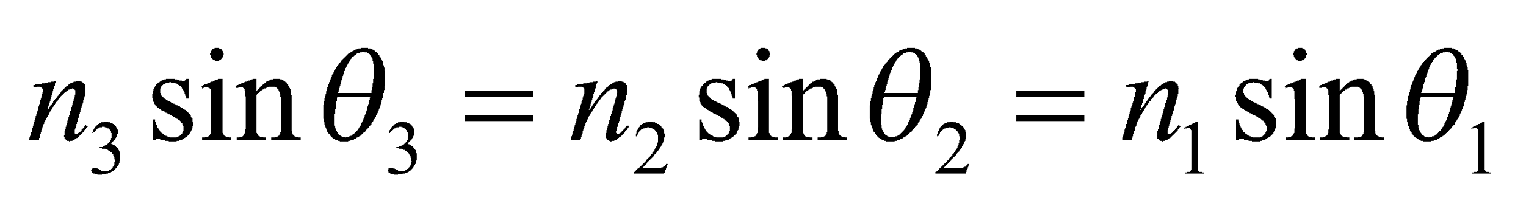

so the angle of refraction in the water (*θ*3) can be found given the angle of incidence in air.



**Evaluate** The angle of refraction is



**Assess** This result is independent of the intermediate material (provided it is transparent).

**53. Interpret** You want to center the screen so the projector's light reflects straight back towards the patient's eyes.

**Develop**The figure below shows the path the light should take from the projector to the patient's eyes. The lengths 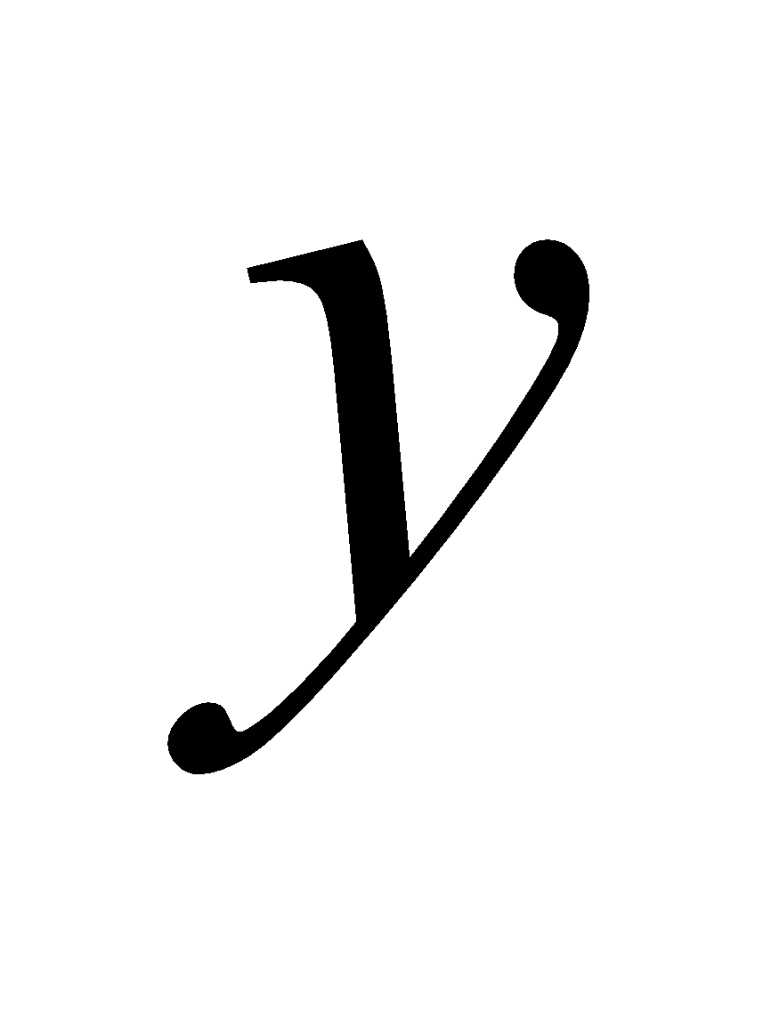 and 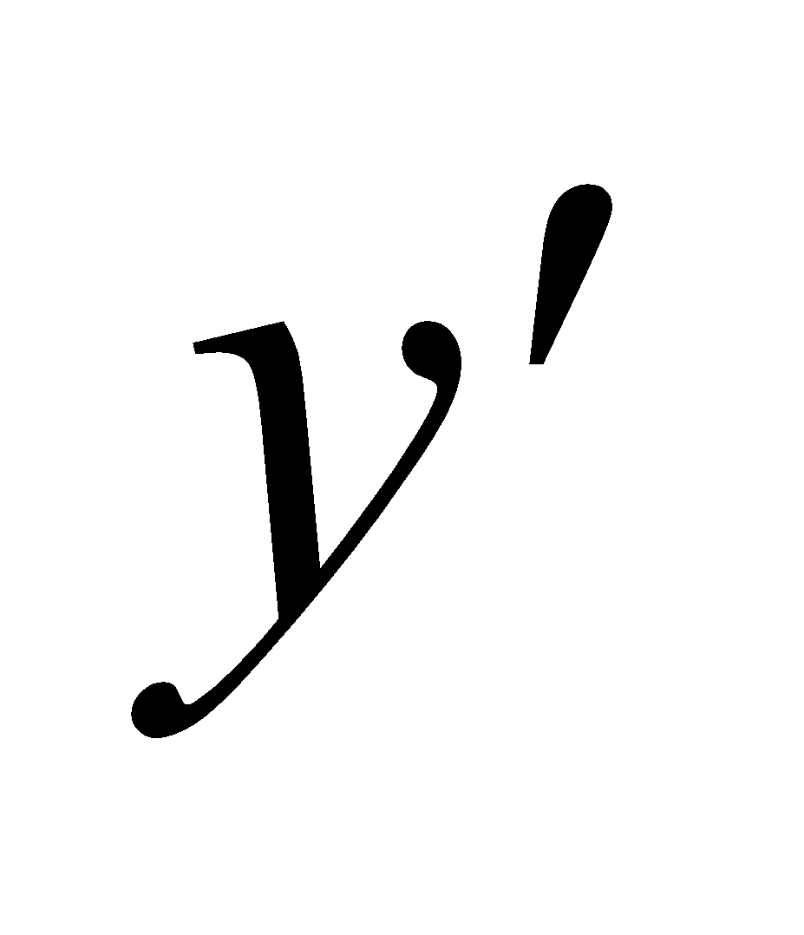 give the vertical distance from the center of the screen to the projector and the eyes, respectively. If you assume specular reflection, the angle of incidence,  is equal to the angle of reflection, 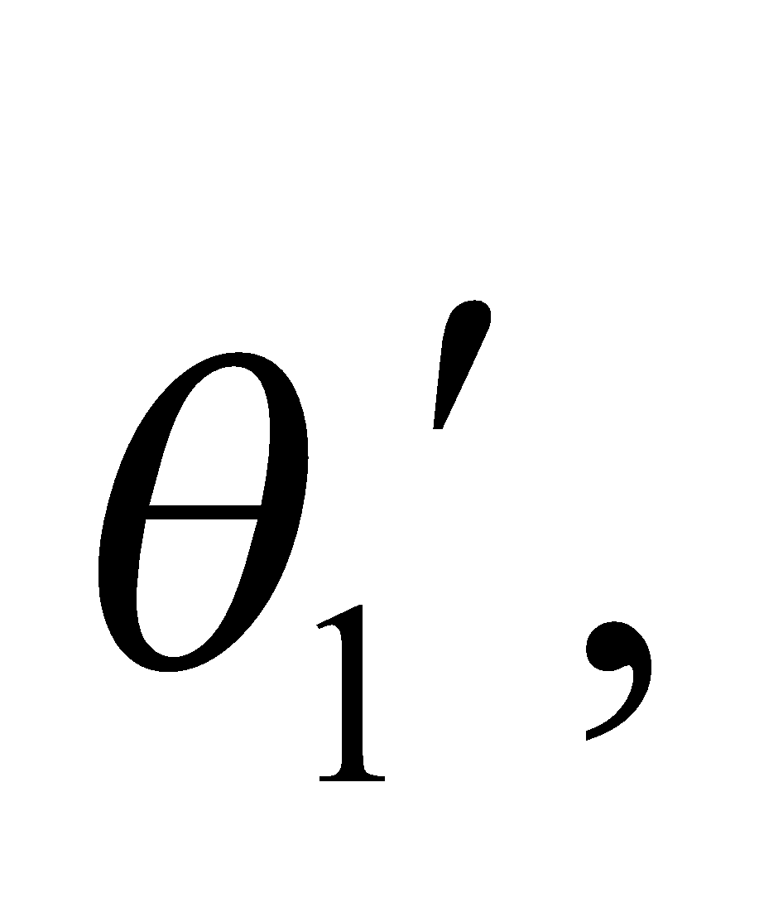 which means

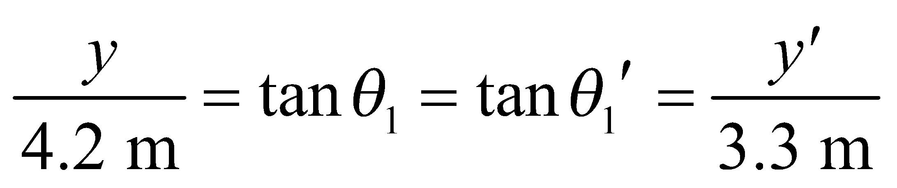

**Evaluate**From the figure, the unknown distances must satisfy: 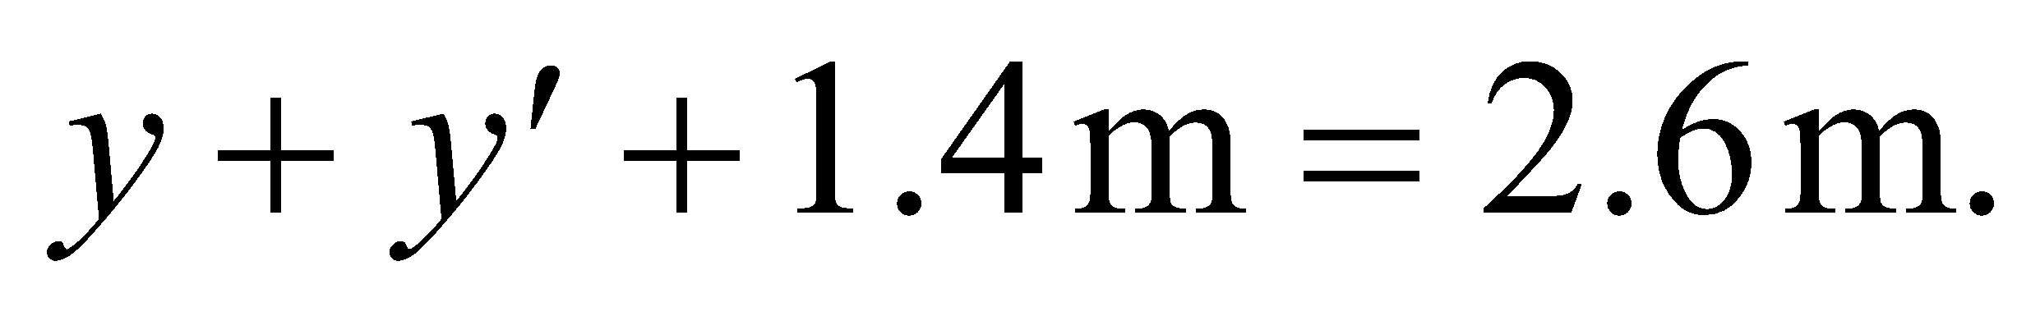 Combining this with the reflection criterion above, we find

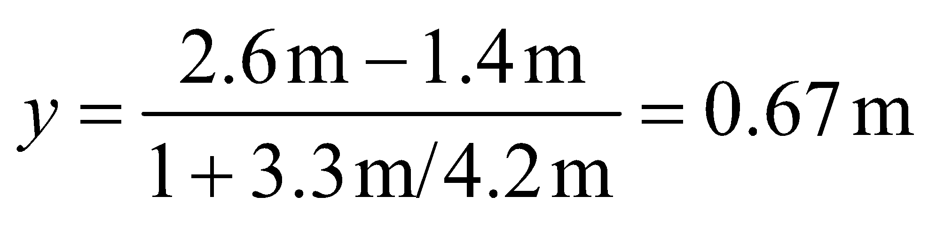

This means the center of the projector should be placed 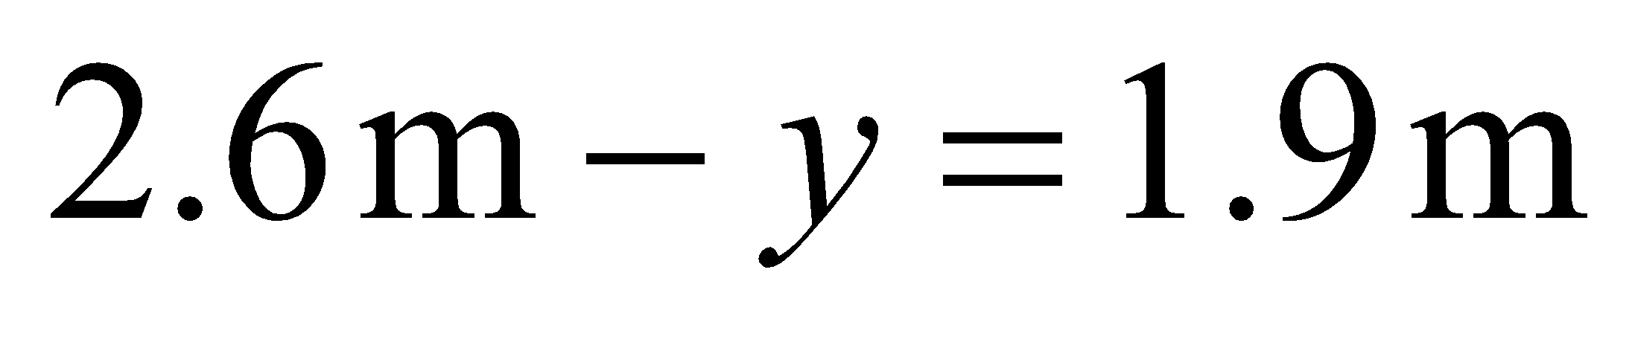from the floor.

**Assess** This is a little lower than the midpoint between the projector and the eyes, which makes sense since the eyes are closer to the screen than the projector.

**54. Interpret** We are to find an expression for the angle of refraction of a ray passing through a transparent slab in air.

**Develop** Consider the figure below. In Figure 30.6, 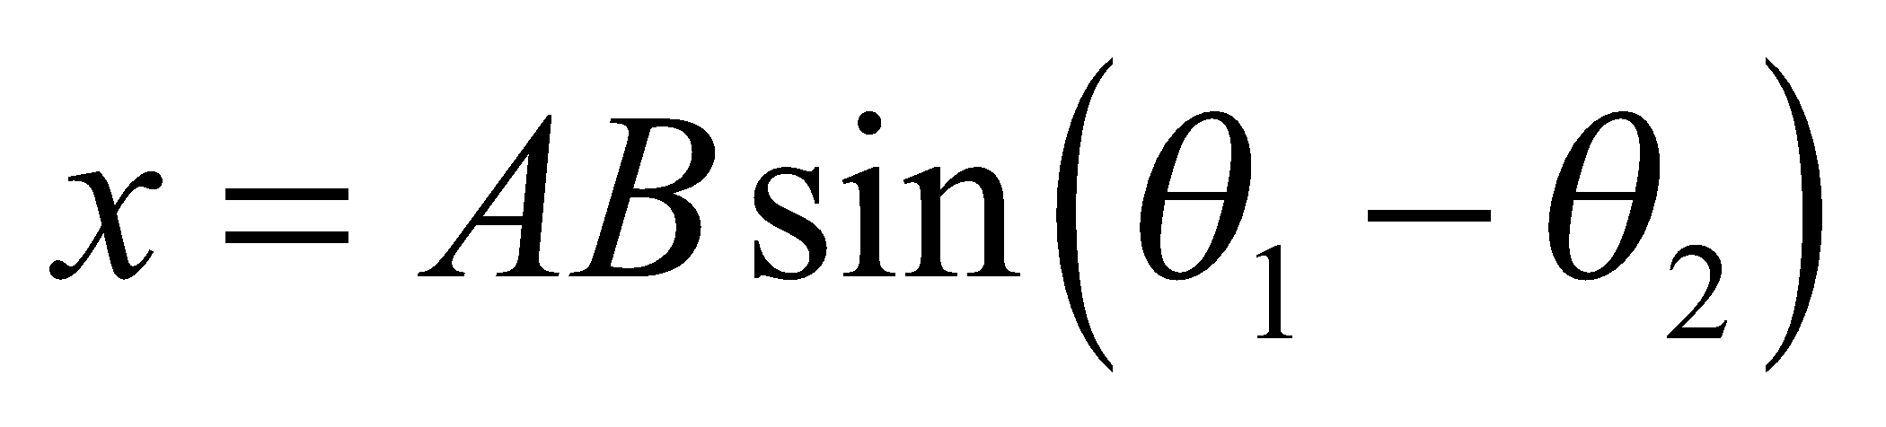 and 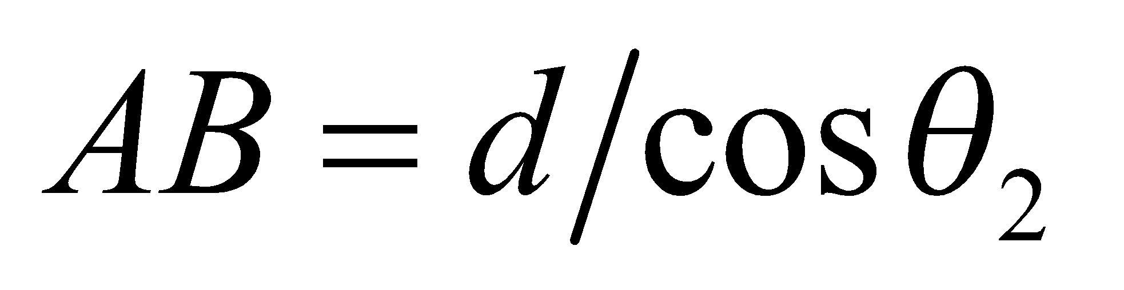.



**Evaluate** With the aid of trigonometric identities and Snell’s law (Equation 30.3,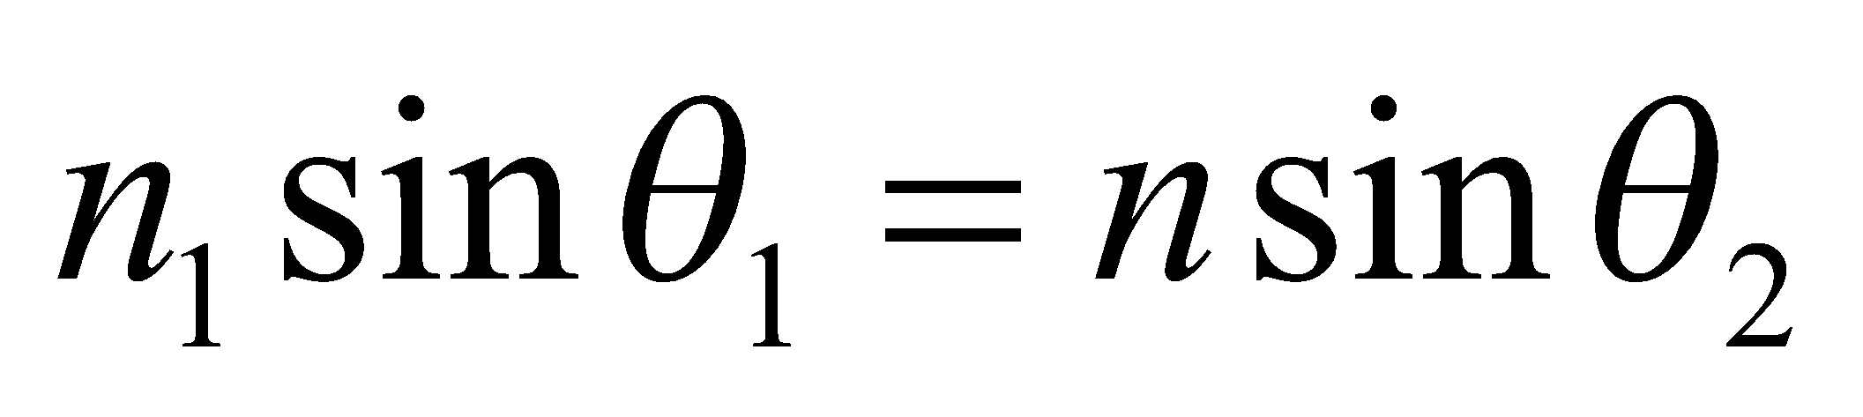), we find

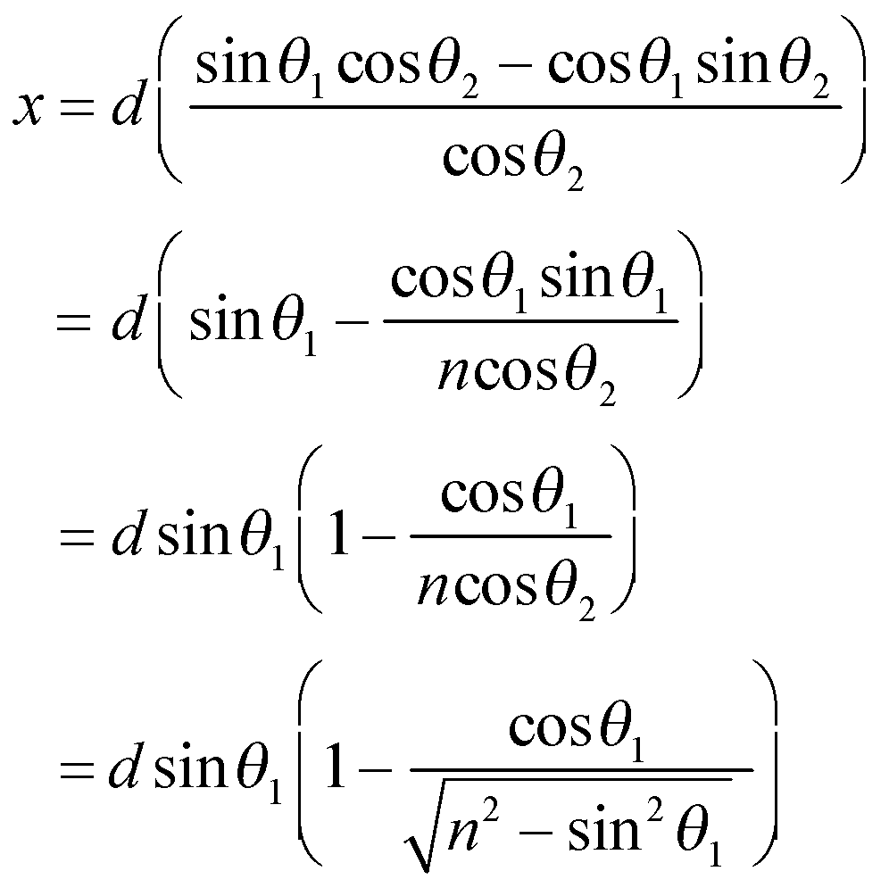

**Assess** For *n* = 1 (i.e., the slab is made of air), this reduces to *x* = 0, as expected.

**55. Interpret** This problem involves two refractions and a total internal reflection as the light ray passes through a spherical raindrop. Thus, we shall use Snell’s law and the relationship of total internal reflection to show that the complement of the angle between the incoming and outgoing rays is as given in the problem statement.

**Develop** Consider the figure below. The angle *φ* can be found by summing the deflections each time the ray in Figure 30.21 is refracted or reflected. The deflection at *A* is 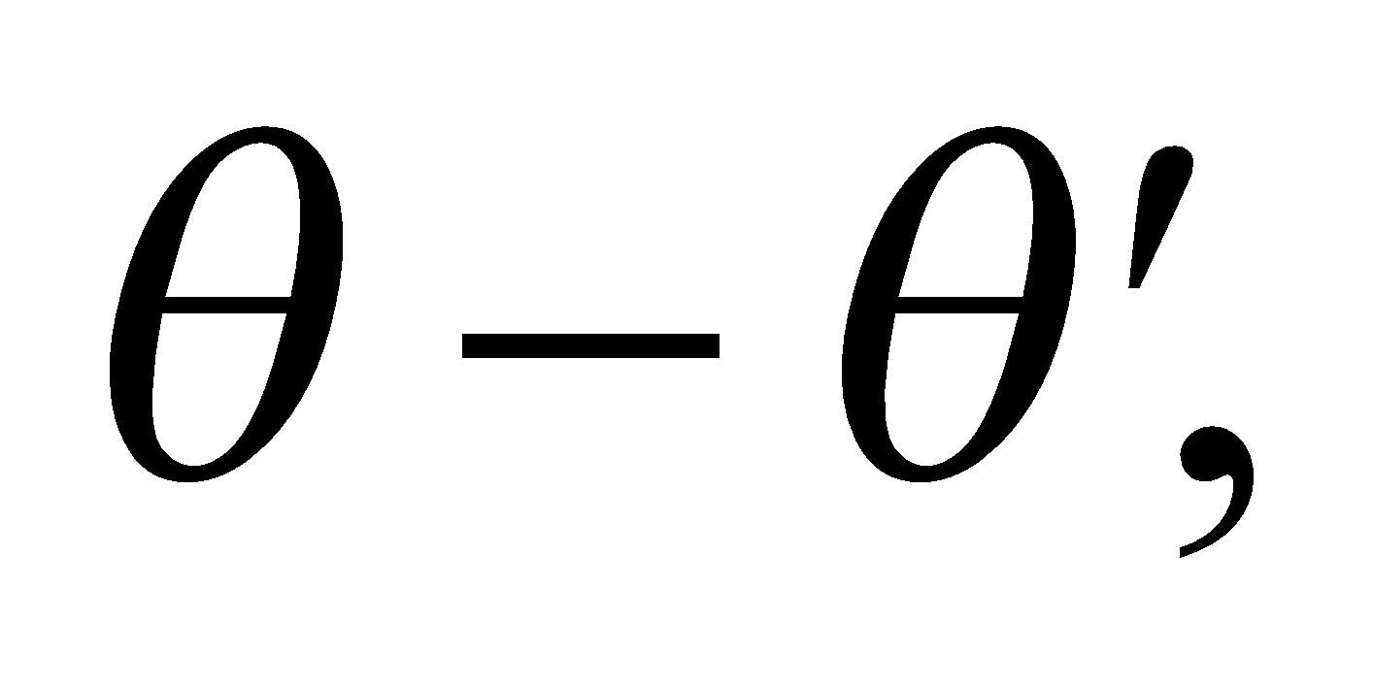 at *B* is 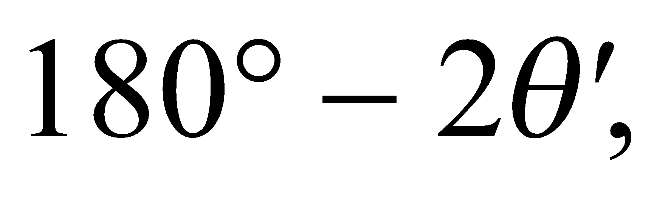 and at *C* is 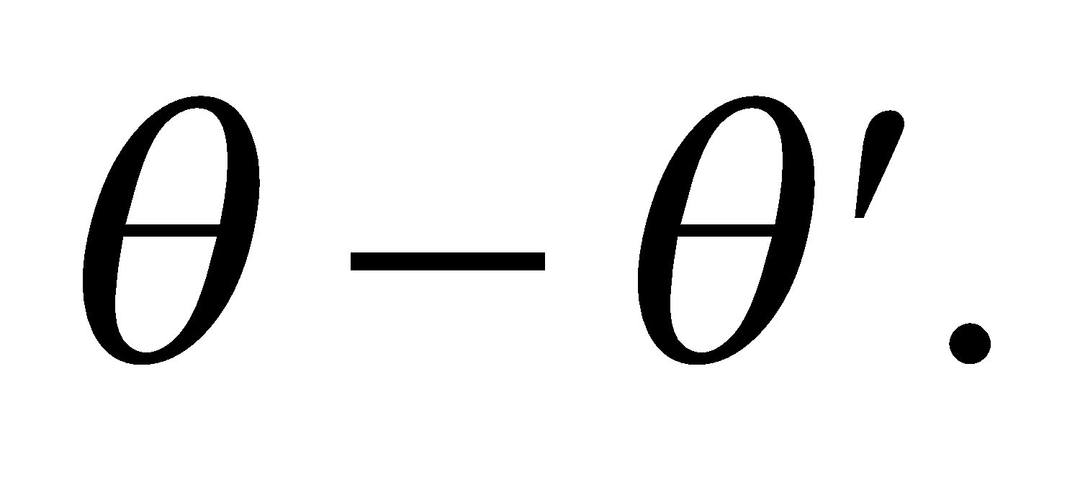 The sum is

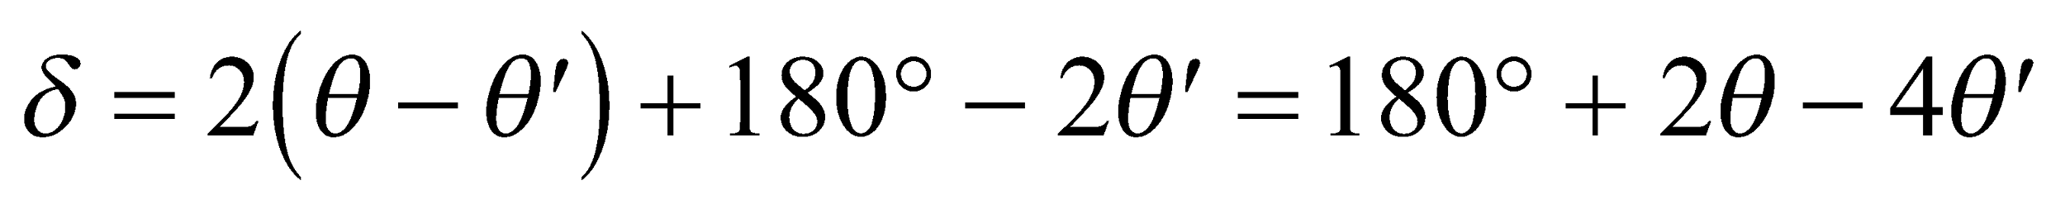

and is related to *φ* by 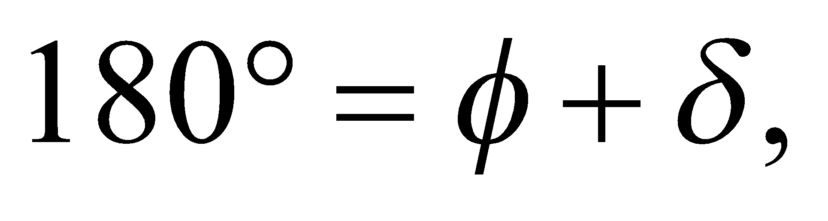 so 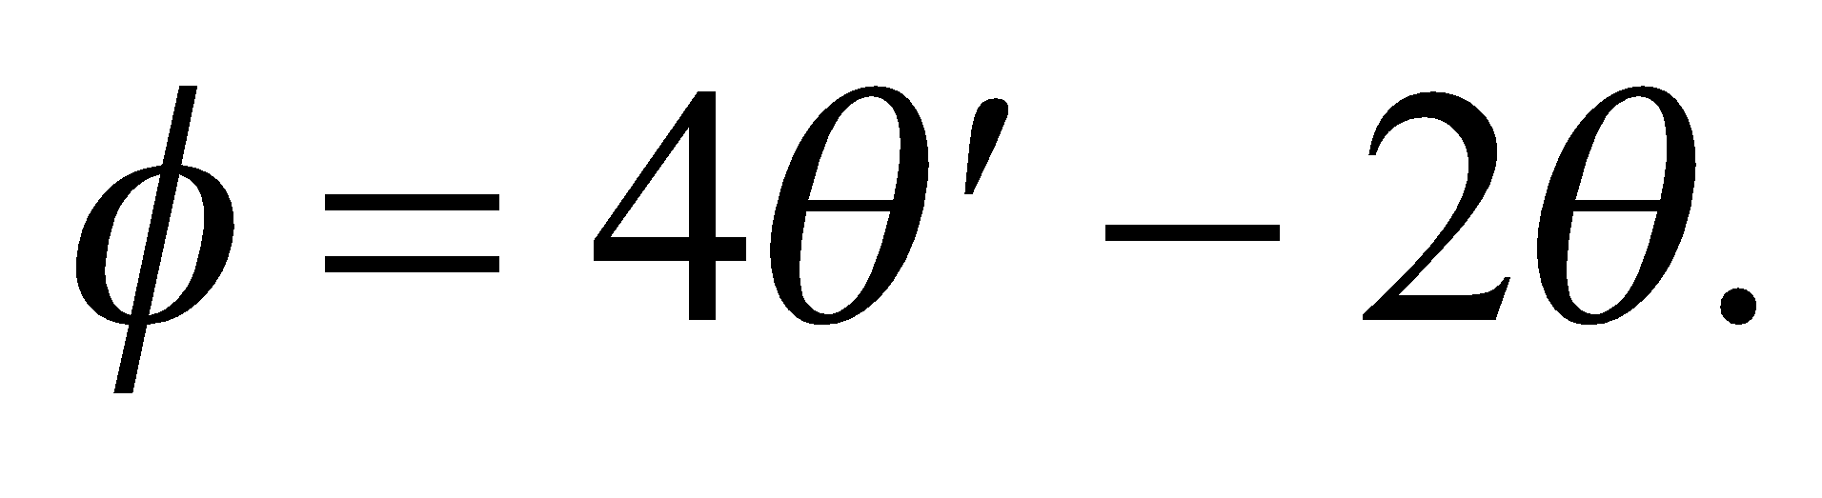



**Evaluate** By eliminating *θ*′ using Snell’s law [Equation 30.3, 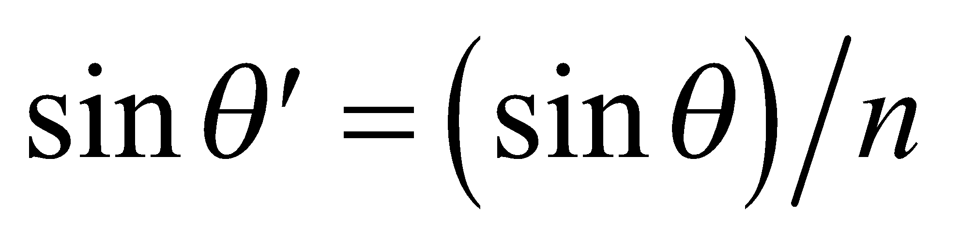], the desired expression

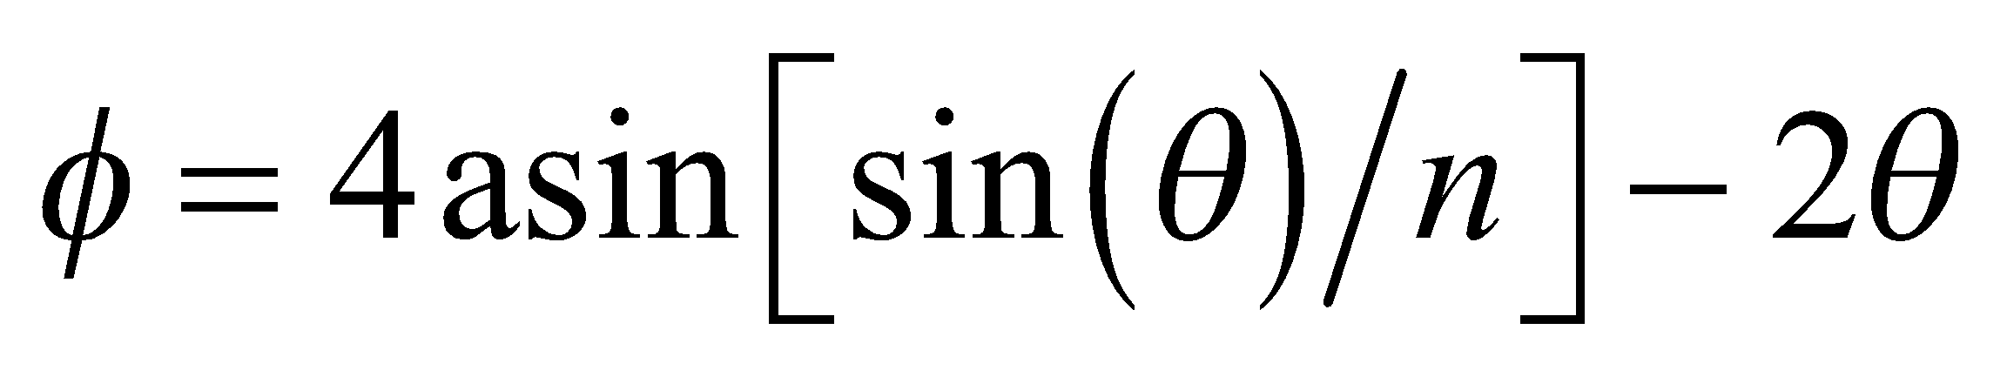

is obtained. Note that light incident at the boundaries of the drop, at *A*, *B*, and *C*, is partially reflected and partially refracted; we show only the rays relevant to the formation of a rainbow.

**Assess** The angle *φ* is a complicated nonlinear function of *θ*, as shown on the right (with *n* = 1.333).The maximum value of *φ* is approximately equal to 42.1°. This is the average angle above the anti-solar direction that an observer sees a rainbow, because *n* is the average index of refraction for visible wavelengths.



**56. Interpret** We are to maximum angle *φ* from the previous problem for which light striking a spherical water droplet is deviated.

**Develop** Differentiate the result of the previous problem, set the derivative equal to zero, and solve for *φ*.

**Evaluate** (a) The derivative is

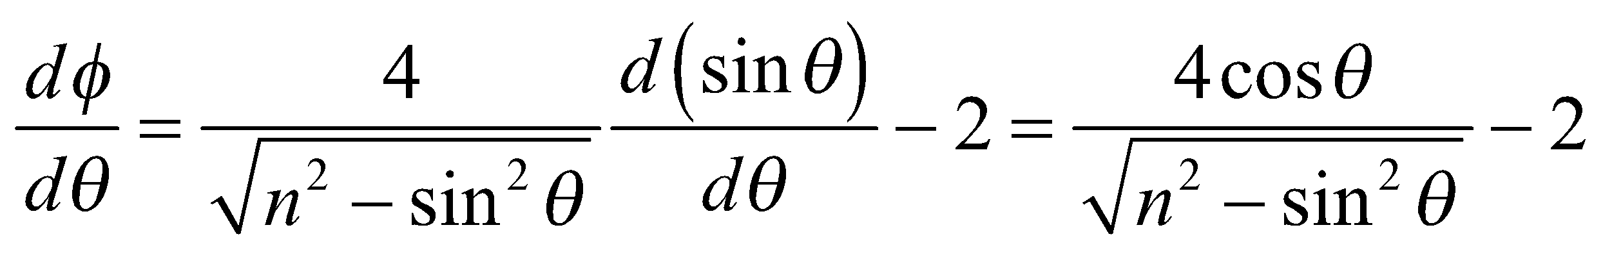

The condition for a maximum, 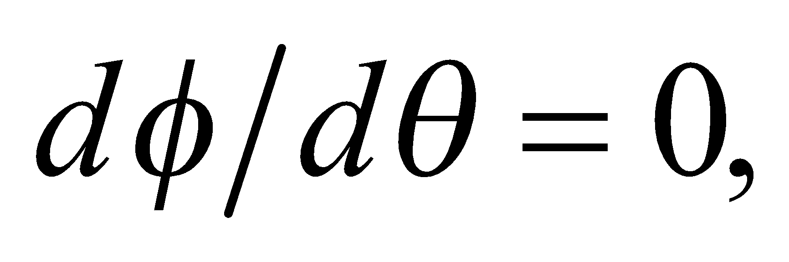 implies that 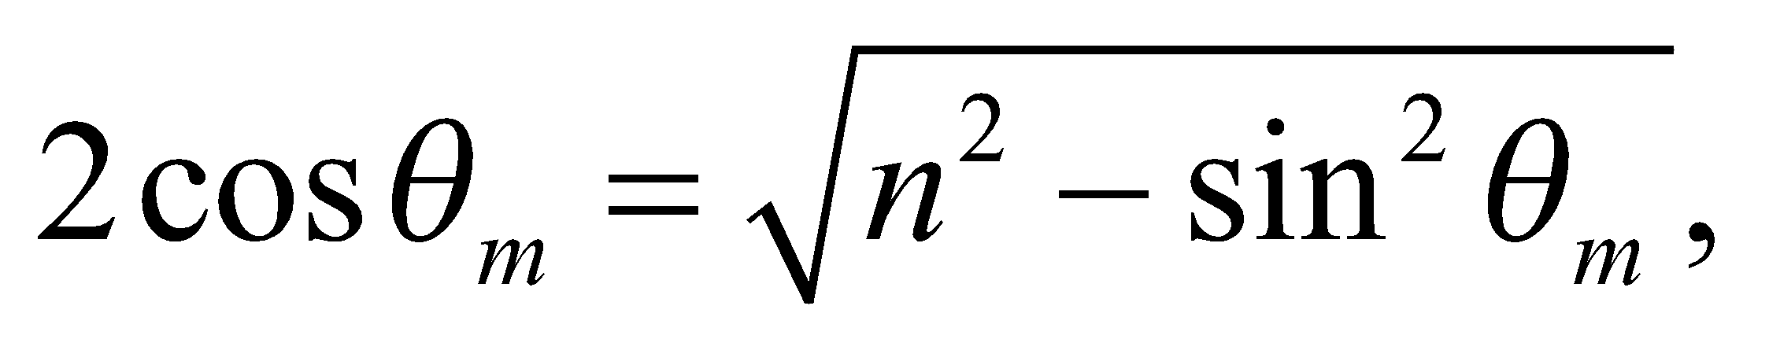 or 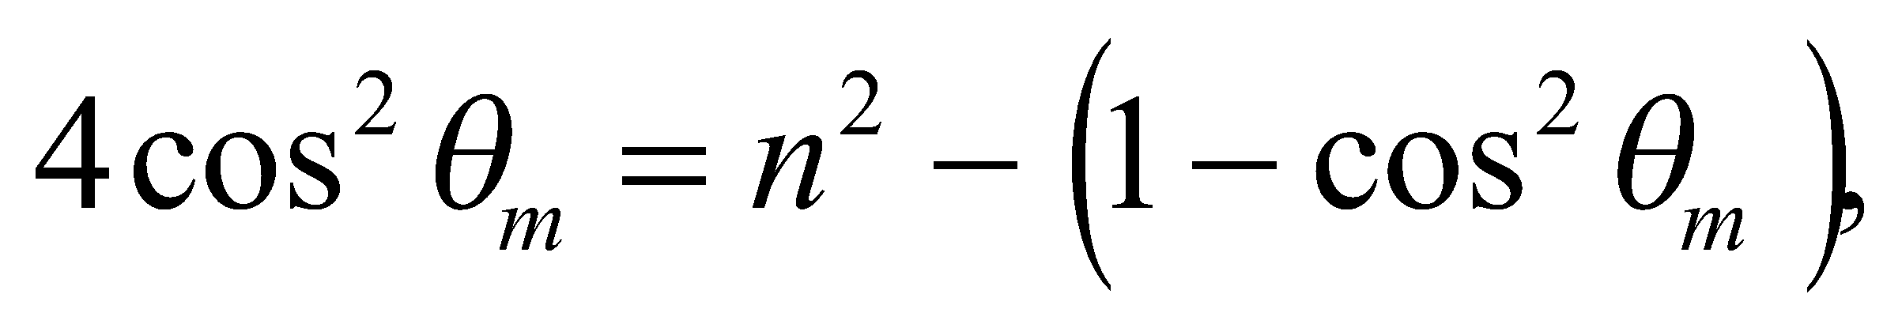 so

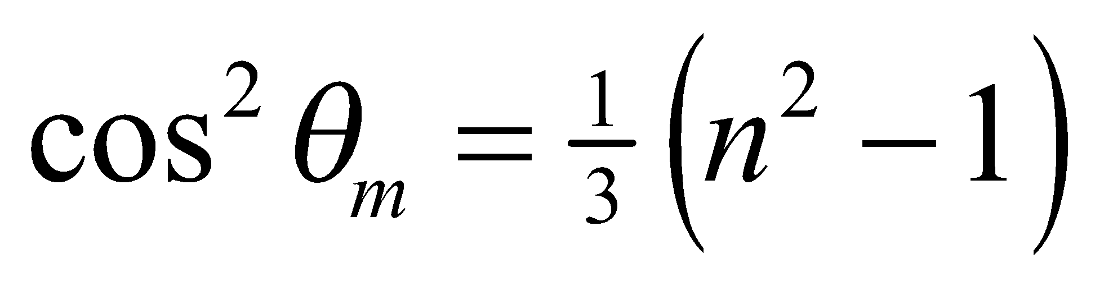

(b) If this value of *θ* is substituted into the expression for *φ*, after noting that 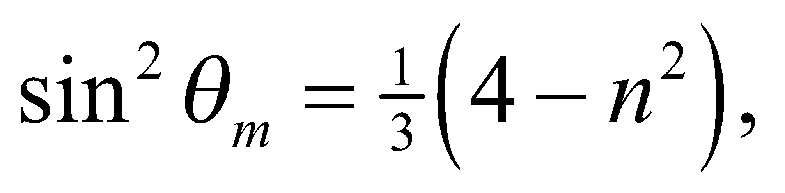 one gets

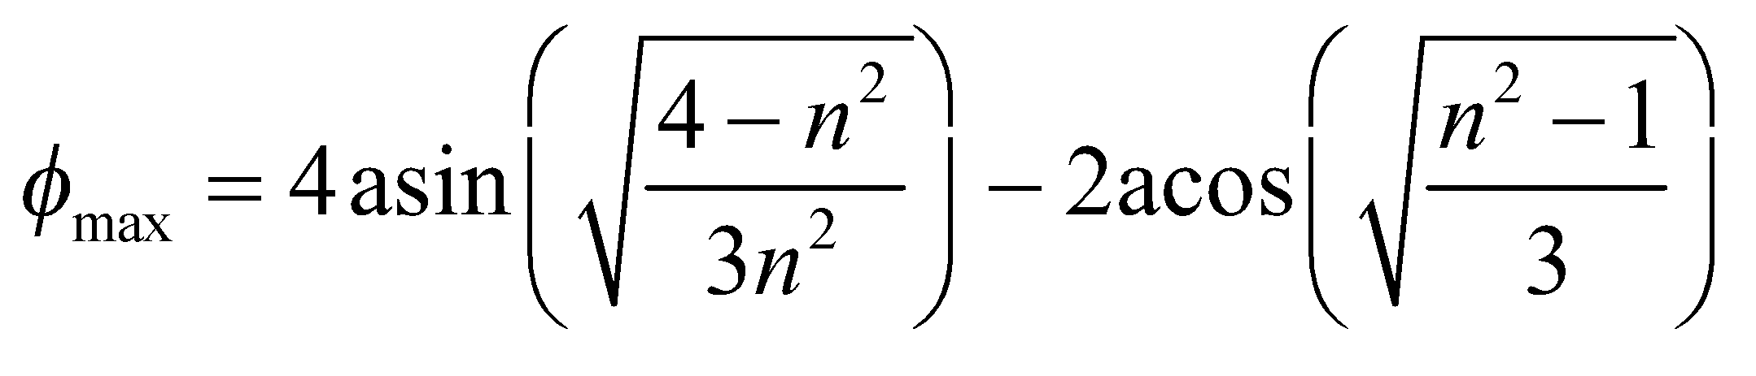

which equals 42.1° for 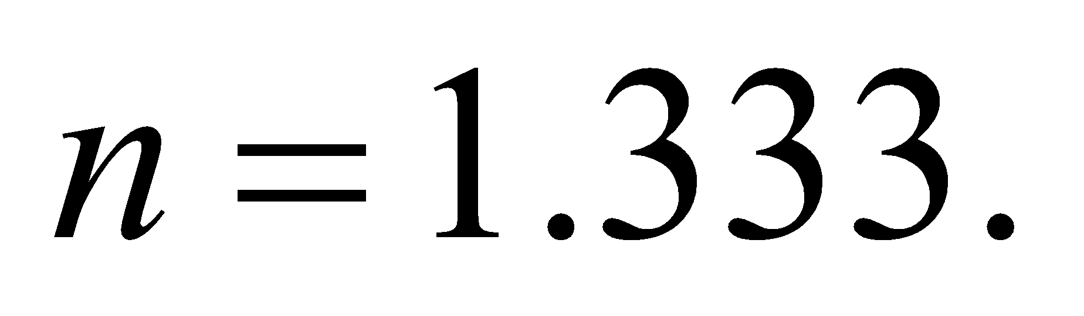

**Assess**  This is the average angle, above the anti-solar direction, that an observer sees a rainbow, because *n* is the average index of refraction for visible wavelengths.

**57. Interpret** This problem involves two refractions and two total internal reflections as the light ray passes through a spherical raindrop. We are to use the results of the two previous problems for this problem.

**Develop** The analysis of the secondary rainbow is similar to that of the primary rainbow (see Problems 55 and 56). The angles for an incident ray, which experiences two internal reflections in a spherical drop of water, are shown in the figure below for the emergent ray traveling downward to an observer on the ground. The total deflection for two refractions and two internal reflections,

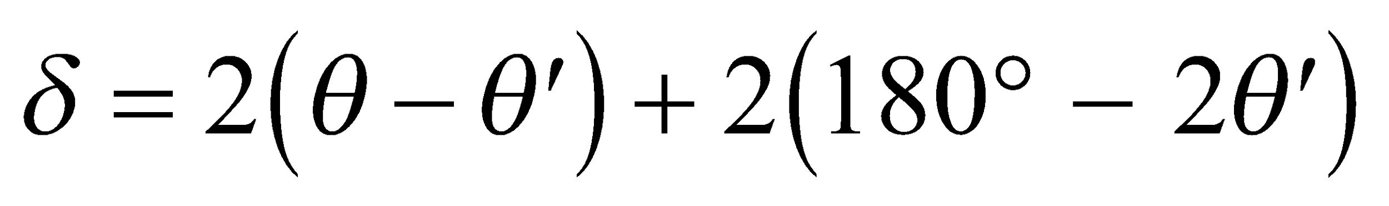

is related to the observation angle from the anti-solar direction *φ* by 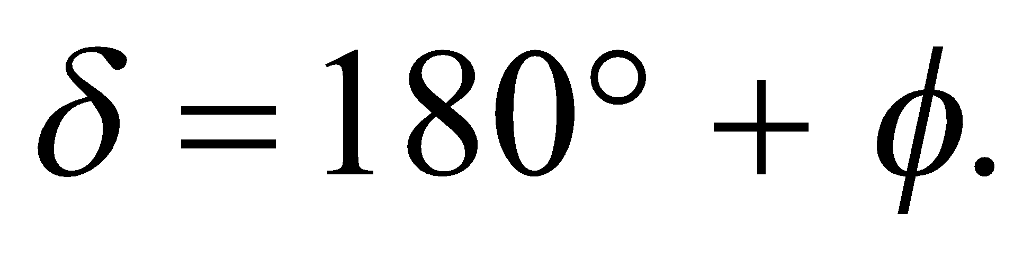



**Evaluate** Combining the two equations, we obtain



If we differentiate Snell’s law with respect to *θ* and substitute for *θ* in terms of *φ* and *θ*, we get

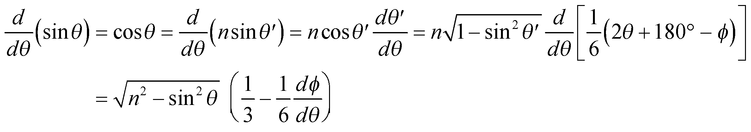

A concentrated beam is formed for the incident angle that satisfies the condition 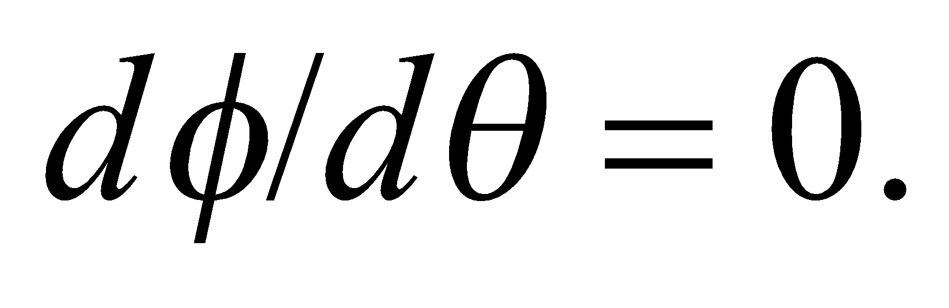 Thus,

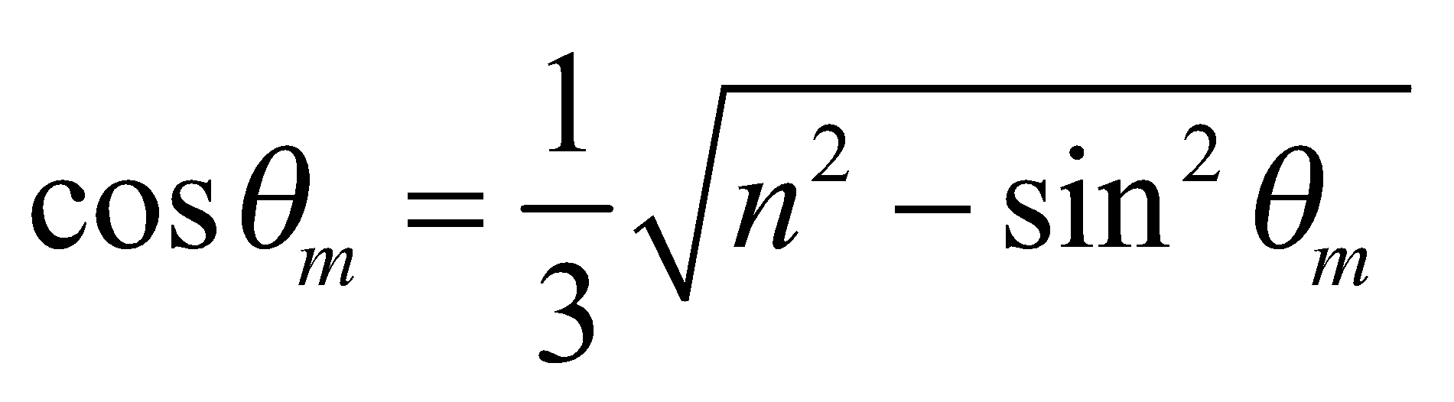

which implies 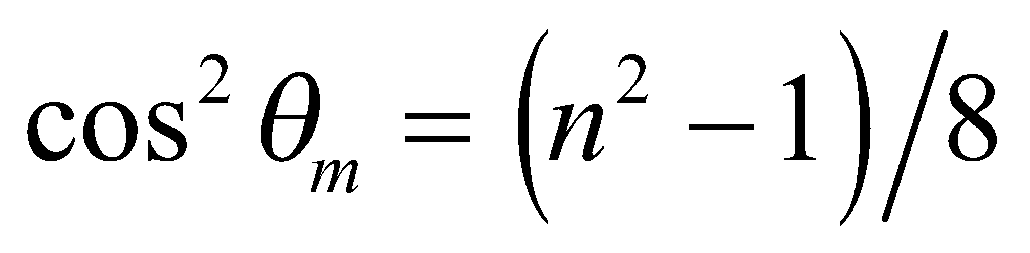 and 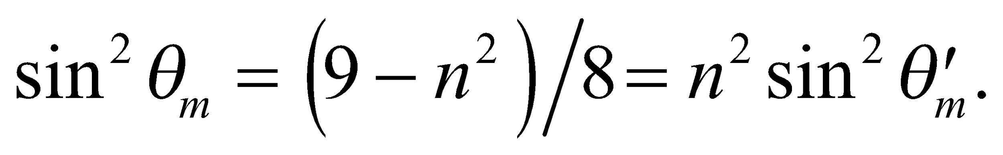 Finally, the maximum value of *φ* is

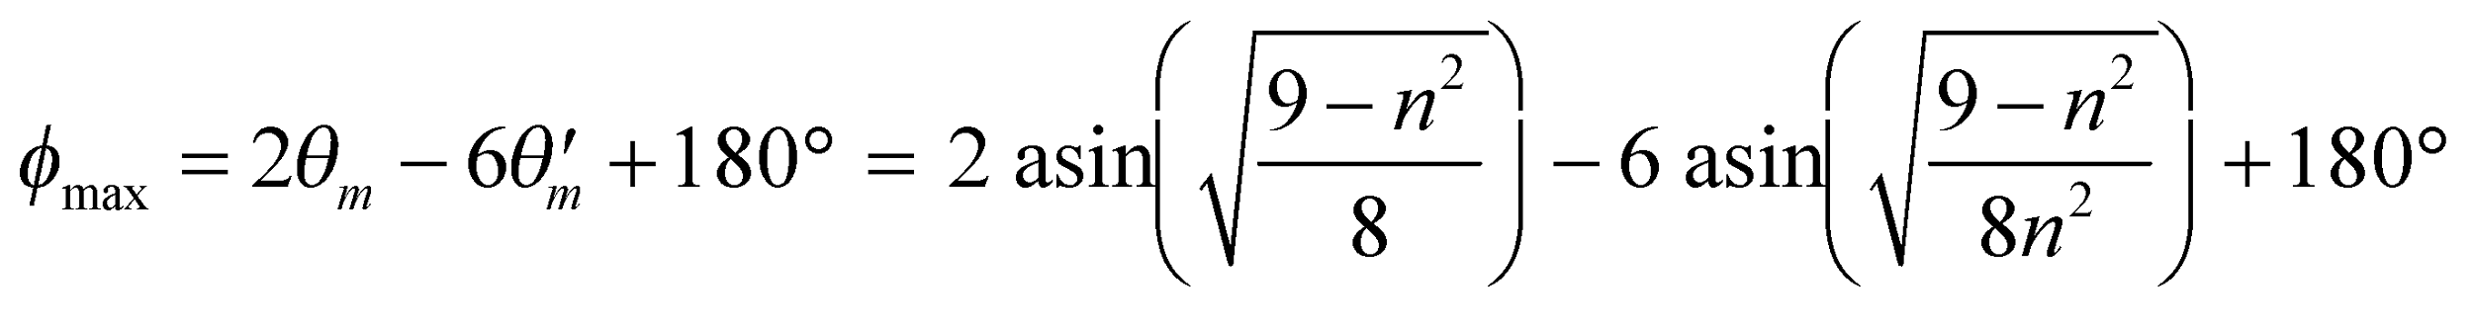

For *n* = 1.333, the average angle is 50.9°. However, substituting *n*red = 1.330 and *n*violet = 1.342, we obtain 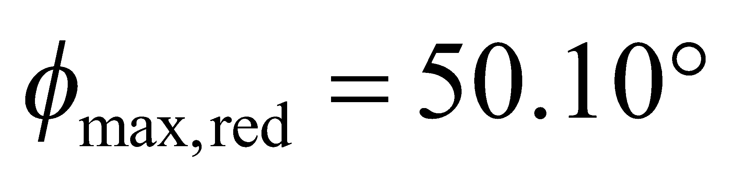 and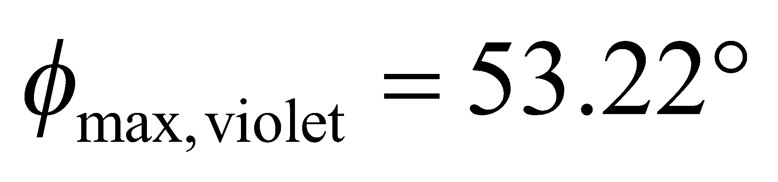 for the secondary rainbow.

**Assess** Since 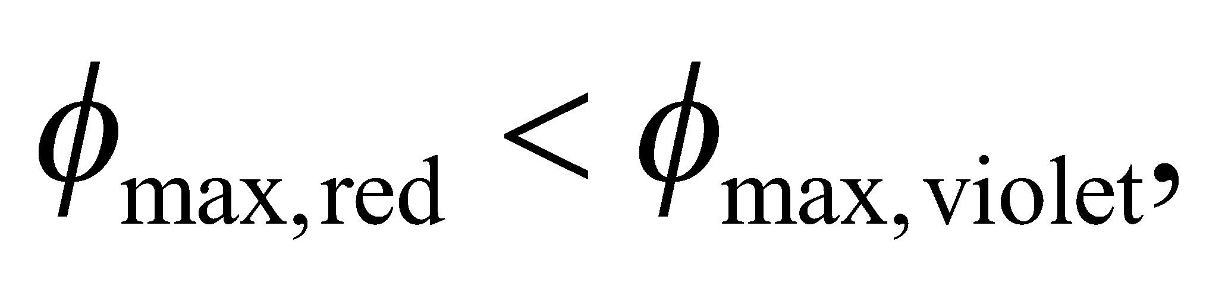 the colors appear in the reverse order from that in the primary rainbow. Although the deflection for violet rays is always larger than that for red rays (no matter how many internal reflections are considered), the relation between *φ* and *δ* depends on the quadrant of *δ* and is different for the primary and secondary rainbows.

**58. Interpret** We are to find the net reflection of a reflector that consists of three plane mirrors oriented to form the corner of a cube (i.e., three mutually perpendicular mirrors).

**Develop** A single plane mirror reverses the direction of just the normal component of a ray striking its surface. For example, a ray incident in the direction

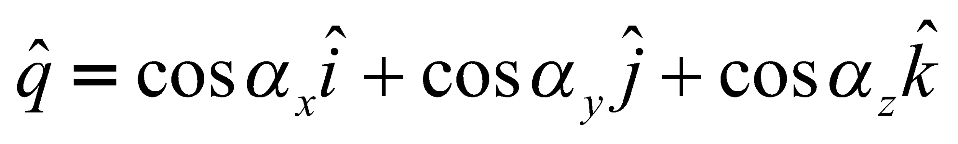

on a mirror normal to the *x* axis, is reflected into the direction

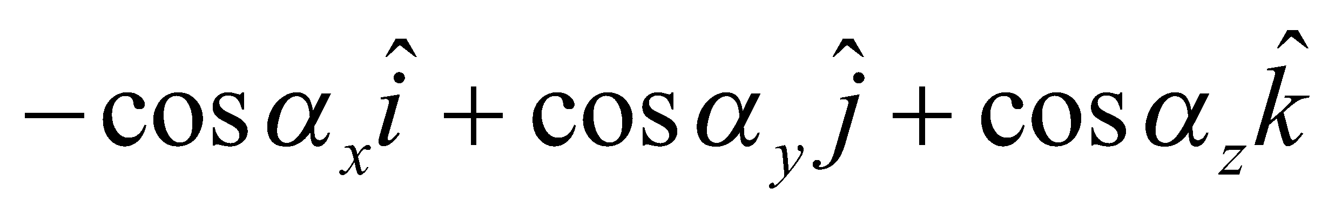

In our notation, 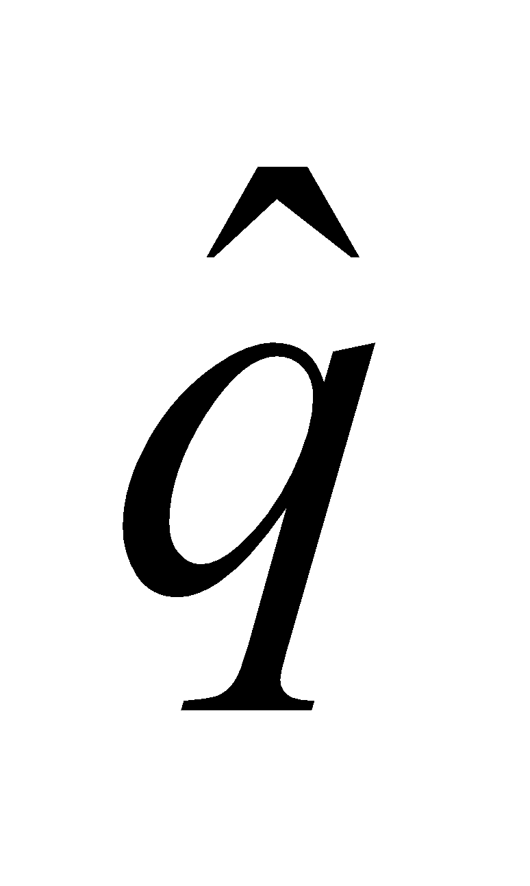is a unit vector, and 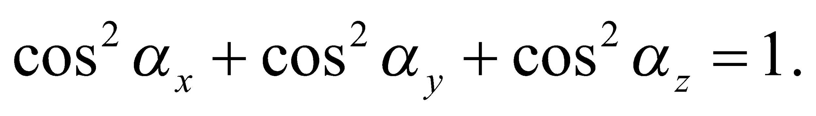

**Evaluate** If the ray also strikes mirrors which are normal to the *y* and *z* axes, as in a corner reflector, it emerges in the direction

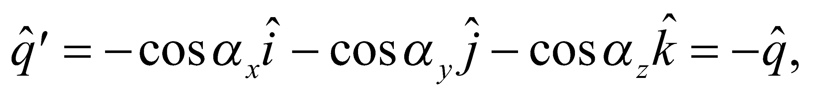

or opposite to the initial direction.

**Assess** In order to strike all three mirrors, the direction cosines of the incident ray must have magnitudes greater than some minimum nonzero value, depending on the size of the reflector.

**59. Interpret** We will prove Snell's law starting from Fermat's principle that says light takes the path of least (or most) time when traveling between two points.

**Develop**We'll assume the two mediums are separated by a flat horizontal interface. Let point *A* be in medium 1 at a vertical distance 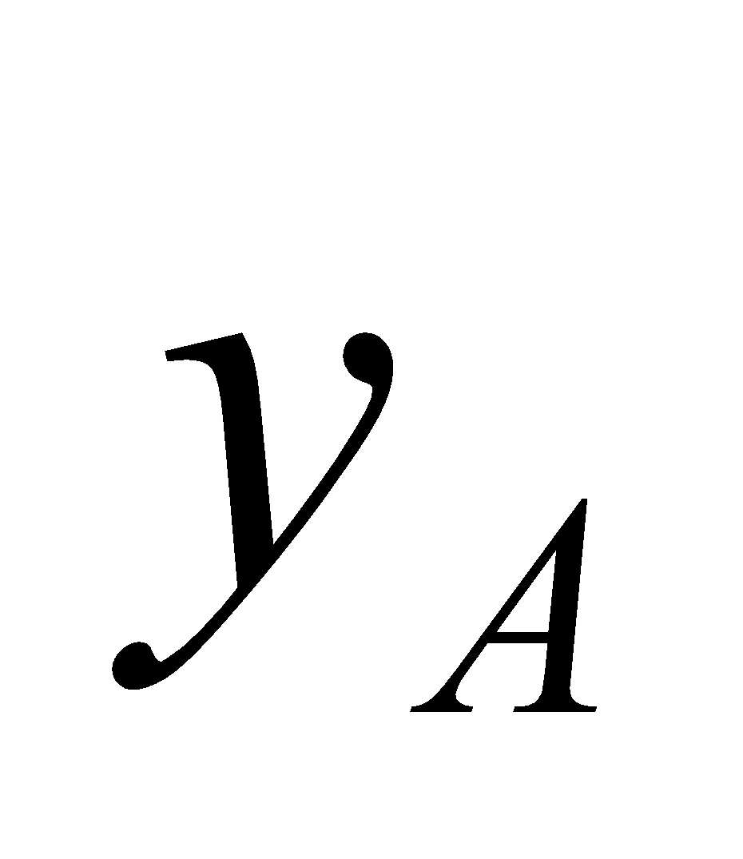 from the interface. Likewise, let point *B* be in medium 2 at a vertical distance 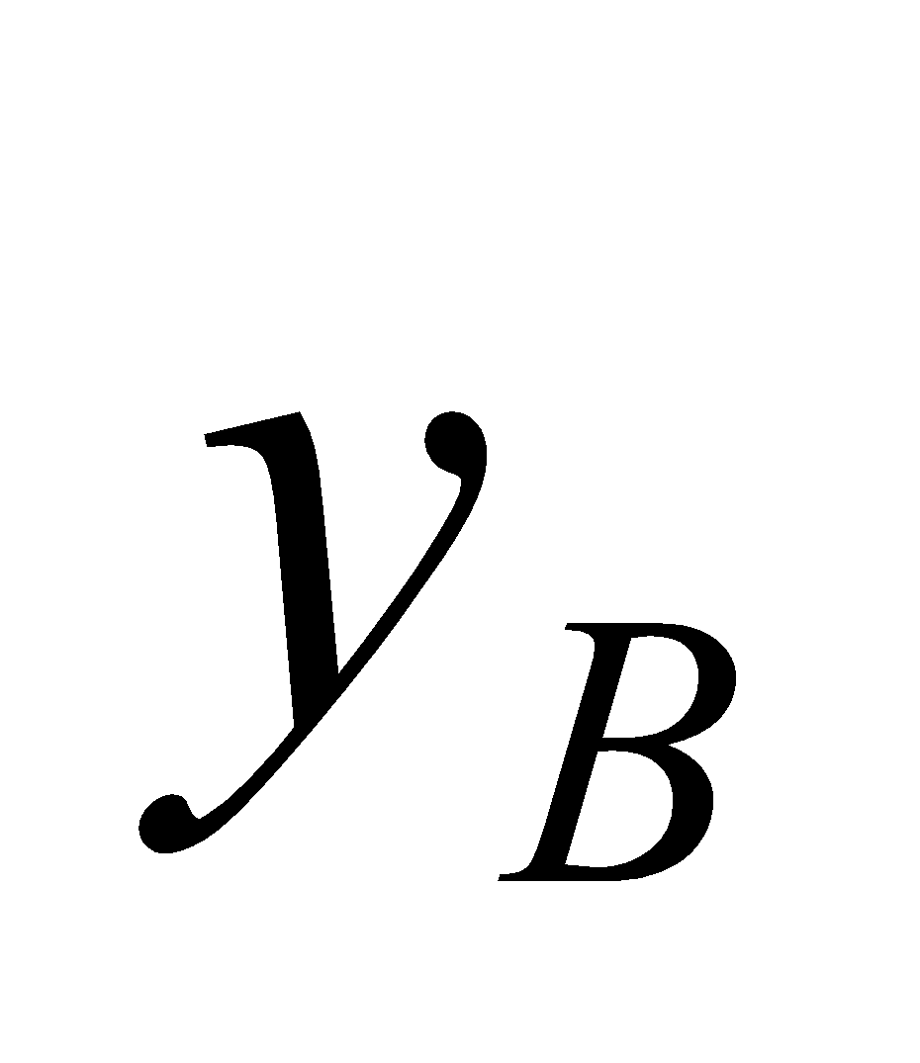 from the interface and a horizontal distance *L* from *A*. See the figure below.



We choose an arbitrary path from *A* to *B*, characterized by the horizontal distance *x* between point *A* and the point where the path crosses the interface. This leaves a horizontal distance of 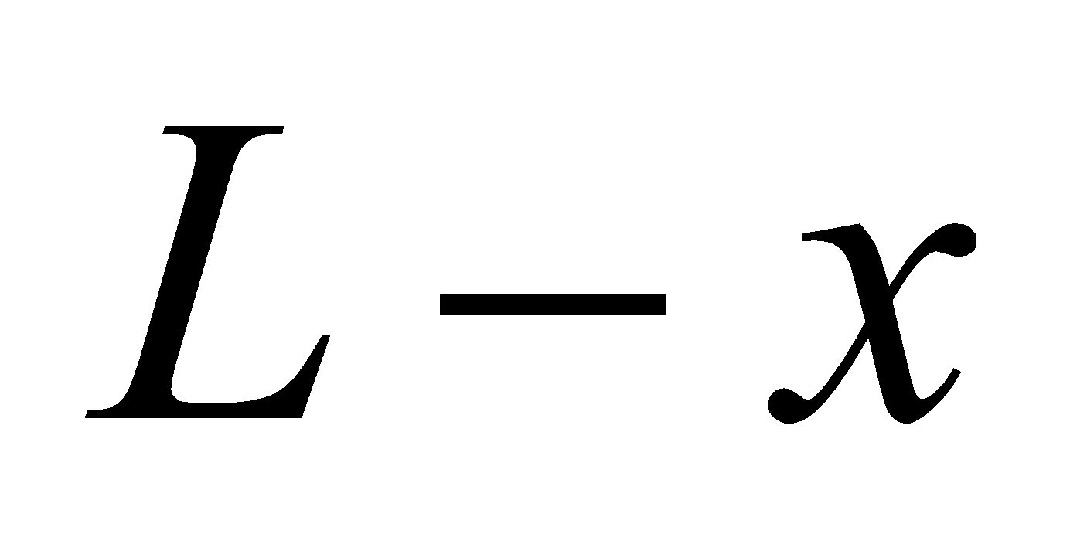from the crossing point to point *B*. As such, the time the light spends in medium 1 and medium 2 can be expressed as:

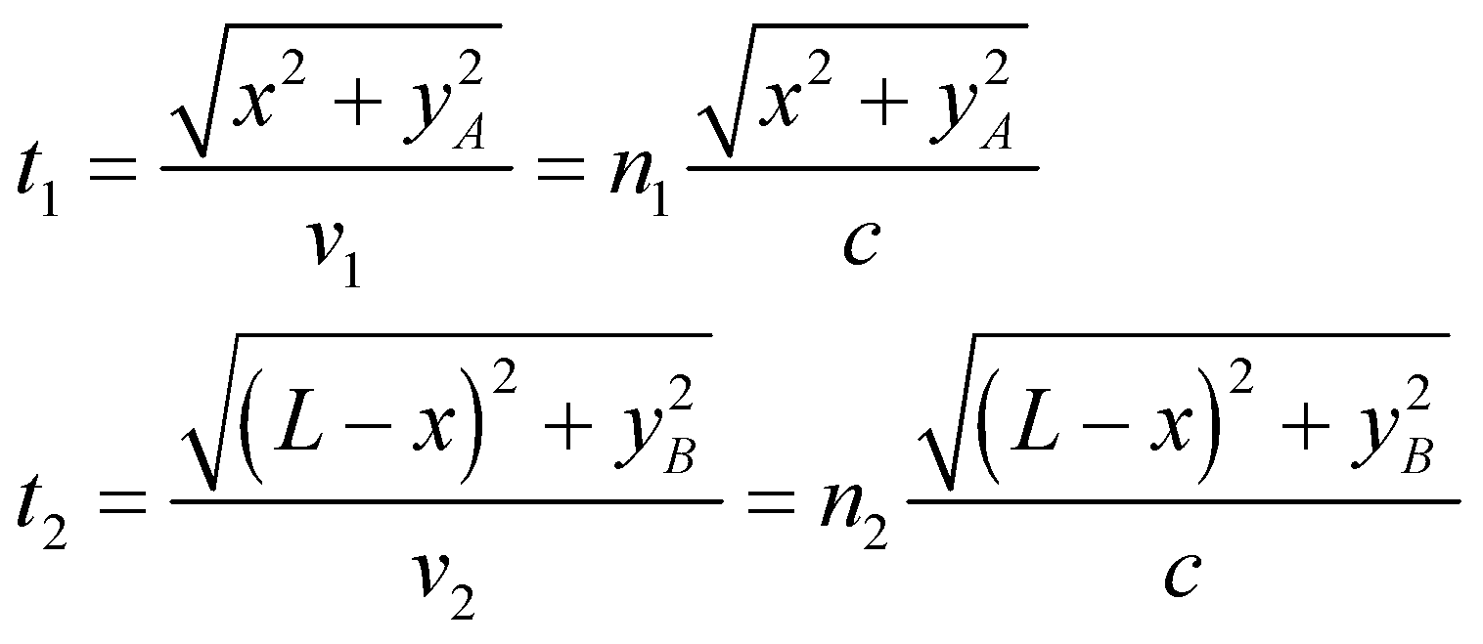

where we have used the speed of light in each medium: 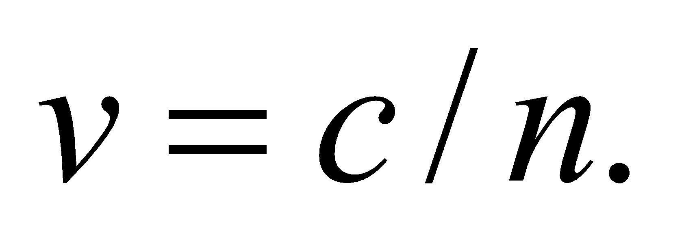 Notice that the only variable in these two equations is the distance *x*; the other parameters are constants. The total time for light to travel along this path is 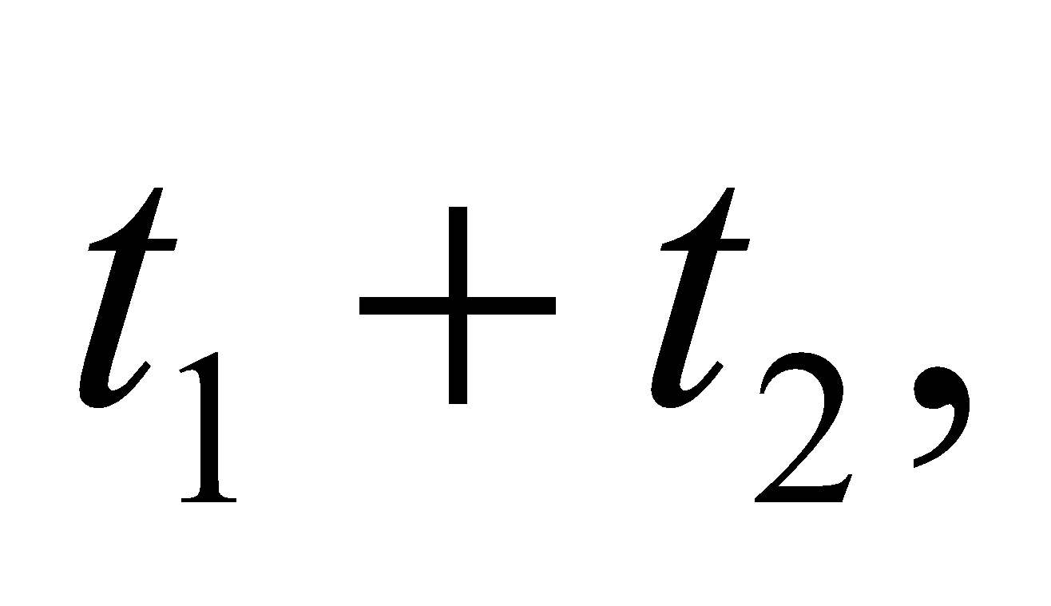which can be differentiated with respect to *x* to find the extremum.

**Evaluate**The derivative of the total time with respect to *x* is

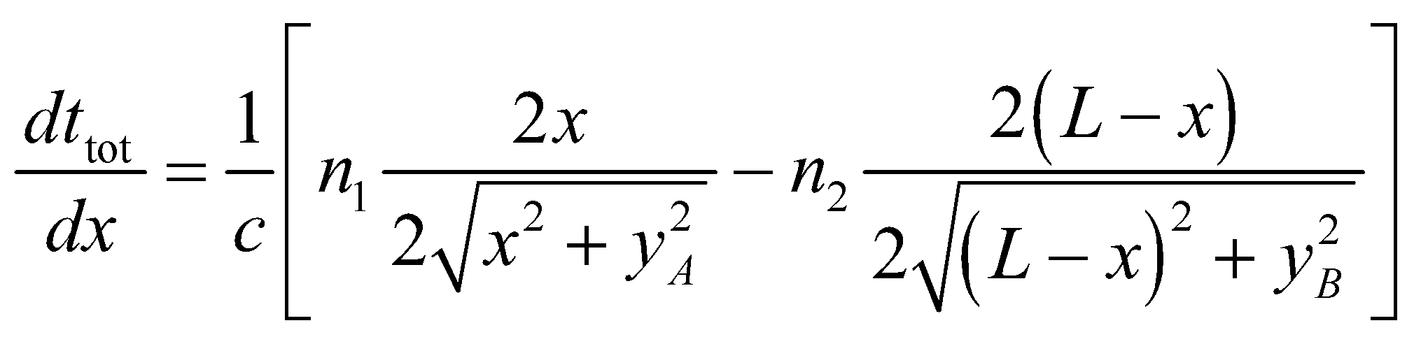

Setting this equal to zero, we find the path that is an extremum obeys Snell's law:

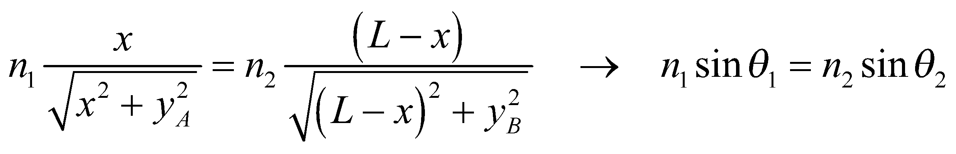

The last step of this derivation follows from the geometry in the figure.

**Assess** If we take the second derivative of the total time, we can show that it is always positive, which means the extremum we have found is a minimum. In other words, light chooses the fastest path from point A to point B. If light moves faster in medium 1 (i.e. 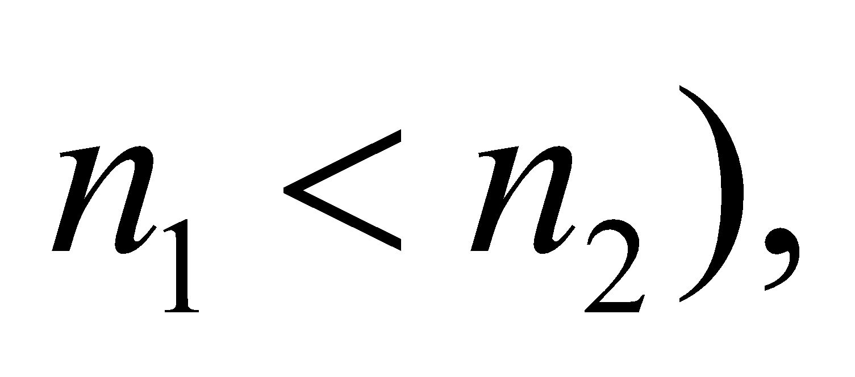 then the path of minimum time will extend the distance traveled in medium 1, in order to reduce the distance traveled in medium 2. An analogy would be a lifeguard rushing to reach a struggling swimmer in a lake. The fastest path may not be a straight line, but instead one in which the lifeguard runs along the shore before diving in. This is because the lifeguard moves slower through the medium of water than of air.

**60. Interpret** We are to determine if total internal reflection in a layer of plastic between two layers of glass in safety glass will pose a problem for the driver. We will investigate this by checking the critical angle at the glass-plastic interface, and then determining whether light from the air-glass interface can reach the plastic at this angle.

**Develop** See the figure below for the definition of the angles and materials. Total internal reflection occurs in materials with a higher index of refraction than the surrounding media, so it is not possible for light to be trapped in the plastic layer. The angle at which light is totally internally reflected at the glass-air interface is

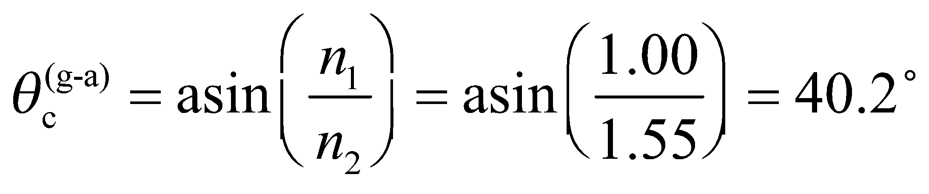

The angle at which light is totally internally reflected at the glass-plastic interface is

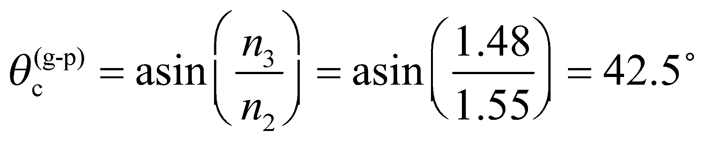

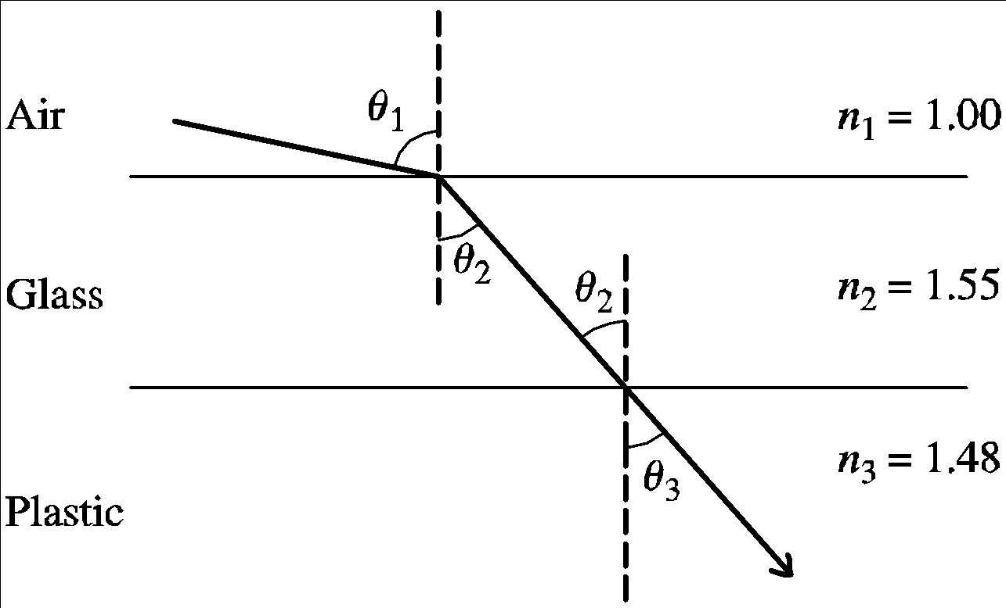

**Evaluate** Because 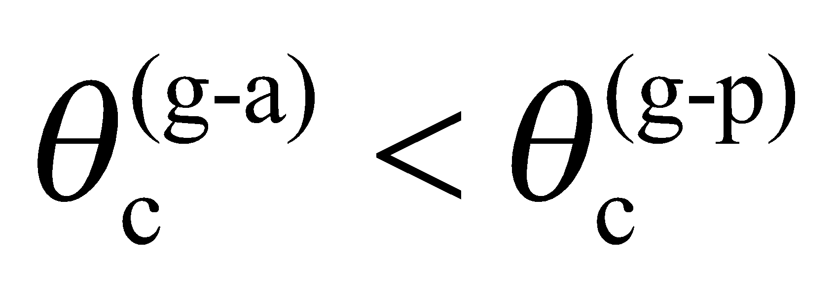, light will be totally internally reflected within the entire composite sheet before it will be trapped within the inner glass layers. Thus, the design is satisfactory.

**Assess** Note that unless *n*3 < *n*1, total internal reflections will never be a problem for this type of layered construction.

**61. Interpret** We want an expression for the time it takes light to traverse a slab of transparent material with an index of refraction that varies with depth. The light enters the material normal to the surface, so there's no angle of refraction to worry about.

**Develop**Inside the slab, the time it takes light to travel an infinitesimal distance, *dx*, is

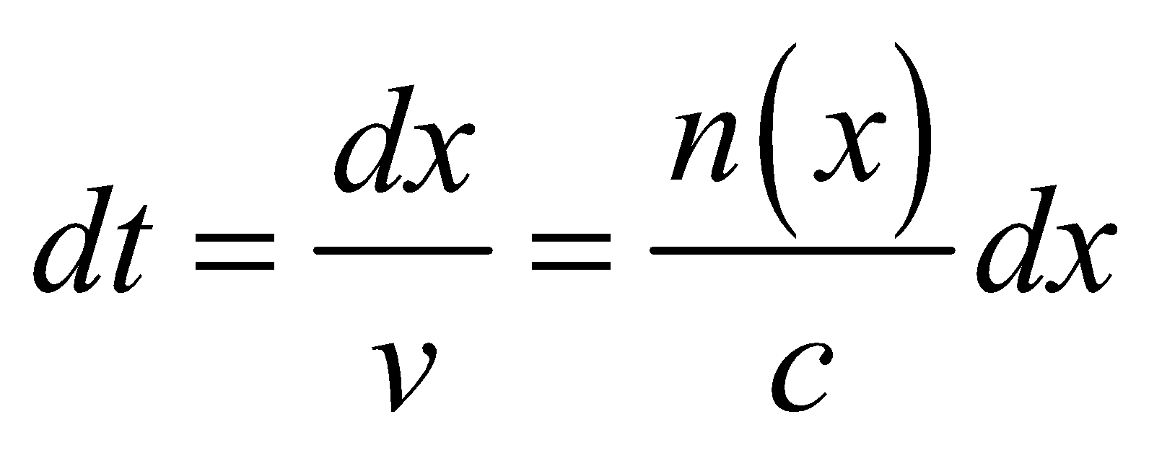

To find the total crossing time, we will integrate this over the slab's thickness, *d*.

**Evaluate**The time to traverse the slab is

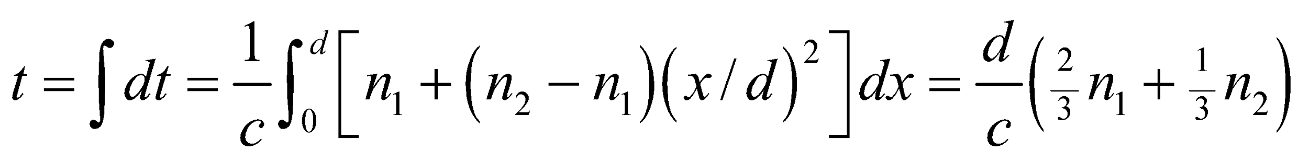

**Assess** Since and have to be greater or equal to one, our result implies that the presence of the slab lengthens the time light takes to travel the distance *d*, as we would expect. If 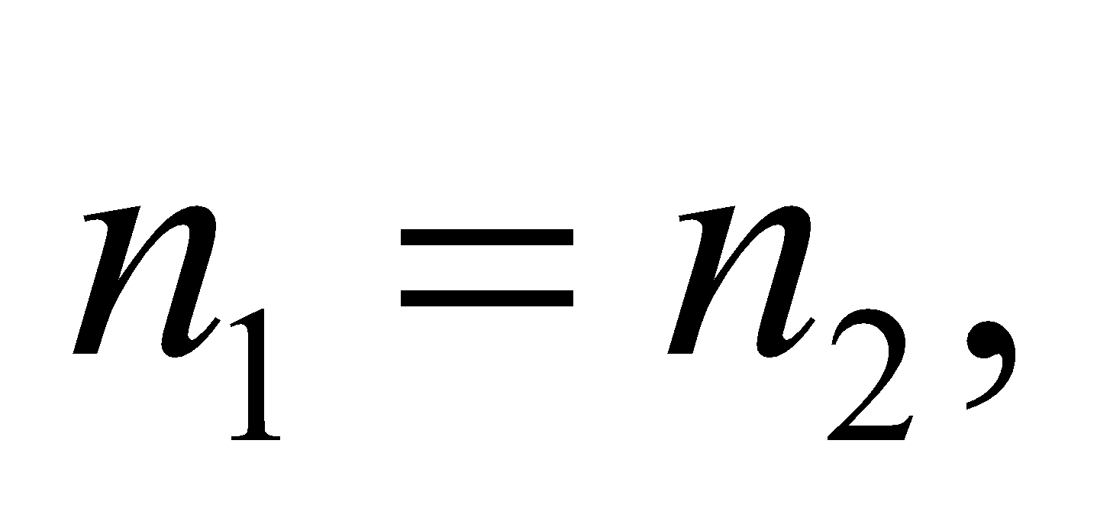then the slab has uniform index of refraction, and the time reduces to 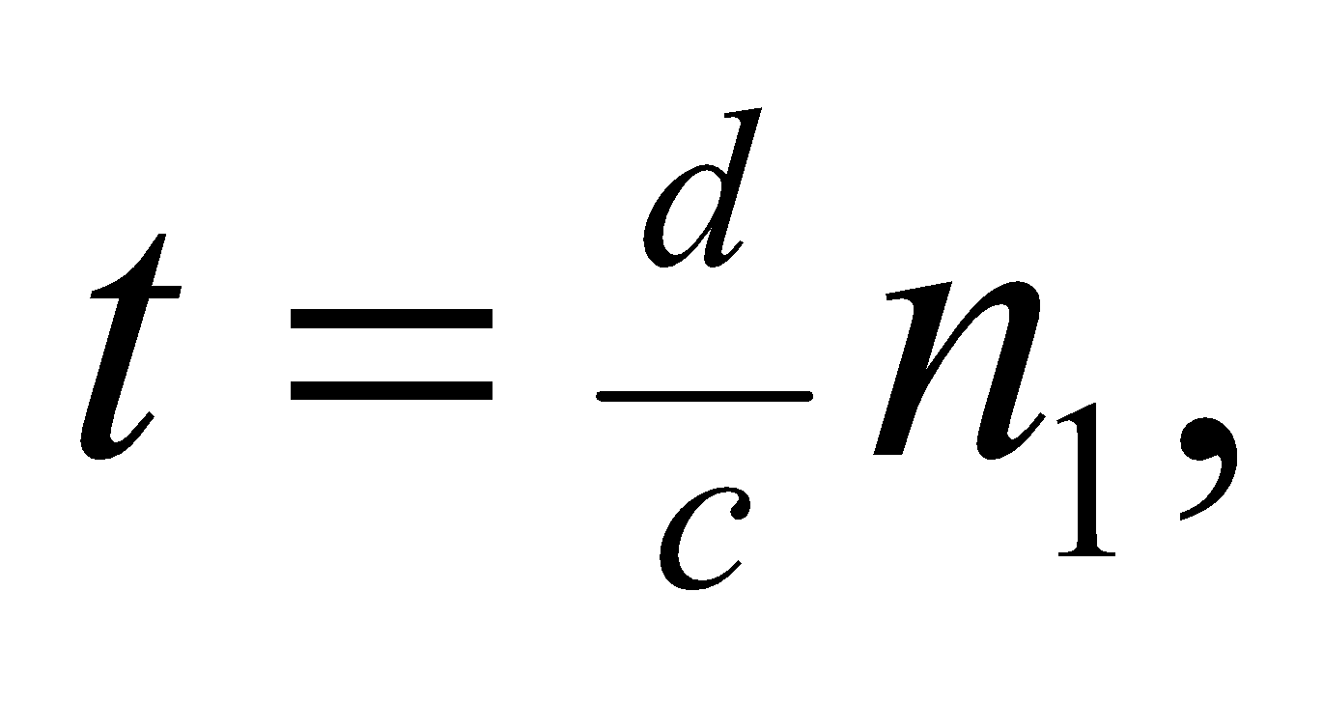again as we would expect.

**62. Interpret** We consider media with varying indices of refraction.

**Develop**In the mirage diagram, the light's vertical direction changes from initially pointing down to later pointing up. This implies that the index of refraction is changing in the vertical direction.

**Evaluate**To determine whether the index of refraction is increasing upward or downward, we imagine a particular point on the light's path where it is approaching the ground. We draw a horizontal line and assume the index of refraction is above this line and  below the line. See figure below.



In this configuration, the tendency is for 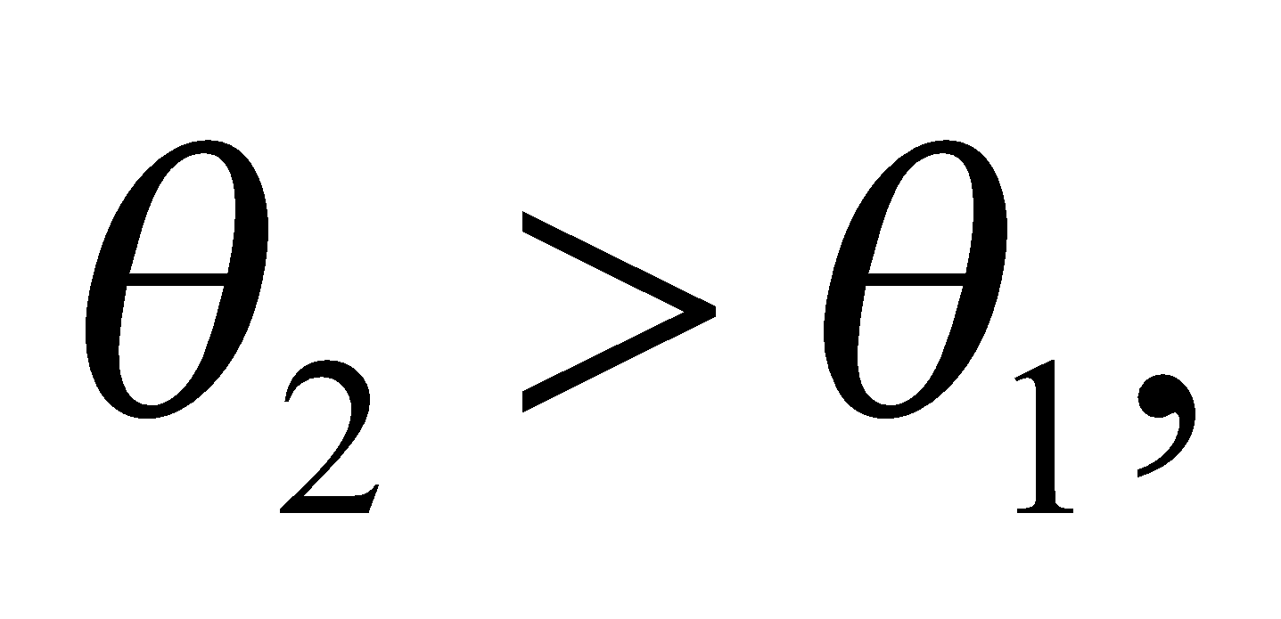 which means  has to be less than  in order to obey Snell's law. Therefore, the index of refraction is increasing upward.

The answer is (c).

**Assess** This variation in the index of refraction is due to a temperature gradient in the air. Warmer air is less dense and therefore has a lower index of refraction than cooler air. In a place where the ground is hot, the air near the surface may be several degrees warmer than the air just a few meters above. The corresponding change in the index of refraction can cause a mirage by bending downward moving light upwards.

**63. Interpret** We consider media with varying indices of refraction.

**Develop**The observer viewing the mirage is unaware of the light's curved path. He only perceives the angle at which the light enters his eye. He assumes what he sees is located in the direction implied by this angle.

**Evaluate**We redraw the figure below, extending a straight line from the observer's eye at the incident angle of the light. It's clear that the mirage will appear at the point A.



The answer is (a).

**Assess** This answer makes sense with our experience of mirages. We think we see water on the ground in the distance, but in fact we are seeing light from the sky that is being refracted from the air near the ground.

**64. Interpret** We consider media with varying indices of refraction.

**Develop**The ionosphere can be thought of as a mirror that only works for certain angles.

**Evaluate**Waves emitted at angles less steep than *θ* are essentially reflected to points farther than point B from point A. Likewise, we'd expect waves emitted at angles steeper than *θ* to be reflected to points between than points A and B, but they're not, so these points will not receive any ionosphere-mediated signal.

The answer is (b).

**Assess** The angle *θ* hre depends on frequency: i.e., the cutoff for reflection to occur is at a smaller angle for higher frequencies. This explains why ionospheric reflection typically works for lower frequencies, such as the AM radio band (535 to 1700 kHz). By contrast, waves in the FM radio band (88 to 108 MHz) are usually not bent enough by the ionosphere to return back to Earth.

**65.** **Interpret** We consider media with varying indices of refraction.

**Develop**If the refractive index of the ionosphere approaches 1 at high frequencies, that means it will have roughly the same index of refraction as the atmosphere below and above it. Thus, there will be relatively no bending of high frequency radio signals.

**Evaluate**Since higher frequencies will essentially pass through the ionosphere, an alternative method, such as satellite-based communication, will be needed to send them over long distances.

The answer is (c).

**Assess** Most satellite-based communication is in the GHz region of the electromagnetic spectrum.